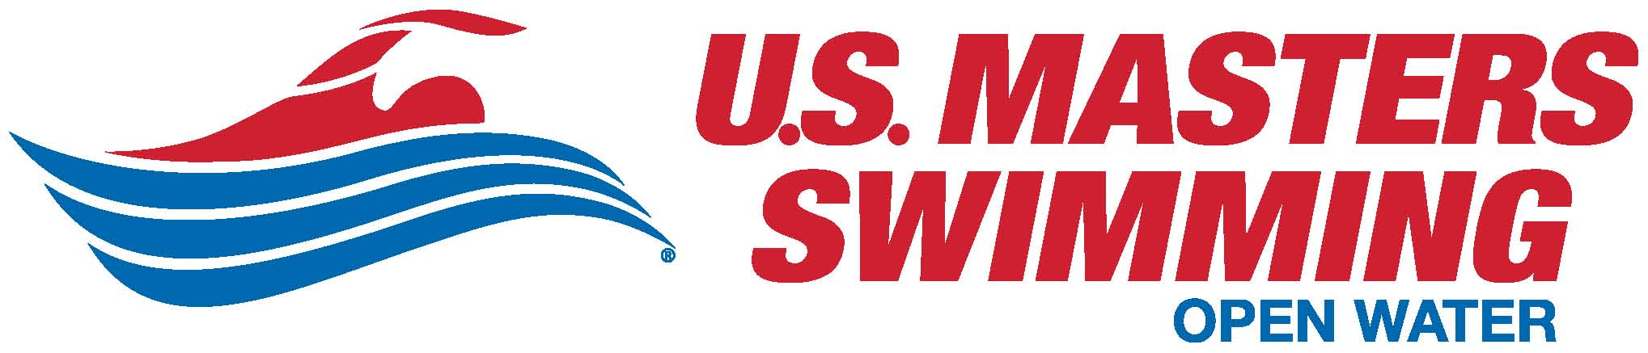

Open Water Safety Checklist
Instructions
- Safety Director: This checklist is intended to help you provide a safe open water swim event according to the USMS-approved safety plan for the event. Please…
- Complete the checklist on each day of the event. We recommend that you check the course with the event Referee, who controls the swims from the start to the finish.
- Complete all other information and forward it electronically to the Event Director after the event.

- Event Director: This completed checklist shows that you conducted the event according to the USMS-approved safety plan, and contains information useful in evaluating this swim and conducting future swims. Please…
- Forward the safety checklist completed by the Safety Director to USMS Open Water Compliance Coordinator David Miner at openwateradvisor@usmastersswimming.org electronically.
- Save this checklist for at least one year after the event.

- Safety Plan: If you need a copy of the approved safety plan—very important for you to have at the venue on the day(s) of the swim(s)—David will send it to you upon request.

Event Information

General Information
Name of Host: Click here to enter host name.
Name of Event: Click to enter event name.
Event Location: Click to enter location.
City: Click to enter city. State: 2 character LMSC: LMSC Abrv.
Event Date(s): Start Date through End Date
Length of Swim(s): Click here to enter text.
Dual Sanctioned with USA-Swimming: Yes or No

Key Event Personnel
Director(s): Click here to enter names.
Event Director: Ref name Phone: 000-000-0000 E-mail: Click here to enter text.
Referee: Ref name Phone: 000-000-0000 E-mail: Click to enter e-mail address
Certified Safety Director: SD name. Phone: 000-000-0000 E-mail: Click to enter e-mail address

Specific Details & Thoughts from Your Event

Water temperature range during the swim(s): Click here to enter text.
Air temperature range during swim(s): Click here to enter text.
Number of swims in the event: Click here to enter text.
Total entrants in the events: Click here to enter text.
Unusual conditions at the venue? Click here to enter text.
If so, what modifications did you make (if any) to account for conditions? Click here to enter text.
Based on your experience this year, what items would you consider changing in either planning or execution that would make your event safer?
Click here to enter text.

Checklist – Complete at the venue on each day of the event.
Emergency Action Plans
- Lead medical personnel (emergency trained) on site & positioned as planned? Yes or No
- Licensed/certified EMT or medical assistance on site or within 10 minutes as planned? Yes or No
- Ambulance(s) onsite as planned: Yes or No
- Phones or radios available onsite for direct communication to emergency facilities? Yes or No
- Route maps to nearest emergency facilities (with phone numbers) posted and available? Yes or No
- Posted emergency plans for severe weather or natural disasters. Yes or No

Venue Safety
- Locker rooms, showers, and rest rooms free of hazards? Yes or No
- Docks & piers free of hazards? Yes or No
- Beach area free of hazards? Yes or No
- Other areas used for the event free of hazards? Yes or No
Course Safety
- Water temperature measured according to USMS guidelines? Yes or No
- Water temperature within USMS temperature guidelines? Yes or No
- Water quality consistent with local governing body standards? Yes or No
- Course(s) constructed & clearly marked as planned? Yes or No
- Course free of non-event boat traffic as planned? Yes or No
- Non-moveable hazards marked and swimmers alerted to them? Yes or No
- Start and finish areas free of hazards? Yes or No
- Swimmer emergency exit points & sheltered areas well defined? Yes or No
- Required pre-race swimmer meeting held before swim(s)? Yes or No
- Method in place to account for all swimmers before, during, & after the swim(s)? Yes or No
- Method in place to account for swimmers who did not finish?
- Method in place to account for swimmers/participants if swim stopped/course evacuated? Yes or No

Safety Personnel & Watercraft
- Appropriate check-in/check-out system for safety personnel? Yes or No
- Adequate number of safety personnel to cover swim(s) as planned? Yes or No
- Adequate number of safety personnel trained in basic life support as planned? Yes or No
- Adequate communication devices for all safety personnel as planned? Yes or No
- All safety personnel & officials attended required pre-race safety meeting? Yes or No
- All watercraft inspected for safety and equipped with adequate safety supplies? Yes or No
- All volunteer power boats have dedicated swimmer monitors? Yes or No
On Site Medical Care & Facilities
- Designated safety area as planned? Yes or No
- Adequate number of safety personnel to cover swim(s) as planned? Yes or No
- Suitable equipment available (rigid spinal board with universal head immobilizer, defibrillator, well-stocked first aid kit) as required? Yes or No
- Procedures in place for all event participants needing emergency care? Yes or No
Cold or Warm Water Events
- Was a USMS-approved Cold Water or Warm Water Thermal Plan required to be in place? Yes or No
If yes…
- What did you do to assist swimmer preparation before the event? Click here to enter text.
- What did you do to reduce swimmer exposure to thermal issues? Click here to enter text.
- What extra medical care did you provide to mitigate & treat thermal symptoms? Click here to enter text.

