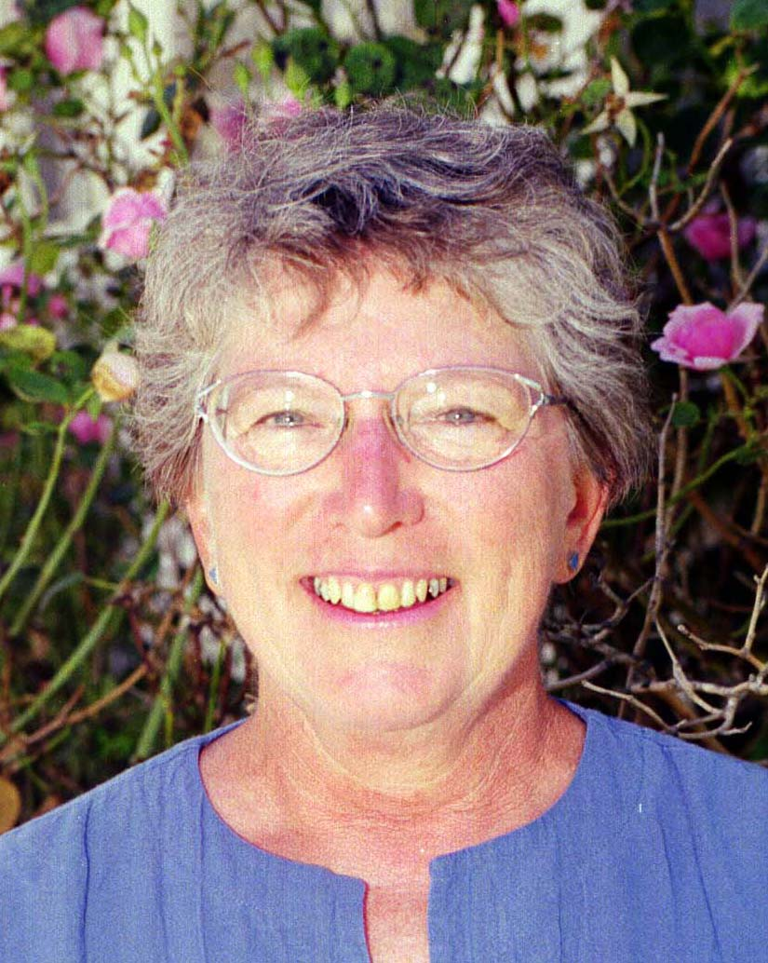
Betsy Durrant
Candidate for President
Why are you interested in being USMS President and why do you believe you would be a good candidate for this position. I am committed to this organization and dedicated to serving in any way I can. I believe that I have the skills, the experience, and the time to do this job successfully. I work well with others and I know how to involve others in projects and decisions.
What do you consider to be the major issues facing USMS in the next four (4) years. As the USMS President, how would you address these issues. One major issue is USMS support of the LMSCs. The national organization can do more to identify what makes a successful LMSC and to make help available to those LMSCs who request it. While there are vast differences in geography and population within our LMSCs, I believe there are common characteristics of LMSCs with a lot of activities and involvement. We should begin by asking LMSCs to identify their strong points and their weak points. When we have compiled lists of what makes an LMSC strong and what problems exist, we can then search for solutions.
The issue of coached workouts and encouraging swimmers of all levels is related to the LMSCs, but even strong LMSCs may not have adequate coached workouts. Wouldn't it be wonderful if every adult swimmer in the country could find a coached workout? To work toward this, I believe we must establish or encourage relationships with YMCAs, colleges, and USA-Swimming teams.
Please list any other experience that relates to your qualifications for office.
- LMSC Chairman, 1980-1984
- LMSC Registrar, 1984-1995
- LMSC Newsletter Editor, 1996-Present
- Meet Co-Director, 1980-Present
- Race Co-Director for open water swim, 1984-Present
- Colonies Zone Representative, 1986-1991
- USMS Zone Chairman, 1991-1995
- USMS Secretary, 1997-2001
Resume for Betsy Durrant
Education
- B.A., Religion, 1963, Duke University, Durham, NC
- M.S., Education, 1987, Old Dominion University, Norfolk, VA
Employment Experience
- Secondary Mathematics Teacher
- 1963-1976—Virginia, California, New Jersey, Kansas, North Carolina
- 1976-1998—First Colonial High School, Virginia Beach, Virginia (Mathematics Department Chairman, 1986-1998)
Masters Swimming Experience
- Began training/competition, North Carolina, 1973-1976
- Continued training/competition, Virginia, 1978-Present
LMSC Involvement
- Chairman, LMSC for Virginia, 1980-1984
- Registrar, 1984-1995
- Newsletter Editor, 1996-Present, LMSC and team newsletter, published monthly
- Meet Director or Co-Director for fall meet, 1980-Present
- Race Director or Co-Director for open water swim, 1983-Present
USMS Involvement
- Colonies Zone Representative, 1986-1991
- Zone Chairman, 1991-1995
- Top Ten Subscriptions, 1992-2000 (Ex-officio to Records & Tabulations Committee)
- Maintained data base of subscriptions/renewals, prepared labels for each issue
- Chairman, Ad-Hoc Committee for Executive Secretary, 1994-1996
- Committee developed job description and established procedure for hiring new Executive Secretary. Received all applications, resumes, etc., and reproduced all materials for Executive Committee.
- Chairman, Subcommittee on Executive Director Position, 1995-1996
- Part of Planning Committee. Developed, conducted, and tabulated survey of convention delegates and LMSC Chairmen.
- USMS Secretary, 1997-2001

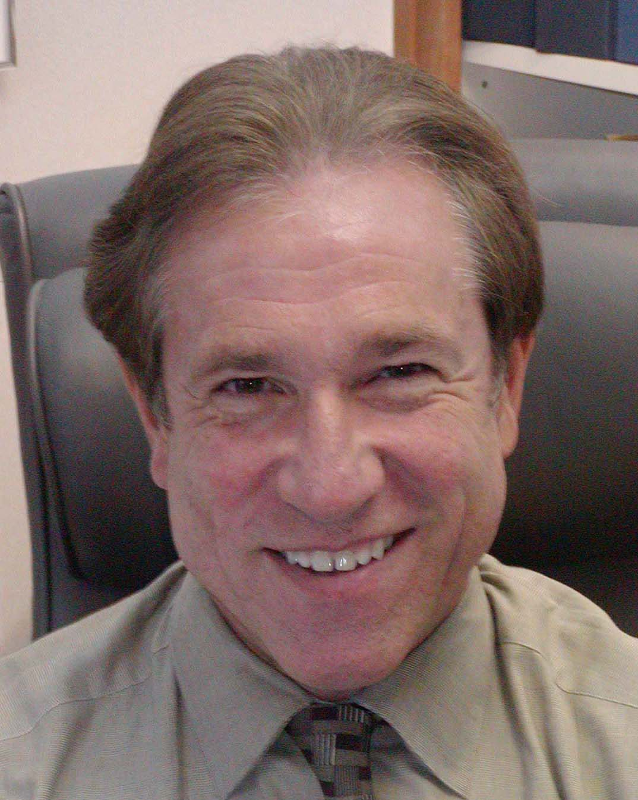
James W. Miller, MD
Candidate for President
Why are you interested in being USMS President and why do you believe you would be a good candidate for this position. I have found a great deal of self-fulfillment through service to USMS over the years in many capacities. My involvement in other organizations both in and out of the world of medicine has served to renew my commitment to our unique body. The concept of an organization of athletes run by their peers with the good of the sport solely at heart is both unique and gratifying.
I bring a unique mix of skills to the Presidency. As a corporate owner, I am familiar with the organization and the day-to-day operations of a professional corporation. I believe that USMS requires such a professional management background in its leadership to continue to successfully address the issue of growth with an expanding base of volunteer and paid positions. The time management skills that I have developed over the years will stand me in good stead in allowing me to devote professional leadership to the running of our organization.
Within USMS, I have chaired three committees: Sports Medicine, Coaches, and Ad Hoc One-Day Registration. I have served on two others: Championship and Long Distance. In addition, since l984 I have held the position of coordinator of medical care for our national championships, overseeing the conduct of health delivery systems at each of our long course and short course nationals.
I have authored many articles and chapters for USMS as well as USA Swimming. Some of these appear as chapters in medical periodicals and textbooks. They vary between articles on defined topics related to sports medicine to the manual concerning the conduct and running of the cable swim.
Between 1993 and 1997, I served as Vice President of USMS and, in that capacity, represented us at international forums and at the National Aquatic Summit. In 1993, I was able to meet with USA Swimming to investigate the potential for Masters swim camps in Colorado Springs. This was a vision which Nancy Ridout has gone on to establish as a regular event. I was fortunate enough to serve as a coach at the first two of these USMS/USA Swimming training camps.
The past four years I have served as one of the eight traveling team physicians with USA Swimming for their national team and have coordinated the speaker series for the USA Swimming Sports Medicine Society. Since 1993 I have also worked with the USOC serving multiple other sports on both a national and an international basis, serving to broaden my background in sports management through exposure to other NGB’s.
On the local front, I have remained active within the Virginia LMSC, coaching on a regular basis and contributing within the local committee structure. I have served as LMSC Chair, team president, and meet director for local events as well as for our two-mile cable swim national championships.
USMS has recognized and rewarded my contributions by naming me Coach of the Year in 1986 and the recipient of the Ransom Arthur Award in 1999. In return, I would like to dedicate my vision and my unique professional and USMS background to carrying our organization forward.
What do you consider to be the major issues facing USMS in the next four years? As the USMS President, how would you address these issues? Our organization is struggling with growing pains. On the one hand, we jealously guard the volunteer organization to which we have all given so much time and talent unselfishly for the pure good of a sport which symbolizes a true passion for many of us. Under this guise, any attempt to run our corporation as a service organization with a core of paid employees has met with resistance.
At 42,000+ members, this system has struggled, resulting in the addition of one paid position at a time seemingly without a master plan as to the final corporate makeup. It remains difficult to define or reach our goals without the ultimate end being clearly defined.
I view USMS as a corporation of volunteers with a support staff whose role is to promote and integrate our committee plans and efforts. The leadership and voting power must remain in the hands of the volunteer House of Delegates and the committee structure with the independent contractor positions clearly defined under contract. Thus, one of my platform issues is to establish a committee to map out the future contractor positions for consideration by the House of Delegates with implementation timetables in place.
Having served for many years on the Championship Committee, I have come to realize that we are facing increasing difficulty in conducting our national championships and in attracting quality experienced hosts. USMS must move quickly to take responsibility for running the “paper” side of the meet, thereby allowing the meet host to devote more time to organizational and fundraising efforts and to developing a high-quality support staff of volunteers, timers, and officials.
The national championship is our showcase for each of our competitive seasons, but those who run the meets are frequently the least qualified to understand the complexities of such an event. There is no reason for us to continue to suffer through their learning curves year after year. We are currently facing long debates within the Championship Committee regarding the conduct of a quality national championship. Is a 9 PM start time conducive to a high-quality performance? Is a timer who has never worked a swim meet conducive to quality? Are semi-empty heats with two to four swimmers conducive to quality?
We need to give as many athletes as possible a chance to experience the thrill of national championship competition by creating a subcommittee within the Championship Committee dedicated to the actual running of these meets. If this is not done, we will see increasing limitations on who and how many can compete. Our first responsibility with regard to the quality of the meet is to run the events as efficiently as possible with head-to-head competition within a timeframe that makes sense. Learning from meet to meet and handling the paper side of the competition is a start in the right direction. This is not a new concept. It was first presented by Championship Committee Co-Chairs Mel Goldstein and Bill Barthold over a decade ago. The time has come to implement it.
USMS has a duty to provide an ever-improving program for fitness and competitive athletes. In multiple surveys, membership retention and growth are seen to be enhanced by creative, quality coaching. Organization at the top of USMS can be no better than the strength of the programs at the local level. USMS must actively strive to expand programs aimed at developing local coaching and leadership. Support of developmental programs must expand, and it is time to raise the level of coaching quality by encouraging educational experiences which will stimulate their interchange of ideas and styles. Utilizing the day prior to the beginning of our national convention to offer a coaching track has been advantageous. It would also be an ideal forum for coaches to receive safety, CPR, or first aid training, moving toward those national safety standards for coaches endorsed by the current Safety Committee Chair, Julie Paque, as early as short course nationals at USC and, more recently, by Scott Rabalais, Coaches Committee Chair. By beginning instruction at this level, it would then be possible to expand these opportunities to the LMSC’s via joint efforts of the Safety, Coaches, Sports Medicine, and Marketing Committees.
In further support of our mission, I would propose escalating support for sports medicine and coaching research specific to Masters swimmers in conjunction with the USMS Endowment Fund.
Please list any other experience that relates to your qualifications for office. My wife and I have dedicated a tremendous amount of our effort, time, and love to helping mold United States Masters Swimming both locally and nationally. Indeed, these standards carry down to our children, who are both now organizing and coaching a swim team together while swimming at the Masters level themselves. USMS is a large part of our family, and I am prepared to devote my considerable energies as well as my broad base of experience to leading it in its next steps forward.
Resume for Jim Miller
Education
- BA - University of Virginia, 1972 - Chemistry / Psychology
- MD - University of Virginia, 1977
- Family Practice Residency - Riverside Hospital, Newport News, Virginia, 1980
- Induction as Fellow of American Academy of Family Physicians, 1986
- Procedural Certification by American Academy of Family Practice for Esophagogastroduodcnoscopy, Nasopharyngoscopy, Colonoscopy, and Colposcopy
- Subspecialty Sports Medicine via Certificate of Added Qualifications
Present Positions
- President, Family Practice Specialists of Richmond, P.C., Richmond, Virginia
- Medical Director, Riverside Wellness & Fitness Center - Briarwood, Richmond, Virginia
- Team Physician, James River High School, Midlothian, Virginia
Memberships, Affiliations, Activities
- American Medical Association
- American Academy of Family Physicians
- American Medical Society for Sports Medicine
- American Geriatrics Society
- Virginia Academy of Family Physicians
- Medical Society of Virginia
- Richmond Academy of Medicine
- Assistant Clinical Professor, Medical College of Virginia
- Assistant Clinical Professor, University of Virginia
- Adjunct Professor, James Madison University
- Physician, United States Olympic Training Center
- U.S. Olympic Sports Medicine Society
- ACLS Instructor
United States Masters Swimming
- Recipient of Ransom Arthur Award 1999
- Vice President, 1993-1997
- Representative and Strokes & Tums Official, FINA World Championships, 1995
- Medical Coordinator, National Championships, 1984-Present
- Local Masters Swim Committee for Virginia, Chairman, 1989-1993
- Championship Committee, 1991- current
- Ad Hoc One-Event Registration Committee, Chairman, 1991-1993
- Coaches Committee, Chairman, 1987-1989, 1989-1997 (member)
- Sports Medicine and Research Committee, 1984-Present (Chair 1996 - current)
- Long Distance Swimming Committee, 1984-1988
- Virginia Masters Swim Team, President 1985-1989
- USMS "Coach of the Year" 1986
- Vice President, Masters Aquatic Coaches Association, 1984-1988
USA Swimming / USOC
- USA Strokes and Turns Official, 1988-Present
- Physician, Olympic Trials, 1995,2000
- Medical Director Women's NCAA Division I National Championships, 1997, 2O00
- Team Physician World University Team, 1997
- Team Physician World Championships, Perth Australia, 1997
- USOC Physician Goodwill Games, 1998
- Team Physician, FINA Open Water World Championships, Hawaii 2000
Publications
- Author, "Injuries and Considerations in Masters Aquatics Sports", Clinics in Sports Medicine, April 1991
- Co-author, "Swimming and the Older Athlete", Clinics in Sports Medicine, April 1991
- Author, "The Organization and Conduct of Cable Swims", September 1989
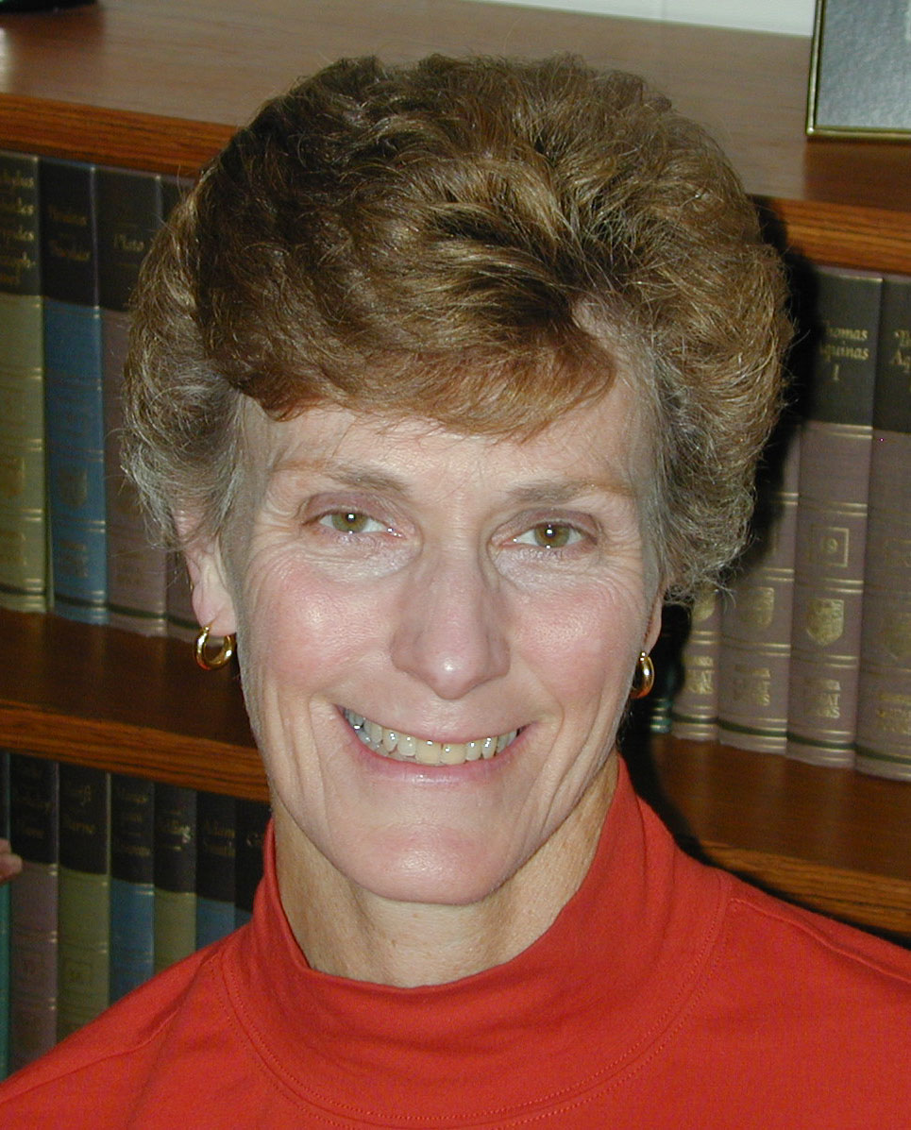
Sandi Rousseau
Candidate for President
Why are you interested in being USMS President and why do you believe you would be a good candidate for this position. I want to be President of USMS because I would like to continue to serve USMS in a strong leadership role. I believe that I am qualified to lead USMS, capable of surrounding myself with enthusiastic and knowledgeable volunteers, and confident enough to seek out the opinions of others when I do not know the answers. I possess demonstrated leadership skills in my work at the national, LMSC, and local levels. I have an ability to delegate responsibilities and yet continue to keep abreast of the progress of plans and tasks, and can build consensus when decision making is necessary. I am able to motivate USMS members to assume volunteer positions, and I possess communication skills that facilitate group interactions and allow for all viewpoints to be presented. I believe my style of “hands on” leadership fits well within this organization, and I believe that I can develop and lead a cohesive Executive Committee and Board of Directors. I am organized, efficient, detail oriented, tactful, and responsive. I have recently retired from my full time profession and now work part time with flexible scheduling, so I have the time to dedicate to being President of USMS. Masters swimming has provided me with over 20 years of wonderful camaraderie and fitness, and I would like to continue to give something back to the organization.
What do you consider to be the major issues facing USMS in the next four (4) years? As the USMS President, how would you address these issues? USMS faces many issues in these next few years. Some of the key issues that I see are as follows:
1. Volunteerism and Paid Positions: I believe USMS is a volunteer driven organization and should strive to remain that way. While I think payment for certain tasks and projects is warranted, this area needs to be critically considered in relation to the future implications for the organization and the impact that significant changes will have on our current volunteer base. I support having appropriately formed search committees for paid positions.
2. Treasury Excess / Endowment Fund: Our treasury has a substantial balance for the size of this organization. While we need to keep enough monies to fund our insurance reserve and general operating reserve, we need to assess whether continued build up of yet more funds is warranted without specific purposes. I support no increase in dues, perhaps a decrease in national dues from the LMSCs, and detailed budgeting from all USMS bodies that have budgets. Funding some special projects may well be feasible with thoughtful proposals that will be good utilization of the excess funds. Currently, there is no definite plan for the Endowment Fund, and I would like to see us specify these funds for a worthy project(s). I would also like to see USMS pursue a Planned Giving program (willing of monies at death) with marketing of this program to our members.
3. Membership Growth: I support continued and steady membership growth, but we need to put more emphasis on membership retention. Continuing to look at ideas to gain information regarding why members do not renew will be important particularly in gaining insight into any avenues of dissatisfaction with USMS and services that no longer seem attractive to members or are not considered a worthwhile value. Marketing USMS and the value that a Masters program can bring to local pools, park districts, and community organizations through education of the local Masters swimmers should become a higher priority. We should also consider marketing the benefits of Masters swimming to health organizations.
4. Recognition of the Non-Competitive Swimmers: I believe we need to provide more services to the rank and file fitness swimmers who choose not to enter competitions. Providing more fitness events and expanding on the types of events offered would be attractive to some. Promotion of more special interest articles, comeback stories, and personal accomplishments might also be ideas to consider.
5. Coaches: To promote Masters swimming we need more Masters coaches. The continuation and expansion of clinics for potential Masters coaches, increasing the visibility of MACA, continued education to other coaching organizations regarding Masters coaches, and providing assistance/information to clubs or local teams who may not have a coach could all be beneficial.
6. LMSC/Club Assistance: I believe that there is more USMS could do to assist clubs, local teams, and workout groups in organizing at the local level. Providing bylaws, job descriptions, coaching agreements, etc., could be beneficial for the growth of start up groups of swimmers. A challenge will be to determine how to seek out these groups to offer assistance and support. I would also like to propose that USMS consider a fund with specific guidelines for usage to encourage small LMSCs with very limited funds to send representatives to convention.
7. Recognition of Volunteers: One can never recognize volunteers enough! This is particularly important for USMS which is volunteer driven. USMS has established numerous avenues to recognize our volunteers, but we can improve on that more and should do so. We should look for ways to acknowledge local volunteers in the national spotlight and recognize the volunteers that work on our national committees. Utilizing our web site for volunteer recognition is one idea that could be considered.
8. Communication: USMS has made great strides in improving member communication via the web, SWIM magazine, Streamlines, mailings to LMSCs, and through our National office staff. However, we can always improve on these avenues of communication and should continue to evaluate if we are utilizing our assets to the greatest degree possible. Our web site has proven to be one of our strongest communication links to our members at the local level and the world. We need to continue to explore even more innovative ways for utilizing this valuable resource.
9. Relationships with Other Organizations: Continuing our quest for enhanced liaisons with other fitness organizations such as YMCAs, Park and Recreation Districts, Community Centers, and swimming related organizations such as the International Swimming Hall of Fame, FINA, etc. are important to the continued health of this organization. Strengthening our liaisons with USA Swimming and USA officials and other certifying organizations for officials is also important.
10. Sponsors: Evaluating the area of USMS sponsorships for maximum benefits for our members and the organization’s visibility and monetary benefit will continue to be important. Considering different or additional mechanisms for encouraging our members to support sponsors could also benefit members as well as attract potential sponsors to the organization.
USMS has a wealth of knowledge, ideas, and skills residing within our members. I have spent a great deal of time during the past year educating myself regarding aspects of the organization with which I have not had much exposure in the past. I believe I am prepared to lead USMS as President. My goal will be to leverage this information to define what is important for the future of Masters Swimming, and lead USMS in that direction. With the assistance of our volunteers, we can continue to improve on the successful start that we have had in the 20th century.
Please list any other experience that relates to your qualifications for office: I have had leadership roles in organizations unrelated to swimming, e.g. President of a time share Condominium Association and numerous roles as chair and committee member within my profession and employment organization. I have participated in several communication seminars, and these have helped fine tune my skills in working cooperatively and collaboratively with people.
Resume for Sandi Rousseau
USMS Experience—National
- Oregon LMSC Delegate 1985-2000 (excluding 1988)
- Championship Committee Chair 1993-Present
- Solicit, coordinate, and review bids for National Championship meets
- Provide guidance and advice to meet hosts
- Coordinate projects within Championship Committee including: Update of Meet Manager’s Manual, Development of Entry Processing Workbook, Development of Meet Liaison Guidelines, Revision of Championship Bid Application, Meet Contract Updates, Rules Proposals from Championship Committee, Top Ten Survey, and On Line Entry Process
- Championship Committee Member 1985-1993
- Co-author of Championship Meet Contract
- Author of Championship Meet Evaluation Forms
- Author of Article on National Meet Limitations for USMS Newsletter
- Authored and Tabulated Survey on National Qualifying Times – Santa Clara, CA, Nationals 5/93
- Liaison to National Championship Meets: Federal Way, WA - LC (8/92); Tempe, AZ - SC (5/94); Cupertino, CA - SC (5/96); Federal Way, WA - SC (5/97); Indianapolis, IN - SC (5/98); Minneapolis, MN - LC (8/99); Federal Way, WA - LC (8/01); Honolulu, HI - SC (5/02)
- Ad Hoc Computer Registration/Top Ten Committee Member 1995-1996
- International Committee Member 1990-1991; Chair of Ad Hoc Committee to recommend changes to MSI Bylaws/Constitution
- Sports Medicine and Research Committee Member 1986-1992
- Convention Committee Member 1988-1989
- Safety Education Committee Member 2000 - Present
- Marketing Committee Member Ex-Officio (Interactions regarding Sponsorships) 1998 – Present
- Attendance at 25 USMS National Championship Meets
- Attendance at 4 International Competitions: New Zealand 1984, Australia 1988, Indianapolis, IN 1989, Portland, OR 1998
- Recipient of USMS National Championship Meets Award – 1998
USMS Experience—LMSC
- Member of Oregon Masters Swimming 1977-Present
- Attendance at LMSC Board Meetings since 1983
- LMSC Board of Directors
- Secretary 1983-1984; Chair 1985-1986; Safety Chair 1994 - Present
- Awards Committee Chair 1991-1992
- Author of OMS Meet Contract - 1986
- Author of Association Meet Guidelines - 1980s
- Author of OMS Safety Guidelines and Warm-Up Procedures - 1983
- Meet Director of USMS Long Course Nationals -1986
- Entry Processing Committee for 1995 LC Nationals
- Founding Member of Tualatin Hills Barracudas (Local Team) - 1981
- Co-author of THB Constitution and Bylaws
- Secretary 1981-1983; President 1984-1986, 1992-1993; OMS Liaison 1996-Present; Meet Director 2000 - Present
- Meet Director for several local meets hosted by the Barracudas 1980s - Present
- Author of Team Brochures 1980s
- 1998 NIKE World Masters Games Swimming Commissioner (8/98)
- Recipient of OMS Ole’ Barnacle Award 1986 (Meritorious Service/Leadership to Oregon Masters Swimming)
- Recipient of OMS Connie Wilson Memorial Award 1987 (Outstanding Long Term Leadership/Service to OMS)
- Recipient of OMS Special Service Award 1998
Professional
- Adult Nurse Practitioner, Internal Medicine, Kaiser Permanente, Portland, OR
- Staff Nursing / Head Nurse – University of Colorado, Denver, CO
Education
- Bachelor of Science in Nursing, Indiana University, 1969
- Masters of Science in Nursing, University of Colorado, 1971
- Adult Nurse Practitioner Certification, University of Colorado, 1973
Other Organizational Experience
- President - Wild Bird Interval Owners Association (Condominium Association), Sun Valley, ID 1988-1997
- Board of Directors 1988 - Present
- Kaiser Permanente Westside Leadership Council - 1990s
- Kaiser Permanente Affiliated Clinician’s Council - 1980s
- Kaiser Permanente Nurse Practitioner Council - 1980s
Other Facts / Interests
- Hiking, Backpacking, Snow Skiing, Bicycling, Gardening
- Amateur Radio Operator WB7NED
- Pear Farmer in the Hood River Valley
- Married 23 years; One Husband/Three Cats
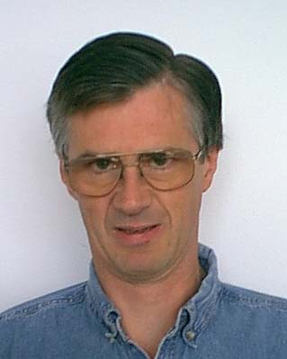
Hugh Moore
Candidate for Vice President
Why are you interested in being USMS Vice President and why do you believe you would be a good candidate for this position. I wish to continue to serve USMS. I strongly believe that USMS should increase its efforts to provide events and programs to motivate all members of USMS toward improved fitness.
I feel that being Vice President would be an excellent use of my communication and organizational skills. I also believe that my broad experience at team, LMSC, and national levels has enabled me to appreciate the diversity of our 40,000 members.
What do you consider to be the major issues facing USMS in the next four (4) years. As the USMS Vice President, how would you address these issues. I feel that the major issues currently facing USMS are primarily related to our growth. These issues include managing our growth, managing our professional staff, continuing to improve communications, and providing programs for all members, including novice swimmers as well as elite athletes.
Most issues must be addressed by harnessing the energy and ides of our members. We must continually make efforts to solicit the ideas of our 40,000 members. We must improve our infrastructure of coaches, administration, communications, and pool availability, so that we can continue to grow at a controlled rate.
Please list any other experience that relates to your qualifications for office. My experiences at work keep me abreast of current technology. I feel that evolving technology, such as the internet, computers, and software, is important to our communications infrastructure and event management.
Resume for Hugh Moore
USMS Experience—National
- Chairman, Communications Committee, 2000-present
- Zone Committee Chairman 1997-2000
- Chairman ad hoc Professional Management 1998-2000
- Chairman, USMS Officials Committee 1993 - 1997
- Chairman, USMS Planning Committee 1991 - 1992
- Member, USMS Planning Committee 1985 - 1994
- USMS Convention Delegate 1986 - present
- Member, USMS Marketing Committee 1987 - 1989
- Chairman, Registration Computerization Program 1987 - 89
- Member, ad hoc Computerization 1989 – 1991
- Ad hoc History and Archives Committee 1999-present
USMS Experience—LMSC (Pacific Northwest)
- Meets Committee Chairman 1997-present
- LMSC President 1985 - 1987
- Member Board of Directors 1983 - present
- Registrar 1984 - 85, 87 - 89
USMS Experience—Team
- President Federal Way Masters 1984 - 87, 1989 – 90, 1998-present
- President SWIM (Swimmers of Wichita - Inland Masters) 1979 - 83
USMS Experience —Meet Organization
- Meet Director of the following Meets:
- 2001 USMS National Long Course Championships
- 1997 USMS National Short Course Championships
- 1992 USMS National Long Course Championships
- National Preview Meet (June, 1992)
- Four Northwest Zone Championships (1991 - 1996)
- Seven Pacific Northwest Association Championships (1991 - 2001)
- Region XII Short Course Championships (April, 1990)
- Six local meets in Wichita, KS (1978 - 82)
Professional Experience
- B.S.E.E. (1976) University of Idaho
- M.S.E.E (1977) University of Idaho
- Employed as Electrical Engineer by the Boeing Company 1978-present
Personal Information
- Married to Jane Moore since 1979
- Daughter – Sarah born 1986

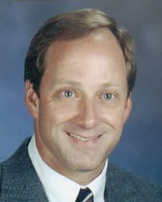
Scott Rabalais
Candidate for Vice President
Why are you interested in being USMS Vice President and why do you believe you would be a good candidate for this position. I wish to continue being of service to United States Masters Swimming and employ my talents and abilities to the Executive Committee of USMS. I believe I am a good candidate for Vice President for the following reasons:
1) I have knowledge in various areas of USMS from the positions in which I have served over the past 13 years. The main positions are Coaches Committee Chairman, USMS Editor for SWIM Magazine, Dixie Zone Representative, LMSC Chairman, Convention Delegate and Masters Coach & Swimmer.
2) I have strong ties and contacts with other swimming bodies, primarily USA Swimming, National Senior Games and High School Swimming.
3) I am a TEAM PLAYER, which is essential in the role of Vice President and as an Executive Committee member. On a local level, I advocate that every swimmer consider their role as a team player, as I believe having a strong, unified force is a key to success in any organization.
4) I have strong leadership qualities, developed and expressed through positions both in USMS and other swimming-related opportunities.
5) I have a strong work ethic. This is particularly important in our organization, as our officers must often balance the demands of family, work, swimming and other interests along with volunteer obligations.
What do you consider to be the major issues facing USMS in the next four (4) years? As the USMS Vice President, how would you address these issues?
1) Redefine our mission, goals and objectives to provide a clear and concise path for USMS to follow in the years to come. As Vice President, I will contribute valuable input for this vision based on my previous experience and my assessment of the desires of our current membership.
2) Build a more “program-oriented” organization that centers on the club as the main benefit-provider for our swimmers. In my opinion, the greatest benefit a USMS member can experience is being a part of a viable local club, run by capable coaches and administrators, where swimmers function as a team and have the opportunity to achieve their personal goals. As coach of a very viable club for the past 17 years, I can share valuable insights on how this may be accomplished nationwide.
3) Increase “broad-based” appeal for Masters swimming. In other words, while there are many adult swimmers in our national population, only a small percentage are members of USMS. I can offer input as to how we may increase our membership base substantially through a program-based USMS.
4) Improve our web-based communication and education. The USMS web site has become a major communications tool over the past few years, and it is likely that demands on the site will increase in the years to come. By and large, USMS swimmers have a hunger for knowledge of swimming, and the web, as well as written publications, can help to fulfill this need for the swimmers.
5) Improve the relationships with other aquatics-related bodies, particularly USA Swimming, YMCA and National Senior Games. The number one priority should be to educate the young swimmers of USA Swimming as to the benefits of a lifetime of swimming, thus increasing the chances that their vast membership will become Masters in the years to come.
6) Improve volunteer contributions within our national committees and on a local level through education of the importance of effective volunteerism in USMS.
Resume for Scott Rabalais
Current and Former Employment
- Director & Masters Coach, Crawfish Aquatics, Baton Rouge, La. (1998 to present)
- Oversee multi-faceted aquatic organization consisting of a USA Swimming team (150 members), Masters team (75 members), High School Swim League, Summer SwimAmerica Swim Lessons, and various aquatics-related classes.
- Coach of Crawfish Masters Swim Team, Baton Rouge, Louisiana (1984 to 1998)
- Coached over 1,000 Masters swimmers with a typical team size of 100 swimmers. While coach of Crawfish Masters, served as creator and coordinator of the February Fitness Challenge from 1992 to 1998.
Masters Swimming/Positions Held
- USMS Coaches Committee Chairman (1997 to present)
- During tenure as chairman, Committee instituted the following: USMS coaches registration/database, LMSC Coaching Representatives, USMS Open Water Clinics, Coaches Committee Quarterly (newsletter), Ask the Coach (SWIM Magazine feature), International Coaching Program and Masters Coaches Compensation Survey. The committee also worked extensively in continuing its established programs and contributed to the Masters training camps at the Olympic Training Center.
- Coach/Coordinator – USMS/USA Swimming High Altitude Training Camps (Camps 1-4), Colorado Springs, CO, at Olympic Training Center
- USMS Liaison to National Senior Games (1999 to present)
- USMS Editor for SWIM Magazine (1993 to 1997)
- Dixie Zone Representative (1991 to 1995)
- Member, USMS Fitness Committee (1991 to 1993)
- Southern LMSC Chairman (1989 to 1993) – also Newsletter Editor and Sanctions Chair
- Meet Director, over 70 local Masters meets (1986 to 2001)
- USMS Convention Delegate (1988 to 2001 – except 1990)
Other Positions Held
- Meet Director for Swimming, 2001 National Senior Games (1,000 participants – est.)
- Meet Director for Swimming, 1993 National Senior Games (860 participants)
- Meet Director for Swimming, Louisiana State Senior Games (1988 to present)
- Meet Director for Baton Rouge High School Swim League (1996 to present)
- Meet Director, 2000 Louisiana State Long Course Swimming Championships
- Official, Baton Rouge Area Special Olympics Swimming, 1990 to present
- Chairman, Southside Summer Swim League (1988 to 1989)
- Meet Director/Creator: Baton Rouge Summer League Championships (1996 to 1998)
Major Awards
- USMS Coach of the Year (1995)
- Masters Aquatic Coaches Association Lifetime Achievement Award (2000)
- USMS Fitness Program Award, Crawfish Masters for February Fitness Challenge (inaugural award - September, 1997)
- Inductee: Southern Masters Hall of Fame (August, 1997)
Writing
- Fitness Editor, SWIM Magazine (1997 to present)
- Published in numerous other magazines and publications, including Swimming World and Swimming Technique.
Clinics Conducted
- Vichy, France Houston, TX
- Baton Rouge, LA Rochester, NY
- New Orleans, LA Richmond, VA
- Bahamas New York, NY
Athletic Achievements
- Four-time USMS All-American, 1500 meter freestyle (LCM & SCM)
- Three-time USMS National Champion (800/1500 meter freestyle)
- Former USMS record-holder, 5 Kilometer Swim
- Former USMS record-holder, 3000 Yard Swim
- Two-time USMS Long Distance All-Star and All-American
- Two-time Southern Masters Outstanding Male Swimmer
- US Triathlon Series National Rankings, 4th place, 1986
- Two-time Hawaii Ironman and professional triathlete (1980 to 1986)
- Louisiana State University varsity swimmer (1978 to 1980)
Personal
- Born September 4, 1958, in Baton Rouge, Louisiana
- College: B.S. in Psychology, Louisiana State University (1976 to 1980)
- Married to Muriel Downs Rabalais; two sons, Ross, age 4, and Ryan, age 1
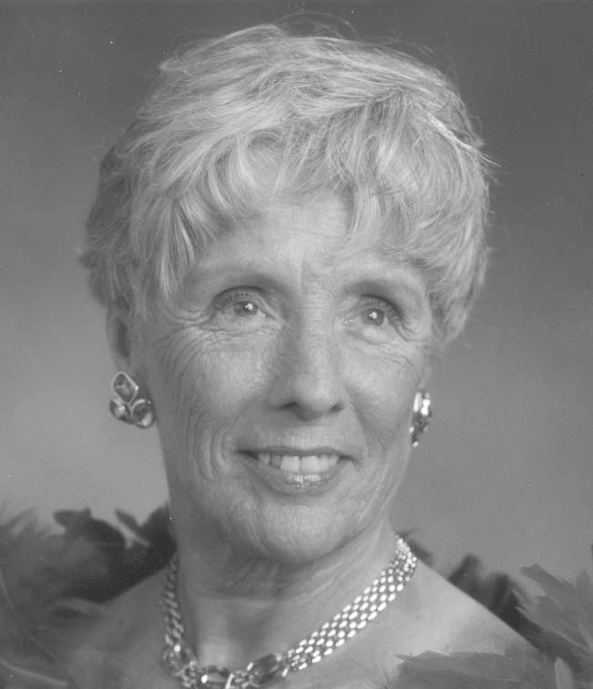
Joan Alexander
Candidate for Secretary
Why are you interested in being USMS Secretary and why do you believe you would be a good candidate for this position. I am interested in running for the USMS office of Secretary. I will have completed most of my current obligations, and will be free to devote much time to the demands of the office. I enjoy working with people and trying to help them resolve problems and consider a variety of solutions as seen through many scenarios. I feel that I am qualified to hold this position because of my background in Pacific LMSC. I have completed one 2-year term and am currently serving my second term. I have been active in our LMSC since 1995, and have attended all conventions since 1996.
What do you consider to be the major issues facing USMS in the next four (4) years? As the USMS Secretary, how would you address these issues? Although we are growing at a steady rate, I feel the major issues facing USMS in the next four years are retention of the current membership, and the need to help small clubs and LMSCs grow. This entails finding pools and pool-time for them and I think this can be done through a community education program. I did talk to several people at convention last year who were having this problem and I believe it needs to be addressed.
Please list any other experience that relates to your qualifications for office. Other qualifications and experience are: I have served as President and Vice President of Ridgeview Homeowners Association (219 units) for 5 years; President of the Pleasant Hill District Arts Commission, (a 3 year term); Secretary of Las Juntas Artists for 2 years and Walnut Creek Masters for 4 years. I do understand the procedures of how a meeting should be run, the decision making process, and a willingness to listen to any point of view. I love working with people and feel that I have something to offer USMS.
Resume for Joan Alexander
LMSC positions held:
- Secretary, 1999-2002 (2 terms)
- Hospitality, Chair 1997-1998, Co-Chair 1995-1997
National Convention & Committees
- My first convention was in 1996. I attended almost all of the meetings and took notes to determine which committees I would be interested in. I decided that Marketing, Planning and Fitness were my top choices, although International, Sports Medicine, and Championship were close. I was assigned to the Marketing and Planning committees. I have attended every convention since then. I do attend other meetings as time allows.
Swimming
- In 1984, I was an injured runner (Track & Field) and was told to swim while my injury healed. I did not swim as a child, so I had to be taught to swim. I missed most of 1985, but then decided to stay with the sport in 1986. Since then I have placed in the Top Ten Nationally and Internationally almost every year in all pool courses. I am now at a place in life (retired) where I have the time and want to give back to Masters Swimming.
Positions Held in Other Organizations
- President of the Pleasant Hill District Arts Commission, 2000-2003
- Secretary of Las Juntas Artists (local), 1998-2000
- Vice President and then President of Ridgeview Homeowners Association (219 units), 1997-Present
- Secretary of Walnut Creek Masters Swim Team and Newsletter Editor, 1989-1996
- Vice President and then President of Casitas Homeowners Association (406 units), 1985-1987

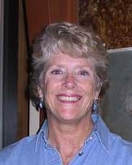
Sally Dillon
Candidate for Secretary

Why are you interested in being USMS Secretary and why do you believe you would be a good candidate for this position. For a number of years I have provided focus to the Long Distance Committee and it’s time for that leadership role to change hands and for me to move on to other areas of participation. I will bring excellent organizational skills to the position of Secretary and am prepared for the challenges and responsibility the Executive Committee provides. Being careful and complete is important to me and I take the time to see that any task is done correctly. I have the technical skills (word processing, etc.) and the organizational skills that will enable me to perform the job of Secretary at the highest level expected. Masters Swimming has been a huge part of my life since 1972. It has given me so much enjoyment over the years that I treasure the opportunity to “give back” to the organization. I am a retired school teacher with plenty of spare time and a very flexible schedule.
What do you consider to be the major issues facing USMS in the next four (4) years? As the USMS Secretary, how would you address these issues? We must assure that USMS’s growth in numbers will lead to improvement in the way we do things within the organization, not just additional dollars in the "kitty."
Our competition schedule and special event offerings need to grow as well. As USMS Secretary, I would initiate communication with LMSC’s, teams and even pool facilities to help USMS expand activities into new areas.
As a volunteer based group, we need to be mindful of member concerns when we expand programs and/or bring on salaried positions. Communication is extremely important and the Executive Committee must be open to constructive criticism and interested member’s suggestions. As Secretary, I would prepare minutes from Committee meetings and make them available to the membership. I support the USMS Goals and would like to see the current Strategic Plan come to fruition and be expanded in the future.
Our convention procedures have improved significantly in recent years but they can be further streamlined and our meeting minutes can be simplified for ease in reading and understanding without losing important content. USMS committees need to be conducted efficiently and according to Robert’s Rules of Order. I would like to see workshops and information be made available to the chairs in order to accomplish this.
Please list any other experience that relates to your qualifications for office. I have experience taking minutes at meetings and have coordinated large mailings (such as the Long Distance National Championship entry forms and Calendar of Events ). I have conducted surveys and compiled handbooks and manuals. I have led workshops, chaired meetings and conducted special events for various organizations.
Resume for Sally Dillon
Qualifications
- I have been a committee chair and member of the Board of Directors since 1990 and have prepared my own convention committee minutes each year. I communicate by letter and E-mail to my committee members and others in the organization throughout the year and I have participated in the production of a number of documents (such as the Long Distance Open Water Manual). My minor in college was English and I have good writing skills. I have equipped my MAC with all of the necessary equipment to read and exchange documents with other computer users.
USMS Experience—National Level
- Convention Delegate (1977 and 1987-present)
- Long Distance Committee Chair (1994-present)
- Long Distance Committee member (1988-present)
- Ad Hoc Officials Chair (1990-1993), Ad Hoc Officials member (1990-present)
- Insurance, Ad-Hoc Professional Management
USMS Experience—LMSC Level
- PNA Awards Chair (1998-present), PNA Long Distance Chair (1998-present)
- PMS occasional member of subcommittees (I lived 3 1/2 hours away from the LMSC meeting location and attended on an irregular basis only so I was never on the Board)
- SPMA Secretary and Top Ten Tabulator (approximately 1974-1978).
USMS Experience—Team Level (I have lived in 3 different LMSC’s)
- Joined Masters Swimming in 1972, provided leadership and organization to Long Beach Masters, directed meets in Long Beach for SPMA (1976-1978).
- Founded and directed Truckee-Tahoe Swim Team Masters (1979), the Donner Lake Open Water Swim 1980-1994) and the Truckee Winter SCY Meet (1979-1993). Co-founded Sierra Nevada Masters (1982). Secretary and Treasurer until 1997 and wrote the team newsletter for many years.
- Joined North Whidbey Masters (1997) and direct the Annual "multi-distance" Pentathlon (1998-present). It is a team within the PNA.
Work Experience
- Lifeguard and swim instructor (1965-1974) at Long Beach, CA pools.
- Teacher of Physical Education in Long Beach, CA (1974-1978)
- Substitute teacher in Truckee and Tahoe City, CA (1978-1981)
- Teacher of Aquatics and High School Mathematics in Reno, NV (1982-1992)
Volunteer Experience
- USA-Swimming Official (1975-present)
- Founder and Head Coach, Truckee-Tahoe Swim Team (age group), Truckee, CA (1979-1997)
- Director, Truckee-Donner Park and Recreation District (1986-1994) and Chair (1990-1992)
- President, Nevada/California Swim League (1992-1995)
- Member, American Association of University Women (1985-present); past president, membership chair, treasurer, public policy chair, program chair, special events coordinator, director of numerous events.
- Director, Surfcrest Homeowner’s Association, Whidbey Island, WA.
Education
- BA -California State University, Long Beach 1974 (Physical Education major, English and Math minors)
- MS - University of Nevada, Reno 1989 (Physical Education major, English minor)
Interests (beyond swimming)
- Dancing (country, swing, ballroom), movies, travel, sailing, yoga, grandchildren (in no particular order)
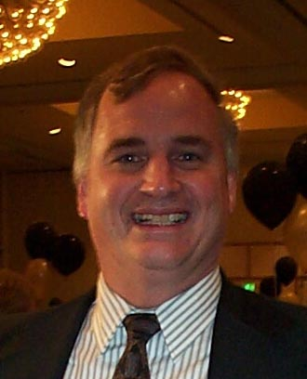
Frank "Skip" Thompson
Candidate for Secretary
Why are you interested in being USMS Secretary and why do you believe you would be a good candidate for this position. I am interested in the position because it represents a sequence in my involvement and the continuation to serve USMS at the National level of our organization. I am very pleased to have the opportunity to influence the future direction of a great organization.
I have a broad range of experience at Club, LMSC, and National levels. I have been a Swimmer, Coach, Meet Director, and LMSC Volunteer at all levels of the Michigan LMSC. I served as the Great Lakes Zone Chair for 7 years following 4 years as an LMSC Chair. I have been a convention delegate for 12 years and served on 4 committees during that time. I have been involved in special projects such as National Elections, National Time Standards, and the ongoing USMS History Project. As a Swimmer and Coach, I have been active every year since I began in 1982. I would like to continue to contribute to USMS and use by background to contribute to the Executive Committee.
What do you consider to be the major issues facing USMS in the next four (4) years. As the USMS Secretary, how would you address these issues.
1) The most significant issue to assure the future success of USMS (or and even the LMSC) will be the development of programs for the large part of our membership which does not participate in competition. As an organization, we have a commitment to provide programs in fitness for these members.
2) Membership retention and growth are two areas that remain as a critical aspect to the future health of USMS. Communicating to our membership a product that they can value which can best be reflected by their continuing support and membership.
3) Professional/ Paid positions verses Volunteer positions will have to be addressed in the future similar to what we have done in the last 4 years. USMS has to look objectively at this.
4) USMS should become more involved and have successful interaction with other bodies such as the YMCA, NSG, FINA, USS, and Park departments. Our involvement with these organizations could carry USMS to the next level in membership and allow our many resources to be utilized by a much larger constituency.
5) In addition to developing programs that will increase our membership, we have to expand our marketing concepts to broaden our financial base so that we do not rely strictly on registration fees to run our organization. Support of corporate sponsors who have sought to assist us as loyal partners needs to be continued and explored in the future.
6) Effective communication between all levels of our organization, from National Office to LMSC and LMSC to members. The development of effective lines of communication with the LMSC's and their respective members is imperative.
7) Another major issue I see is the lack of enough younger volunteer talent to contribute at both the local and national level. This is very important because these people will be the leaders of USMS in the future.
Please list any other experience that relates to your qualifications for office. I work as a Project Manager / Applications Engineer for the second largest automotive supplier in the world, Visteon. I work very well with people in a very collaborative way. I am a good listener and communicate and organize effectively. I have proven leadership abilities as demonstrated by my employment and by my volunteer work on the National and Local levels of USMS.
Resume for Skip Thompson
USMS Responsibilities
- 1992 - 1999 - Great Lakes Zone Representative
- 1992 - 1999 - USMS Board of Directors
- 1992 - 1999 - Zone Committee and Nominating Committee
- 1999 - Present - Coaches Committee
- 1993 - Present - Planning Committee
- 1989 - 1993 - Championship Committee
- 1989 - 2000 - USMS Convention Delegate
LMSC Responsibilities
- 1991 - 1993 - President - Chairman of the Michigan LMSC
- 1989 - 1991 - Vice President/Vice Chairman of the Michigan LMSC
- 1987 - 1991 - Treasurer of the Michigan LMSC
- 1999 - 2001 - Secretary of the Michigan LMSC.
- 1984 - 2001 - Coach/Team Rep of Michigan Masters Club at USMS Nationals
- 1984 - Present Coach/Team Representative Plymouth YMCA at YMCA Nationals
- 1993 - 1994 - Fitness Chairman of the Michigan LMSC
- 1993 - 1997 - Records Chairman of the Michigan LMSC
- 1987 - Received YMCA Service Award from Greater Detroit Metropolitan YMCA
- 1991 - Received Chetrick Award for Outstanding Service to the LMSC
- 1995 - Received Lawrence Award for Outstanding Swimmer for the LMSC
- 1999 - Received USMS Service Award for Outstanding Service
- 2000 - Received USMS National Coach of the Year Award
Meet Administration
- Meet Director - Michigan Master State Championship-1985,1989,1991,1992,1996,1999
- Meet Director - Great Lakes Zone (LCM) Championship - 1988 - Dunworth Pool
- Meet Director - Great Lakes Zone (SCM) Championship - 1990 - Univ. of Mich
- Meet Director - Great Lakes Zone (SCY) Championship - 1997 - Eastern Michigan
- Meet Director - Local SCY SOS Club Swim Meet - 1984 - 1991 - Oakland C.C. Meet Director - Local LCM SOS Club Swim Meet - 1984 - 2000 - Dunworth Pool. Meet Director - Local LCM Ann Arbor Swim Meet -1992 - 2000 - Fuller Pool. Meet Director of the First outside event (1989 SCY State Championship Meet) at the Canham Natatorium - University of Michigan. Meet Director of the First Short Course Meters Zone Championship (Nov.1990) in the Great Lakes Zone at the Canham Natatorium - University of Michigan.
National Championships Meet Administration
- Records/Top Ten National Liaison - 1996 LC Nationals – University of Michigan
- Championship Committee - Served as a Meet Evaluator/Liaison for the following USMS National Championships - 1990 SC Nationals USC Los Angeles, 1991 LC Nationals Elizabethtown KY, and 1992 LC Nationals Federal Way, WA
Coaching - Team Accomplishments Coach
- Team Treasurer/Administrator of the Plymouth YMCA/SOS from 1984 to the Present. Responsible for administering workouts 12 months a year. The team has been Michigan Masters State Champions (82,85,89,90,91,92,93, 94,95,96,97,98,99,00) more than any other team in Michigan Masters history. Coach/Team Coordinator for the Plymouth YMCA which were Overall Small Team Combined National YMCA Champions (1993). Men's National YMCA Champions (1993) and Women's National YMCA Champions (1994).
Committee Project Assignments and Accomplishments
- Championship - USMS Time Standards
- Planning / Zone - USMS Election Survey
- Great Lakes Zone - Implementing a Zone Championship Meet for all 3 courses
- Ad Hoc History/Archives - Contributed as a key member in the early stages
- Coaches Committee - Chair of the 2001 Coach of the Year Award and parameters
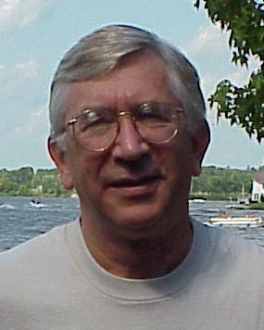
Douglas D. Church
Candidate for Treasurer
Why are you interested in being USMS Treasurer and why do you believe you would be a good candidate for this position. I have served as Chair of the Finance Committee of USMS for the past three years and served on the Finance Committee for several years prior to that. I have served as Treasurer of my LMSC for the last 10 years. I have expressed an interest in the general operations of USMS since beginning my tenure as a delegate to the convention and I am prepared to devote the time and energy to the job of Treasurer and Executive Committee member.
What do you consider to be the major issues facing USMS in the next four (4) years. As the USMS Treasurer, how would you address these issues. Two responses:
First, as Treasurer, I will do my best to handle the responsibilities of that office effectively, which is to say, to see there is effective coordination of the financial affairs of the corporation; that checks are written and bills paid in a timely manner; books and records of the corporation are maintained as they should be; funds deposited and invested in accordance with FOG and in accordance with sound practice for a not-for-profit organization.
Second, as a member of the Executive Committee, I will be an advocate for good planning, good management and balanced representation of our membership. I believe that our major challenges are (1) to encourage growth of the organization throughout the country; (2) to continue the movement toward professional management of the organization; (3) to acknowledge and address the diverse interests of our membership, from the very competitive to the fitness swimmer; (4) to encourage ways and means of good communication to all members. USMS is uniquely positioned to be the voice for all adult fitness swimmers and we need to find a way to give that voice full volume. This organization can be a “big tent” that will provide quality opportunities for the elite competitive swimmers, fitness swimmers, triathletes, water aerobics participants, open water swimmers, and so on. I should also be clear on my support for the USMS Endowment Fund. As a tool for research and development of information and opportunities for Masters swimmers and all adults, the potential is incredible and, as yet, untapped. I will continue to pursue development opportunities for increased funding of the Endowment Fund in order to begin making grants for worthy projects.
Please list any other experience that relates to your qualifications for office. I have coached the Noblesville Adult Swim Team (NASTI) for 21 years. I have served as a co-meet director for 2 USMS National Short Course Championships and on the Local Organizing Committee for the FINA Masters World Championships, the Pan Pacific Masters Championships and numerous regional meets.
Resume for Doug Church
Personal
- Douglas Denton Church, born on January 22nd, 1944, at Methodist Hospital in Indianapolis, Indiana. Married to the former Kathleen Ann Gilpatrick of Evansville on August 20, 1966. Father of two children: Julia, born May 19, 1969, a graduate of Indiana University, AB, and Loyola University Law School in Chicago, JD, currently employed as a law clerk for the Honorable Allen Sharp, Judge, Federal Court for the Northern District of Indiana, married to Jeffrey Kozicki; and Jordan, born July 25, 1970, a graduate of Wabash College, AB, and Indiana University Indianapolis School of Law, JD, married to Hillary Harmless. Jordan served two years as a VISTA volunteer in Iowa City, Iowa, and Concord, New Hampshire, prior to beginning law school. Jordan is a partner in the firm of Church, Church, Hittle & Antrim. One Grandchild: Joseph Douglas Allen Kozicki, born August 22, 1998! Two more on the way!
Educational
- 1962 graduate of Muncie Central High School; 1966 graduate of Indiana University (AB); 1970 graduate of Indiana University School of Law (JD); President, Phi Delta Phi Legal Fraternity, Willkie Inn, 1969; Law Clerk, Indiana Appellate Court, 1968-70; graduate, Harvard Law School, Program of Instruction for Lawyers, 1986; certified civil mediator since 1995.
Professional
- Bar Admissions: Indiana Supreme Court, May 20, 1970; Federal Court for the Southern District of Indiana, May 20, 1970; United States Court of Appeals for the 7th Circuit, May 17, 1995; Federal Court for the Northern District of Indiana, March 13, 2000.
- Other: Managing Partner, Church, Church, Hittle and Antrim Law Partnership, (celebrated it’s 120th anniversary in the year 2000); Member: Hamilton County Bar Association (President, 1979-81); Indiana State Bar Association (Member, Board of Governors, 1999-2000; Chairperson, Young Lawyers Section, 1982; Chairperson, Local Government Section, 1983; Chairperson, Budget and Finance Committee, 1996-98; Chairperson, Facilities Review Committee; Treasurer, BARPAC); American Bar Association (7th Circuit Governor, Law Student Division, 1969; Gold Key recipient, 1969; National Co-Chairperson, Small Firm Litigation Management Committee, 1993-2000); Master Fellow, Indiana Bar Foundation; Advocate Rank, American Board of Trial Advocates; Member, Indiana Trial Lawyers Association; Noblesville City Attorney 1987-1995; Fishers Town Attorney, 1980 to present; Member, Board of Directors of the Indiana Municipal Lawyers Association, 1995 to present, President, 1999-2000; occasional faculty member, Indiana Continuing Legal Education Forum and other continuing education organizations, on the subject of municipal law and litigation issues. Articles: Recent Developments in Planning and Zoning, ICLEF Municipal Law, 1984; A Brief Review of a Few Current Cases, ICLEF The Nuts and Bolts of an Automobile Negligence Case, 1987; Quality of Life: The New Zoning Agenda, American Society of Farm Managers and Rural Appraisers 59th Annual Convention, 1988; Hedonic Damages: Laying the Foundation, ICLEF Hedonic Damages, 1994; Planning: What Is It and Why Do It?, IMLA/IACT, Municipal Law XIII Handbook, June, 1996; Road and Access Law In Indiana: Authored chapters on Ethical Considerations, Litigating the Road Case, Transaction Considerations. National Business Institute, 1999. Member, Board of Reviewers, The Journal of Cognitive Rehabilitation.
Civic and Charitable
- Hamilton County Leadership Development Academy, Board and Faculty Member, Dean (1992), President (1996-98); Immediate Past Chairperson and Member, Board of Trustees, Conner Prairie, Inc. an Earlham Museum; Member, William Conner Society; President, Hamilton County YMCA Advisory Board (1996-97) and Member of the Board of Trustees of the Greater Indianapolis YMCA (1996-2001); Member, Board of Trustees, United Theological Seminary, a seminary of the Methodist Church (2000-2005); President, Hamilton County Progress Committee (1997-98); President, The Friends of Central Pool, Inc. (1997-2001); Chairperson, Board of Governors of the United States Masters Swimming Endowment Fund (1997-2001); Chairperson, Finance Committee, United States Masters Swimming, Inc.; Co-Meet Director, 1998 and 2000 United States Masters Swimming Short Course National Championships; member, Board of Directors, Hamilton County Extension Service, 1997 to present; former Board Member, Tri-County Mental Health; former Board Member, Hamilton County Cancer Society; former Board Member, Indiana University Indianapolis Law School Alumni Association; Noblesville Chamber of Commerce, President (1983-85) and Board Member (1981-87); Chairperson, Initial Fund Drive (1977-78), Life Member, Riverview Hospital Foundation.
Honors, Awards & Recognition
- Certificate of Merit and Appreciation, The Appellate Court of Indiana, 1970; American Bar Association Gold Key Award, 1970; Indiana State Bar Association Citation of Merit, 1982; Irv Merritt Award, Greater Indiana Masters Swim Association, 1989; Volunteer of the Year, Hamilton County Branch, Greater Indianapolis YMCA, 1996; Man of the Year, Hamilton County Branch, Greater Indianapolis YMCA, 1997; Frank Campbell Service Award, Hamilton County Bar Association, 1997; Hamilton County Citizen of the Year Award, Topics Newspapers, 1997; Josiah K. Durfee Award Recipient, Noblesville Preservation Alliance, 2000; Indiana State Bar Association “Cinch Strap” Award, 2000.
USMS Committees
- Finance (6 years), Coaches, Legal Counselors, USMS Endowment Fund Board of Governors (Chair).
Miscellaneous
- Coach, Noblesville Adult Swim Team; Treasurer, Greater Indiana Masters Swim Association; member, Columbia Club; member, First United Methodist Church of Noblesville; member, 50 Club of Hamilton County.

