2018 ENDLESS SUMMER BEACH SWIM
SHORELINE 1.2 OR 2.4 MILE O.W.S.
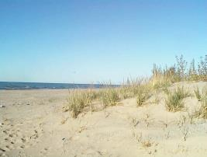
USMS Sanction #:
Welcome to the Munster Masters Association 2018- 1.2 or 2.4 mile shoreline open water swim!
When: Saturday, August 18th, 2018. POSITIVE Check-ins starts at 7:00 a.m. C.S.T.-Required SAFETY meeting will be held at 8:00 a.m. at the start line before the start of the event.
Where: Marquette Beach, 1 North Grand Boulevard Gary, IN 46403 Pavilion 4 (Lake Michigan)
Who: All USMS swimmers, both beginners and high level competitive swimmers, or those wishing to train for the upcoming big shoulders event OR complete and IRONMAN ½ or Full swim. Bring your families to cheer you on and stay for the after swim picnic and beach activities. The event registration is only open to the first 200 swimmers who mail in their entries; last years’ swimmers get preferred entry. Entry deadline closes August 14th at Midnight.
Eligibility: Event is open to U.S. Masters registered swimmers 18 years and older or Masters Swimming members of a FINA member federation. To register for the event, you must provide proof of current membership or purchase a One Event registration (OEVT). You may take care of membership registration during your event entry process.
Cost: $60.00 per swimmer, mail-in or electronically thru Club Assistant.
Seeding: Swims are seeded fast to slow using your submitted time. Seeding is by waves with 50 swimmers per wave. Each wave will be required to wear a color coded swim cap. Swimmers will be marked with registered swim number on one arm and one leg at Positive Check in
Timing: Timing will be done by chip.
Swim along the shoreline of the beautiful southern Lake Michigan. This is a perfect swim for those doing their first Open Water Event (weather permitting) as you can swim close to shore in waist deep water. The more competitive swimmers can swim in the deeper and faster waters 50 feet off shore. This is a perfect family and spectator event as your cheerleaders can walk along the beach to motivate the swimmers. Choose either a 1.2 mile (1/2 ironman) or the 2.4-mile (full Ironman) straight line course. The average water temperature at this time of the year is between 70-80 degrees with air temps 80-85+ degrees. After the swim stick around as we will grill out in the park for all swimmers, family and friends. We will also have beach volleyball nets set up and other great activities for the family. Last year swimmers were treated to special start of the race with the Planes from the Chicago Air-Show; this event is timed to take place at the same time. All swimmers who entered will receive an event Tee-shirt! This is also a great warm-up to the Big-Shoulders event in Chicago!!!
2017 ENDLESS SUMMER BEACH SWIM Mail-In ENTRY FORM
(If not using Club Assistant to sign up)
Event (Check one only): ___ 1.2-Mile Swim ___2.4-Mile Swim
Name: ____________________________________________________________
Age (as of December 31st, 2017): ________ D.O.B. ____________ E-mail:________________________
Sex: M / F USMS #: ______-__________ or One-Time Event Entry _______
Address: _________________________________________________
City: _____________________________ State: ___________ Zip: _________
Home Phone: (___)_____-________ Cell: (___) ____-_______
Emergency Contact Name: _________________________ Phone: _____________
Have you ever competed in any type of open water swim before? Y / N
(Please note this is for our records only, it will not eliminate you from the competition)
Please enter either a recorded or an estimated time for at least one of the below:
500Y Free ______ 1000Y Free _____ 1500M Free _______ 1650Y Free _______
Shirt Size (circle one): S M L XL XXL
Number of expected guests: _______ Parking: You will receive on parking permit per swimmer
All entries must be postmarked no later than August 12th, 2017. If the event is filled a notice will be posted on the event web site located at: https://www.teamunify.com/EventShow.jsp?returnPage=%2FEventsCurrent.jsp%3Fteam%3Dinmmm&id=837747&team=inmmm
Or on our Face Book Event page: https://www.facebook.com/events/286790828481627/?active_tab=about
Entry fee is Non-Refundable $60.00 US. Those that send it in after the 200 swimmer mark reached will receive a refund of a non-cashed, voided check.
Make Checks payable to: Munster Swim Club (if not using club assistant)
Mail this entry, A COPY OF YOUR USMS card, the signed and completed USMS release, and check to:
Munster Swim Club
Attn: Coach Matt Lee
242 Briar Ln. Munster, Indiana 46321
Questions please email either Matt Lee matthewalee@comcast.net or Mike Carlson 1mcarlson@comcast.net
We will be following all rules of USMS OWS. We will allow swimmers to momentarily use objects or course observation craft without DQ as long as no forward motion in the course occurs.

PARTICIPANT WAIVER AND RELEASE OF LIABILITY, ASSUMPTION OF RISK AND INDEMNITY AGREEMENT

For and in consideration of United States Masters Swimming, Inc. (“USMS”) allowing me, the undersigned, to participate in any USMS sanctioned or approved activity, including swimming camps, clinics, and exhibitions; learn-to-swim programs; swimming tryouts; fitness and training programs (including dryland training); swim practices and workouts (for both pool and open water); pool meets; open water competitions; local, regional, and national competitions and championships (both pool and open water); and related activities (“Event” or “Events”); I, for myself, and on behalf of my spouse, children, heirs and next of kin, and any legal and personal representatives, executors, administrators, successors, and assigns, hereby agree to and make the following contractual representations pursuant to this Waiver and Release of Liability, Assumption of Risk and Indemnity Agreement (the “Agreement”);

1. I hereby certify and represent that (i) I am in good health and in proper physical condition to participate in the Events; and (ii) I have not been advised of any medical conditions that would impair my ability to safely participate in the Events. I agree that it is my sole responsibility to determine whether I am sufficiently fit and healthy enough to participate in the Events.

2. I acknowledge the inherent risks associated with the sport of swimming. I understand that my participation involves risks and dangers, which include, without limitation, the potential for serious bodily injury, sickness and disease, permanent disability, paralysis and death (from drowning or other causes); loss of or damage to personal property and equipment; exposure to extreme conditions and circumstances; accidents involving other participants, event staff, volunteers or spectators; contact or collision with natural or manmade objects; dangers arising from adverse weather conditions; imperfect water conditions; water and surface hazards; facility issues; equipment failure; inadequate safety measures; participants of varying skill levels; situations beyond the immediate control of the Event organizers; and other undefined, not readily foreseeable and presently unknown risks and dangers (“Risks”). I understand that these Risks may be caused in whole or in part by my own actions or inactions, the actions or inactions of others participating in the Events, or the negligent acts or omissions of the Released Parties defined below, and I hereby expressly assume all such Risks and responsibility for any damages, liabilities, losses or expenses that I incur as a result of my participation in any Events.

3. I agree to be familiar with and to abide by the Rules and Regulations established by USMS, including any safety regulations. I accept sole responsibility for my own conduct and actions while participating in the Events.

4. I hereby Release, Waive and Covenant Not to Sue, and further agree to Indemnify, Defend and Hold Harmless the following parties: USMS, its members, clubs, workout groups, event hosts, employees, and volunteers (including, but not limited to, event directors, coaches, officials, judges, timers, safety marshals, lifeguards, and support boat owners and operators); the USMS Swimming Saves Lives Foundation; USMS Local Masters Swimming Committees (LMSCs); the Event organizers and promoters, sponsors and advertisers; pool facility, lake and property owners or operators hosting the Events; law enforcement agencies and other public entities providing support for the Events; and each of their respective parent, subsidiary and affiliated companies, officers, directors, partners, shareholders, members, agents, employees, and volunteers (individually and collectively, the “Released Parties”), with respect to any liability, claim(s), demand(s), cause(s) of action, damage(s), loss or expense (including court costs and reasonable attorneys’ fees) of any kind or nature (“Liability”) which may arise out of, result from, or relate in any way to my participation in the Events, including claims for Liability caused in whole or in part by the negligent acts or omissions of the Released Parties.

5. I further agree that if, despite this Agreement, I, or anyone on my behalf, makes a claim for Liability against any of the Released Parties, I will indemnify, defend and hold harmless each of the Released Parties from any such Liabilities which any may be incurred as the result of such claim.

I hereby warrant that I am of legal age and competent to enter into this Agreement, that I have read this Agreement carefully, understand its terms and conditions, acknowledge that I will be giving up substantial legal rights by signing it (including the rights of my spouse, children, heirs and next of kin, and any legal and personal representatives, executors, administrators, successors, and assigns), acknowledge that I have signed this Agreement without any inducement, assurance, or guarantee, and intend for my signature to serve as confirmation of my complete and unconditional acceptance of the terms, conditions and provisions of this Agreement. This Agreement represents the complete understanding between the parties regarding these issues and no oral representations, statements, or inducements have been made apart from this Agreement. If any provision of this Agreement is held to be unlawful, void, or for any reason unenforceable, then that provision shall be deemed severable from this Agreement and shall not affect the validity and enforceability of any remaining provisions.

Last Name | First Name | MI | Sex (circle)  M F |  | Date of Birth (mm/dd/yy)
Street Address, City, State, Zip
Signature of Participant |  |  |  | Date Signed
Revised 07/01/2014

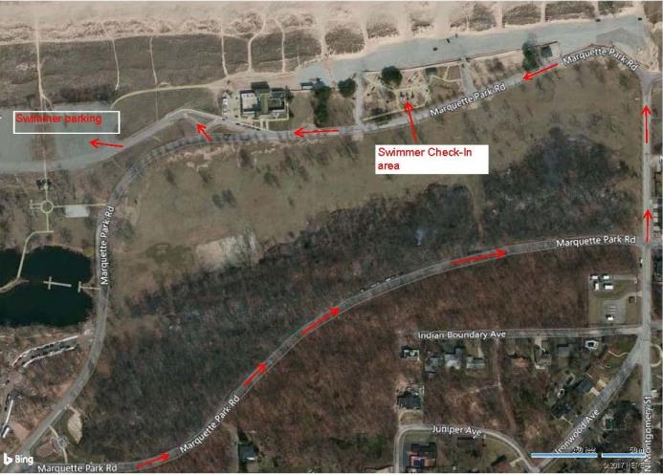
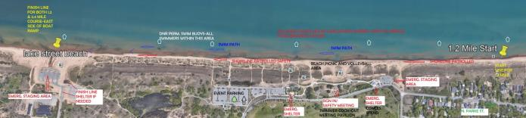
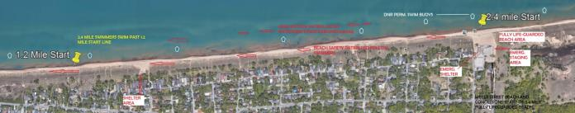

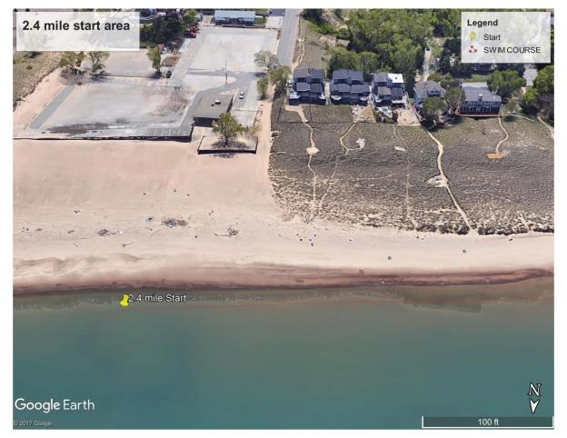
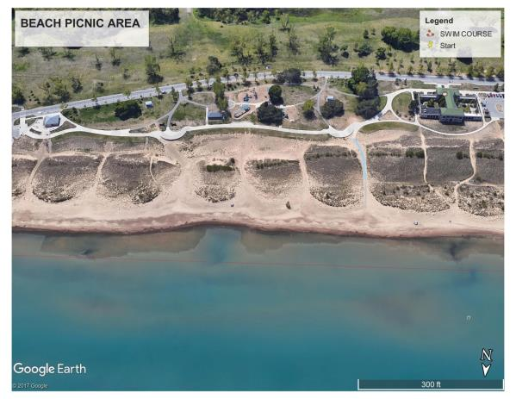
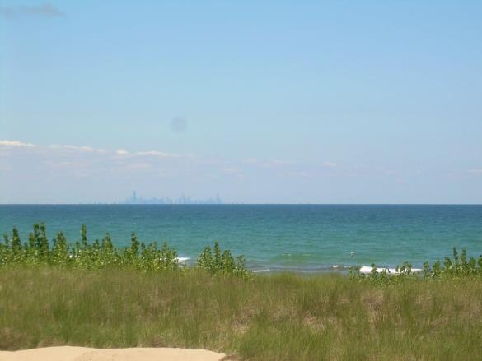
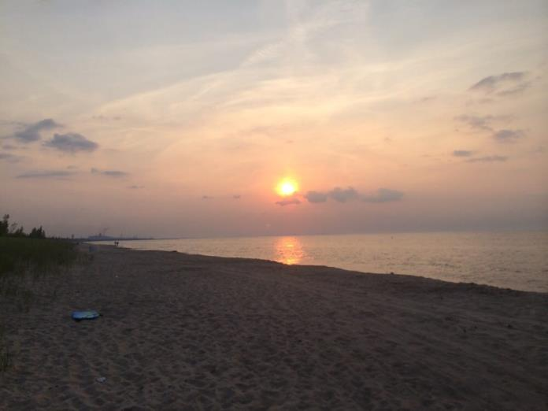
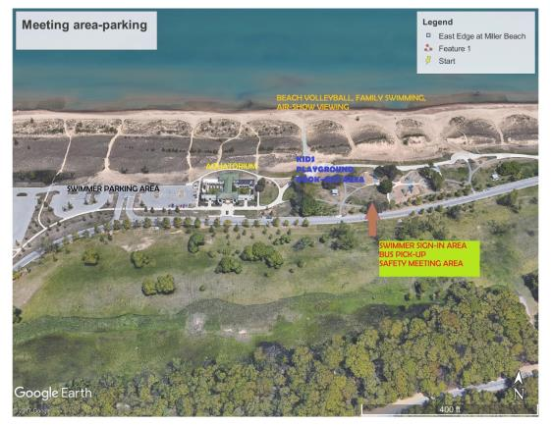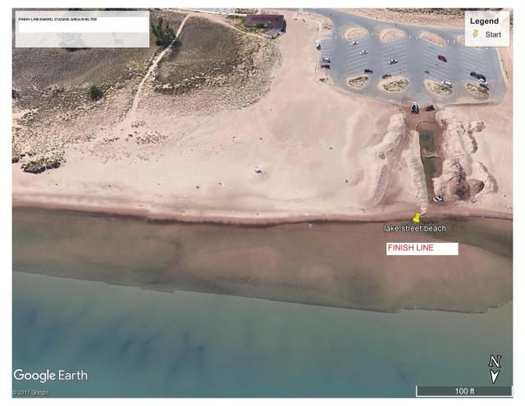
HOPE TO SEE EVERY ONE HERE!!!!!!!
