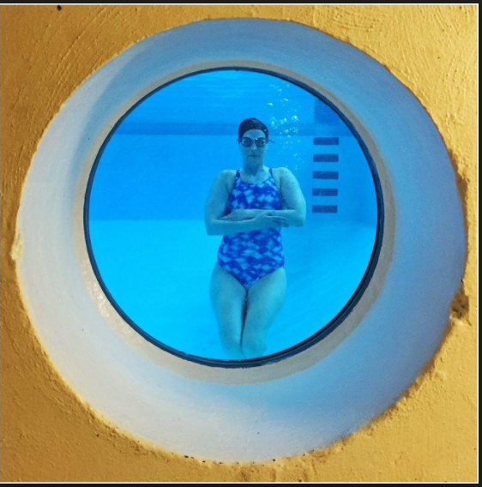
2017 Beth Calabotta Swim Challenge Registration Form

  - September 2, 2017

1 Mile, 5k or 10k Swim Challenge
The 2nd Annual Beth Calabotta Swim Challenge will be held at Sheridan Swim Club on September 3rd starting at 7:00 a.m. Participants have the opportunity to complete a 1 mile, 5k, or 10k swim. The suggested donation to participate is $25 with 100% going to The Cancer Couch for metastatic cancer research.

Name: Date:

Address: City/State:

Email: Swim Club:

Event (Circle One): 1 Mile Walk or Swim 5k Swim 10k Swim

Gender: Male Female Date of Birth: Age:

USMS Member: Yes No USMS Number:

USS Member: Yes No USS Number:

Emergency Contact Name: Phone:

Please read carefully before signing.
I understand and acknowledge that by signing below, I am legally agreeing to the terms and rules for the event.

Terms: 1. I understand that I take part in the event at my own risk and of my own free will. I understand that whilst the swim has been made as safe as possible, this event is not without risk and that the events require varying degrees of physical excursion. 2. I confirm that I do not know of any medical reason why I cannot participate in the event and that I have prepared accordingly. I understand that if in doubt about my health or have a medical condition that could be affected by exercise (other that was I have already stated), particularly a heart condition; I should obtain my doctors approval before participation. 3. I understand that the organizers may take photographs or video footage of me taking part in the event and permit them to use the images and film for promotional purposes.

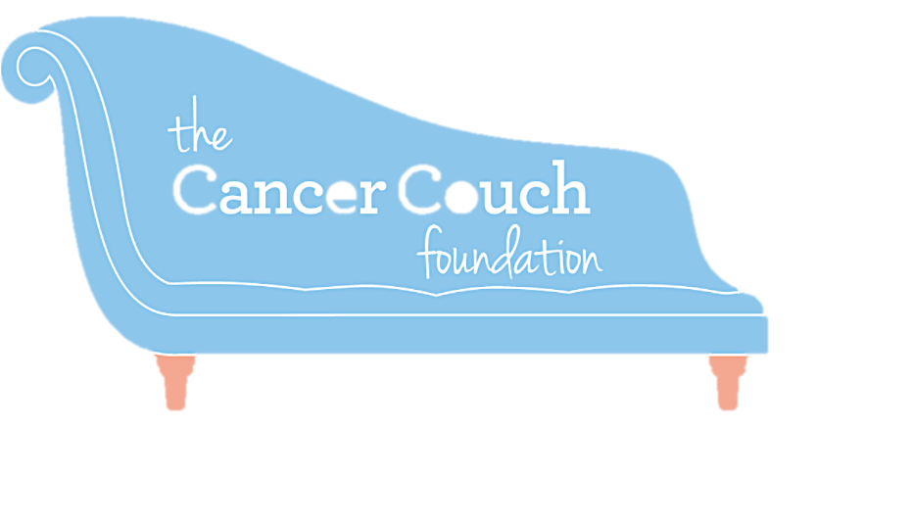

SIGNATURE

DATE

