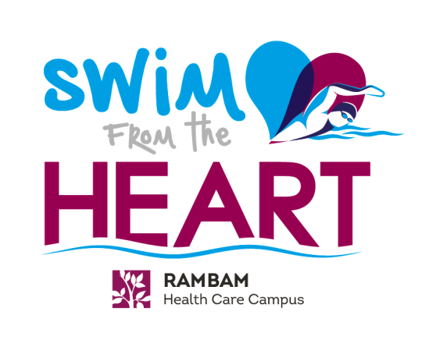
Swim for the Cure!
Help ‘Hearts at Risk’ for
Sudden Cardiac Death

2nd Annual International
‘Swim from the Heart’ Open Water Swim
Friday, June 2, 2017, Cape Carmel, Haifa, Israel
www.SwimfromtheHeart.org

Choose from four events: 1 km, 2.6 km, 4.5 km & 7.6 km

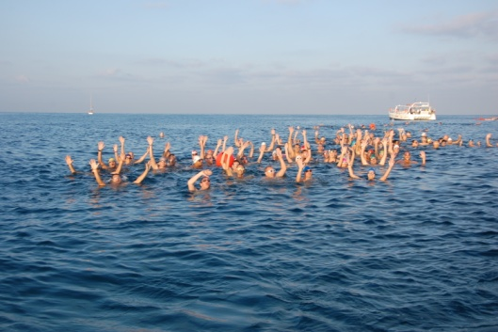
Join hundreds of swimmers in the Haifa Bay, in Northern Israel and swim for a worthy cause. Proceeds from ‘Swim from the Heart’ will support the Rambam Health Care Campus in its mission to find a cure for SCD. Participants of all ages and abilities are welcome. Swim in the blue, warm waters of the Mediterranean – and enjoy ancillary swims in waters from biblical history!

Early Bird Notice - Save the Dates and Book Your Flights
Suggested Arrival: May 30, 2017, Departure: June 7, 2017

Join Us in Israel and Swim in Three Seas

Enjoy a one-of-a-kind travel itinerary with a unique opportunity to swim in the Mediterranean Sea, the Sea of Galilee and the Dead Sea. Experience Israel’s archeological and geological treasures and take home memories that will last forever!

Travel Itinerary Overview
Visit www.SwimfromtheHeart.org for more information. Itinerary is subject to change.
Estimated airline and hotel costs are $3,200 per individual for 9 days.

Tuesday, May 30: Arrival Ben Gurion International Airport in Tel Aviv, Israel
Suggested Accommodations: Dan Panorama Hotel, Tel Aviv
Room reservations and associated costs are the responsibility of the participant. Reservations can be made directly with the hotel at 011 972 3-519-0190. Depending on the number of participants, a group discount may apply (participants will be notified).
Hotel dates: May 30 to June 1 (morning check out).

Wednesday, May 31: Morning swim in the Mediterranean from the world-famous beaches of Tel Aviv. Enjoy a walking tour of the city in the afternoon. Hosted evening dinner; experience Israeli cuisine and culture.

Thursday, June 1: Morning tour of Tel Aviv. Complimentary transportation to Haifa.
Suggested Accommodations: Dan Carmel Hotel, Haifa.
Room reservations and associated costs are the responsibility of the participant. Room reservations can be made directly by calling the hotel at 011 972 4-830-3030. Depending on the number of participants, a group discount may apply (participants will be notified).
Afternoon tour of the picturesque Baha’i Gardens in Haifa. Hosted early evening cocktail reception.

Friday, June 2: 7:00 AM swim check-in. Complimentary transportation provided for swim participants. Free-time in the afternoon. Hosted dinner at the Dan Carmel hotel.

Saturday, June 3: Complimentary transportation to the Sea of Galilee. Swim and tour archaeological sites of religious interest. Enjoy a hosted dinner in the evening and experience the distinctive flavor of northern Israeli cuisine.

Sunday, June 4: Complimentary transportation to tour the Old City of Jerusalem, followed by a visit to the Dead Sea, Earth’s lowest elevation on land. Entrance to the beach, use of spa, and dinner offered at $50 per person.

Monday, June 5: Your participation supports a profound and meaningful cause. Complimentary transportation to Rambam Health Care Campus for a tour, including Rambam’s stem cell lab for SCD research, as well as the world’s largest fortified underground emergency hospital. Dinner in Haifa.

Tuesday, June 6: Realize the impact of your contribution. Complimentary transportation to Rambam Health Care Campus for participation in activities and gala during Rambam’s Annual Scientific Summit.

Wednesday, June 7 – Shalom and farewell. Transportation to the airport can be coordinated through American Friends of Rambam.

For information on registration, group travel arrangements,
and costs please call or email
Sari Arshadnia (424) 240-8083, Sari@aforam.org, www.aforam.org

The Cause is Why We Swim
Be a part of an urgent effort to accelerate our understanding, and ultimately a cure for Sudden Cardiac Death (SCD) - a major cause of natural death in children and young adults worldwide. With no warning symptoms until the fatal incident, prevention for SCD has been difficult. In the young, SCD is usually due to inherited genetic disorders that may result in the death of otherwise healthy individuals. Particularly tragic is the sudden death of a young child or athlete with no previous exhibited physical problems. Clearly new approaches are needed to enable early detection, prevention, and management to assure a promising future for people at risk for SCD.

As a leader in SCD research, Rambam’s breakthrough studies can have a global impact. Learn how you can help raise funds for this critical research, which is more important than ever!
www.SwimfromtheHeart.org

