ddf

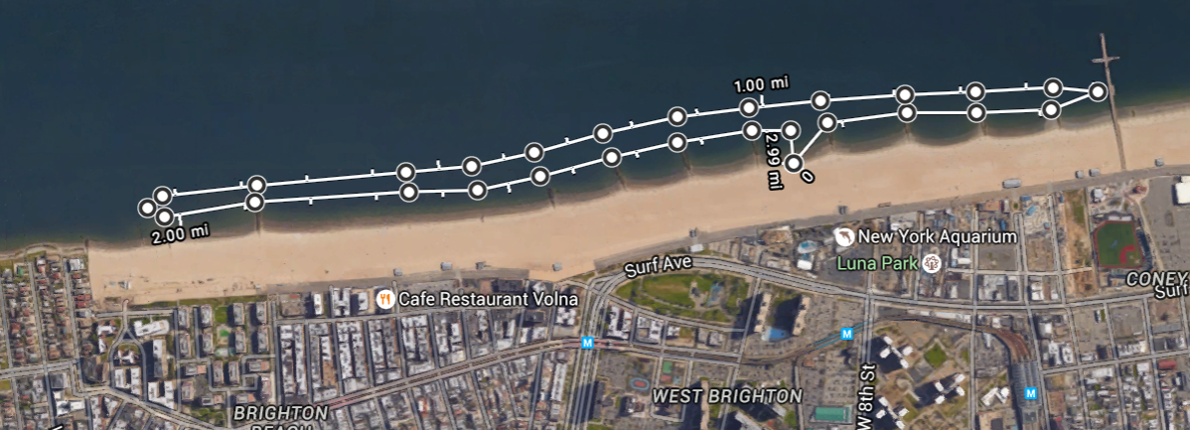

3-2-1 Course Map
1Mile, 2Mile and 3Mile Swim Race at the New York Aquarium
Saturday, September 24, 2016

All races start and finish in front of the New York Aquarium’s Education Hall.

COURSE MAP ABOVE SHOWS – THREE MILE COURSE

The direction of the course will depend on conditions and/or currents at the time of the event.
The course and turnaround points will be marked with buoys and a safety boat.
Paddlers will help keep swimmers on course, and to help secure assistance should a swimmer require it.
The length of the course may be shortened, depending on water and weather conditions, but never extended.

RACE DIRECTOR:
Capri Djatiasmoro
CELL: 646-436-3277

SAFETY DIRECTOR:
Bonnie Schwartz
CELL: 917-903-2333

LEAD SAFETY BOAT – AGENT ORANGE:
David Barra
CELL: 845-706-5029

