Course
The course poctured below is a 1.2–mile rectangle with 18 buoys to guide swimmers. The course is swum in a counterclockwise direction and is be marked by larger orange buoys at the four corners, smaller buoys on the straight legs with 2 smaller red buoys marking half way on the long length. Each buoy is approximately 100 yards apart. Swimmers in the first two waves will complete two laps of the course. Those in the third wave will complete a single lap.
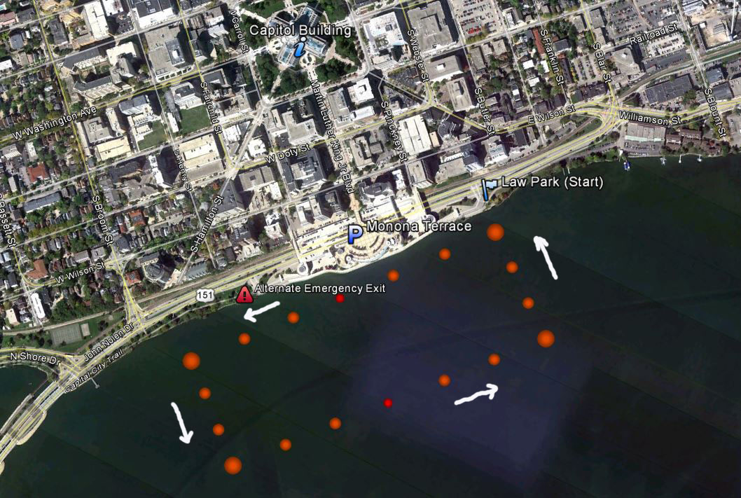
Participants will begin in the water at Law Park and swim counterclockwise on the outside of the orange buoys. The finish line is on shore marked by 2 large banners.

