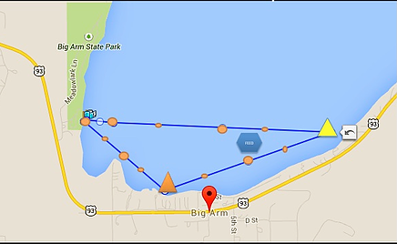
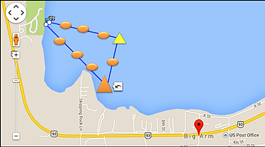
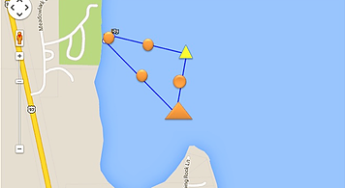

5K and 10K Course. The 5K will consist of one lap and the 10K will consist of two laps.

1 Mile Course. One lap.

1/2 Mile Course. One lap.

Home

2016

Selection Process

About

Flathead Lake Swim Series

Blog

How You Can Help

More
﻿Enduring Waves Foundation

