Hurricane Man Safety Plan
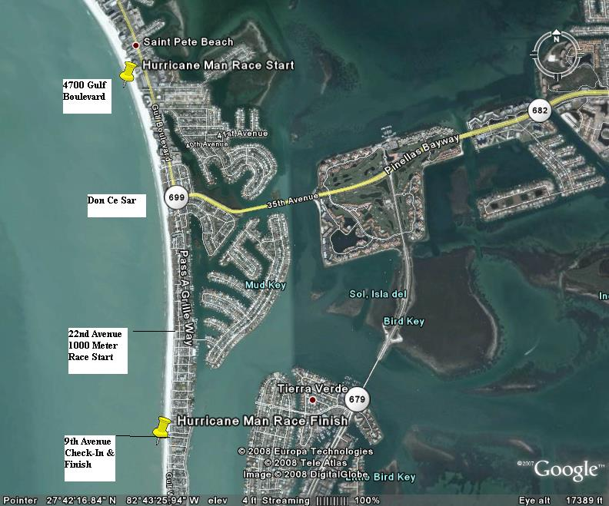
Kayakers/SUP’s on course :
1000 meter race course - meet @ check-in (across from Hurricane Restaurant) 6:30AM - double back to beginning of 2.4 race:
Joe Gross Scott Adams
2.4 Mile Race - meet @ 2.4 race start (County Park 4700 Gulf Blvd.) 6:45 AM
Bob Aldrich Nat Glackin

Lifeguard Assignments:
1000 meter race –meet at check-in (across from Hurricane Restaurant) 6:30 AM, front of race guard will double back to pick up front of 2.4 race, back of pack guard will also work back to 2.4 mile race
Elena Atenza 813-484-0096 Olivia Igou 410-4700

2.4-mile race – meet at 2.4 race start (County Park 4700 Gulf Boulevard) 6:45 AM, one in front (drop back to middle as 1000 meter guard picks up front),two in middle, one in back
Addie Brainard 543-0105 Justin Gaeta 776-6397 Patrick McEntagert 417-2549

4 Beach Walkers/Officials
Dan Nardozzi/Joe Finke - 2.4 Race
Kevin Mooren/Charles Kohnken - 1000 meter
Race Officials – Contact Info
Patty Nardozzi - Race Director 452-3893
Kern Davis - Race Director/Medical 480-2697
Dan Nardozzi - Official 492-3898
Bruce Day - Beach set-up/Safety 642-8533
FWC Boat – Matt Dallarosa 386-527-6553
Beach Guard Boat – John Sleppy 727-642-0040/Tyler West 484-1476

HURRICANE MAN SAFETY PLAN

- Florida Fish & Wildlife Boat – required by City of St. Pete Beach

- Lifeguards – minimum of 6 American Red Cross trained lifeguards for both races. Guards from 1000 meter race also double back to cover 2.4 mile race. At least four of the guards are beach trained from Ft. DeSoto Park.

- Kayakers – minimum of 4 kayakers, but usually have 6 or more in place for both races.

- Officials – one referee and one starter on each course. All walk the course with cell phone.

- Cell phones are primary communication tool. Phone numbers are distributed to all safety personnel prior to race.

- Paramedic/EMT’s are located at St. Pete Beach Fire Department station located at 1950 Pass-a-Grille Way (approximately 11 blocks from race finish. AED’s are located here and at the Hurricane Restaurant (race finish). A first aid area is set up on the beach adjacent to the finish and manned by one of our race director/doctors.

- Expected air temperature – 82 degree, expected water temperature – 80 degrees, water quality at this time of year has consistently tested as “good”.

HURRICANE MAN EMERGENCY ACTION PLAN

Swimmer in distress:
- Lifeguards will activate their water rescue protocols.

- Swimmers withdrawing from the race will report to one of the officials walking the beach and report. Official will contact race director to make notification of same.

- Swimmers needing emergency care will be administered to by lifeguard on duty or St. Pete Beach Fire Department.

- Swimmer requiring evacuation will be transported to Palms of Pasadena Hospital, 5.2 miles from race finish and approximately 10 minute transit time.

Missing swimmer:
- All swimmers must check in before competing and verify emergency contact number for that day.
- At race meeting prior to start, all swimmers will be instructed to inform the officials if they have checked in and are choosing not to compete. They will also be instructed that if they withdraw from the race, they must inform the official.

- At the finish, all competitors are given a card with their recorded time. They must turn this in to be scored and all competitors are accounted for as either a no show or a time before results are posted.

- If swimmer is unaccounted for, search and rescue is activated and emergency number is contacted.

- All swimmers that enter and finish race are identified by the race number located on both sides of upper arm.

HURRICANE MAN CONTINGENCY PLAN

Parameters for abandoning the race:
- Any one of the following individuals are empowered to independently order the race abandoned due to unsafe course or other conditions:
Meet Referee – Dan Nardozzi
Safety Officer – Kevin Mooren
Water Safety Supervisor – Troy Loggins
- If the race is to be abandoned, meet referee will phone all safety personnel to signal abandonment. The signal to abandon the race is:

From Police Boat – 5 short blasts followed by 1 long blast
From Lifeguards – 5 short blasts of the whistle followed by 1 long blast
From Beach Officials – 5 short blast of airhorn followed by 1 long blast

- Swimmer actions are to:
Discontinue swimming
Immediately exit the water
Look for directions from officials or water safety personnel
Once safe on beach, report to finish area and check-in

Contingency Plan:

- Due to venue restrictions there will be no change to the shape of the course.

- If weather conditions require, the direction of the swim and the location of the start/finish may be changed.

- If the race is abandoned, it will not be re-scheduled.

