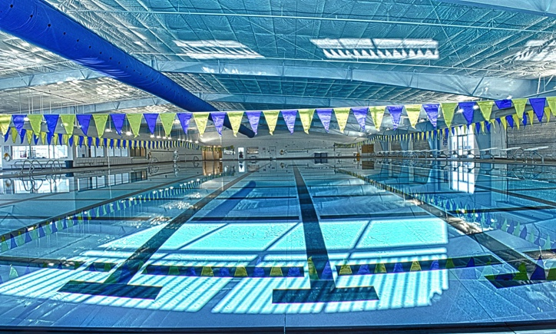

A Carter Family Update
  - [Street Address], [City], [State][Postal Code]

8353 Legacy
Frisco, Texas
75034

A Carter Family Update
  - [Street Address], [City], [State][Postal Code]

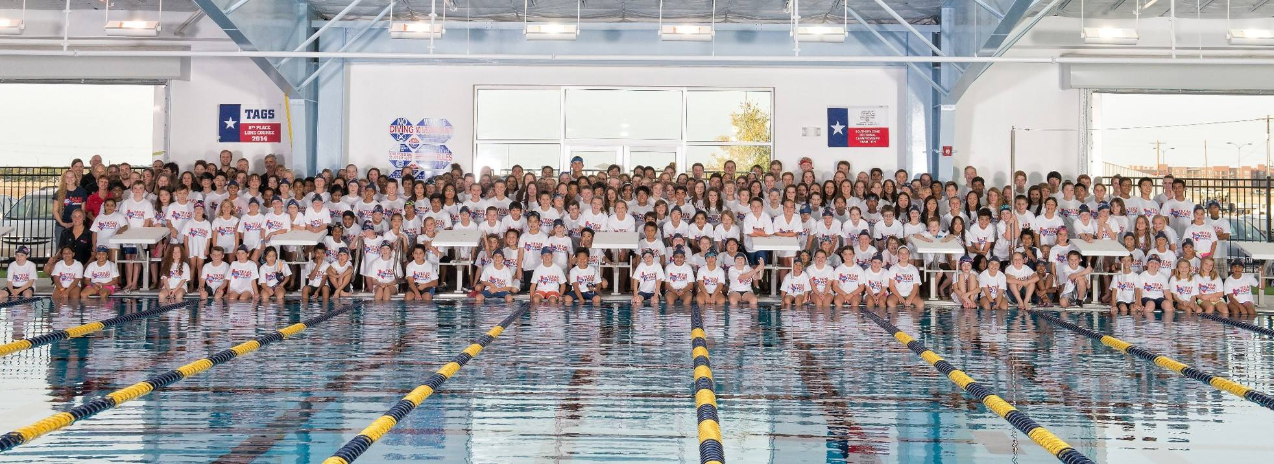

MASTERS SPRING ZONE CHAMPIONSHIPS

April 8th -10th

HOSTED BY: Texas Ford Aquatics Masters

TYPE OF MEET: 25-yard timed finals.

DATES & TIMES & WARM-UP:

Friday, April 8th
Session 1:
Warm-up 4pm
Meet Start 5pm

Saturday, April 9th
Session 2:
Warm-up 7:30 am
Meet Start 8:30 am
------
Session 3:
Warm up: 11 am
Meet Starts: 12 noon

Sunday April 10th
Session 4:
Warm-up 7:30 am
Meet Start 8:30 am

LOCATION: 8353 Legacy Frisco, Texas 75034

POOL SPECS: 10 lane 25 yard pool.
8-lane Warm-up and Warm Down available (25 yards)
The length of the competition course without a bulkhead is in compliance and on file with USMS in accordance with articles 105.1.7 and 107.2.1

TIMING EQUIP.: Colorado timing system with scoreboard, Touchpad software and LIVE updates and results. MEET ASSISTANT.

ELIGIBILITY: All participants must be registered with United States Masters Swimming. A copy of your 2016 USMS card is required with the completed entry.

SEEDING: Times will be seeded Short Course Yards. All events (except the 1650 yard Free) will be seeded slow to fast without regard to age. The 1650 yard Free will be seeded fast to slow without regard to age. Women and Men may swim in a combined heat of the 1650 depending on number of entries.
The 1000 yard freestyle will be combined heats of women and men.
AGE GROUPS: 18-24, 25-29, 30-34, 35-39, 40-44, etc.
Relays: 18+, 25+, 35+, 45+, etc.

SCRATCHES: No penalty for scratching on the block.

ENTRY LIMIT: Five (5) individual events per day, plus relays.
No limit to the number of relays entered - indicate as "A", "B", "C", etc.
Swimmers over entered will be removed from their last event on each day over entered.
TIME STANDARDS IN ORDER TO ENTER:
500 Freestyle <10:00
1000 Freestyle <40:00
1650 Freestyle <60:00

ENTRIES : Online Entry is preferred and available for this meet. Online entry can be found at the following link below:
Online entries will open January 18th and will close April 4th
All mail-in entries must be received by March 30th.

ENTRY FEES: $50 per swimmer for full meet
$25 per swimmer for 1-day

***NO DECK ENTRIES***

Mail in Entries
Masters Spring Zone Championships
ATTN: Lindsay Kenney
8353 Legacy Frisco, Texas 75034
Please Make Checks Payable to: Texas Ford Aquatics

CHECK IN: Swimmers are considered checked-in for all individual events with a distance of 200 Meters and less.
**Swimmers must have a positive check in for 400 IM, 1650 Freestyle, 500 Freestyle and 1000 Freestyle**

AWARDS: Individual Events & Relay Events: 1st – 3rd Medals & 4th – 8th Ribbons
Championship Team Awards will be presented for combined team, Men’s team and Women’s team.

SCORING: Individual: 9-7-6-5-4-3-2-1
Relays are double points.

OFFICIALS:
Head Referee: Tom Osterland
Starter: Toni Kline
Chief Stroke & Turn: Ben Mok
Head Marshall: Samantha Kluttz
Meet Directors: Lindsay Kenney
Computer: Kathy Reddin/ Max Sachau

RULES: Current USMS Swimming Rules and Regulations will govern the meet.

INFORMATION:

Lindsay Kenney
CoachLindsay@texasfordaquatics.com

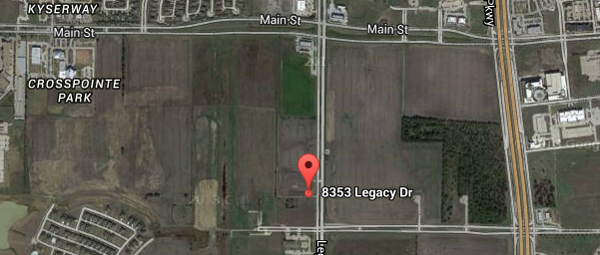
From East of Dallas North Tollway
- Head west on Main Street from the Dallas North Tollway.
- Take a left at Legacy Drive.
- The pool is located about .4 miles down the road on your right.

From South of Dallas North Tollway

1 Head North on Dallas North Tollway
2 Exit Cotton Gin Road
3 Take a left on Cotton Gin Road
4 Take a right on Legacy, pool located on your left.
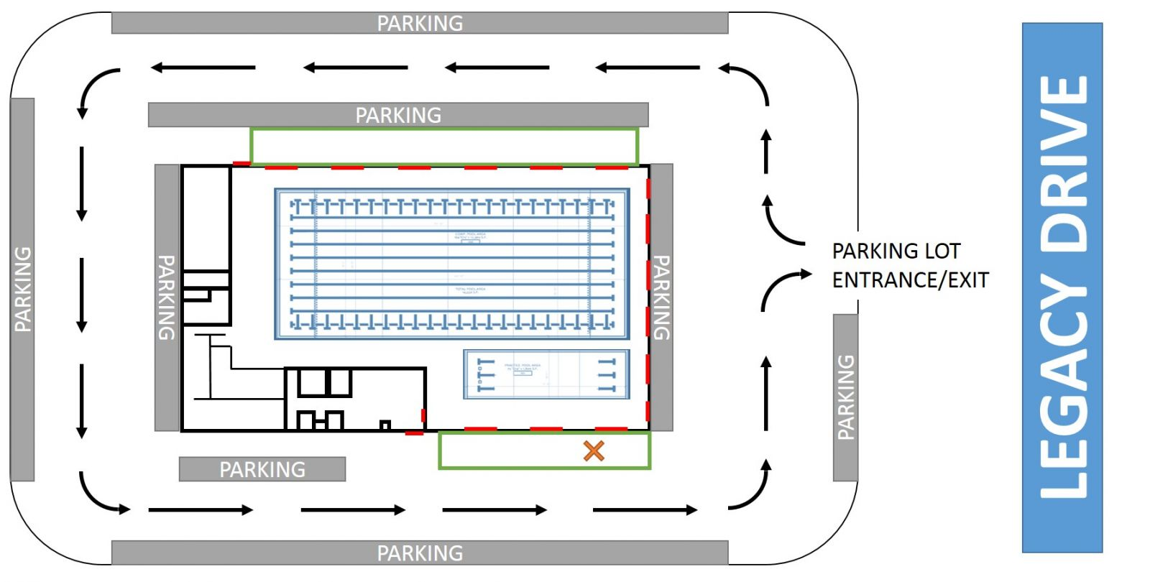

Number | Gender | Event
Order of Events

Session 1: Friday, April 8th
1 | Mixed | 800 Free Relay
2 | Women | 400 IM
3 | Men | 400 IM
4 | Women | 1650 Freestyle
5 | Men | 1650 Freestyle

Saturday, April 9th
Session 2:
6 | Women | 500 Freestyle
7 | Men | 500 Freestyle
8 | Women | 800 Free Relay
9 | Men | 800 Free Relay

Session 3:
10 | Mixed | 400 Medley Relay
11 | Women | 200 Backstroke
12 | Men | 200 Backstroke
13 | Women | 100 Breaststroke
14 | Men | 100 Breaststroke
15 | Women | 50 Freestyle
16 | Men | 50 Freestyle
17 | Women | 100 IM
18 | Men | 100 IM
19 | Women | 400 Free Relay
20 | Men | 400 Free Relay
21 | Mixed | 200 Medley Relay
22 | Women | 100 Butterfly
23 | Men | 100 Butterfly
24 | Women | 50 Breaststroke
25 | Men | 50 Breaststroke
26 | Women | 200 Freestyle
27 | Men | 200 Freestyle
28 | Women | 400 Medley Relay
29 | Men | 400 Medley Relay

Session 4: Sunday, April 10th

30 | Women | 1000 Freestyle
31 | Men | 1000 Freestyle

Session 5:

32 | Mixed | 400 Free Relay
33 | Women | 200 Breaststroke
34 | Men | 200 Breaststroke
35 | Women | 50 Butterfly
36 | Men | 50 Butterfly
37 | Women | 100 Backstroke
38 | Men | 100 Backstroke
39 | Women | 200 Medley Relay
40 | Men | 200 Medley Relay
41 | Women | 100 Freestyle
42 | Men | 100 Freestyle
43 | Women | 200 Butterfly
44 | Men | 200 Butterfly
45 | Women | 50 Backstroke
46 | Men | 50 Backstroke
47 | Women | 200 IM
48 | Men | 200 IM
49 | Mixed | 200 Free Relay
50 | Women | 200 Free Relay
51 | Men | 200 Free Relay

Hotels

Hilton Garden Inn
7550 Gaylord Pkwy, Frisco, TX 75034
(469) 362-8485

Attractions
Frisco
DrPepper Ballpark, Home of the Rough Riders
7300 Roughriders Trail, Frisco, TX 75034
Stonebriar Centre
2601 Preston Rd, Frisco, TX 75034
Manny’s Tex-Mex
6705 Main St, Frisco, TX 75034
Babe’s Chicken Dinner House
6475 Page Street Frisco, Texas 75034

Aloft Frisco: Frisco Hotel
3202 Parkwood Blvd, Frisco, TX 75034
(972) 668-6011

Plano
Arbor Hills Nature Preserve
6701 W Parker Rd, Plano, TX 75093
Shops at Legacy
5741 Legacy Dr Suite 315, Plano, TX 75024
Whiskey Cake
3601 Dallas Pkwy, Plano, TX 75093

Dallas
Klyde Warren Park
2012 Woodall Rodgers Freeway, Suite 403, Dallas, TX 75201
NorthPark Center
8687 N Central Expy, Dallas, TX 75225
Nick and Sam’s Steakhouse
3008 Maple Ave, Dallas, TX 75201

