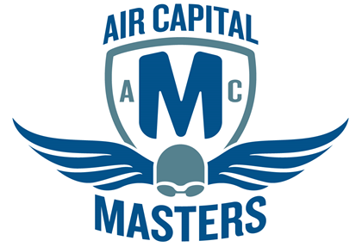
AIR CAPITAL MASTERS & WICHITA SWIM CLUB
Fall 2015 SCY Masters Swim Meet

Date: Saturday, Oct 3, 2015
Time: Warm up → 1:30 pm
Swim Meet → 2 pm
Location: Garvey Aquatic Center
8323 East Douglas Avenue
Wichita, KS 67207
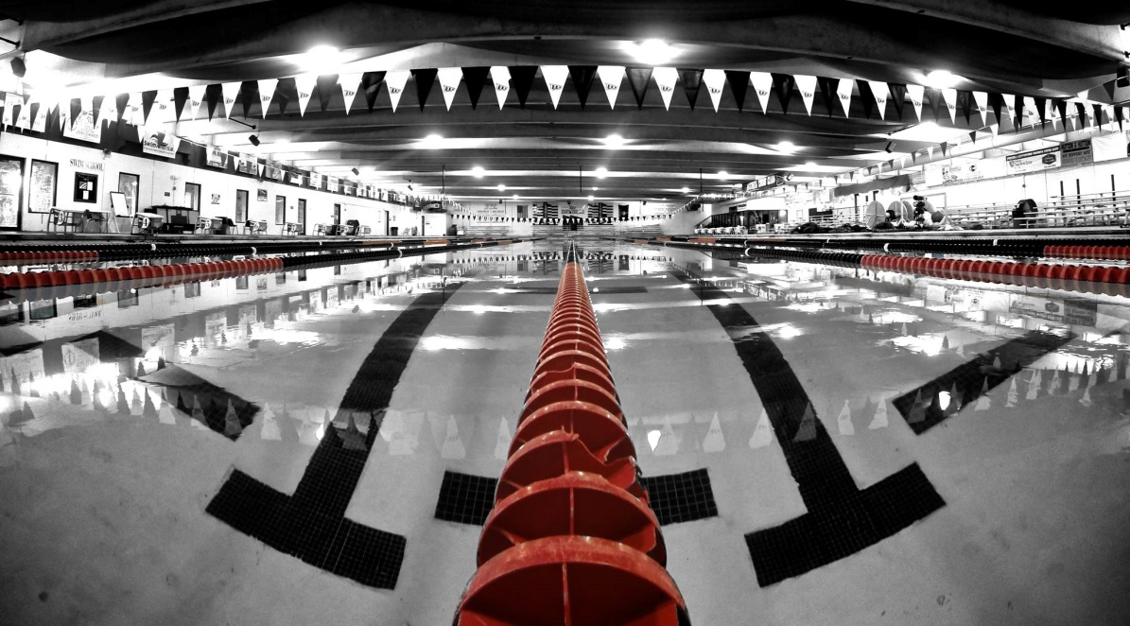
The Garvey Aquatic Center is the home of the Wichita Swim Club. The pool is located on the south end of The Independent School campus.

----------------------------------------------------------------- ENTRY FORM--------------------------------------------------------------------
$25 Entrance fee if post marked by September 28, 2015. Mail entry forms to J. Schmidt, 1634 Womer Dr., Wichita, KS 67203. Deck Entry Fee $30. Deck entries will be accepted up to 1:30 pm on the day of the meet. Online entry will also be available on usms.org.
Fees/checks should be payable to: Jeff Schmidt
NAME (exactly as it appears on your USMS registration card)
____________________________________________________________________________
BIRTHDATE_________________ SEX: M F USMS REG#___________________________
SWIM CLUB_________________ PHONE__________________________________________
ADDRESS___________________________________________________________________
CITY/ST________________________________________________ ZIP CODE____________
EMAIL ADDRESS _____________________________________________________________
EMERGENCY CONTACT (name/ phone number)____________________________________
-----------------------------------------------------------------ORDER OF EVENTS----------------------------------------------------------------------
Warm up lanes available beginning at 1:30, continuously available throughout the meet.
Saturday, Oct 3 21, 2015 - Session 1 (Begins at 2:00 PM)
# | Sex | Event
1 | Mixed | *1650 Y | Free
2 | Mixed | *1000 Y | Free
Saturday, Oct 3, 2015 - Session 2 (Begins at 3:00 PM)
* You may swim either the 1000 or 1650, not both. These events may be combined and are limited to the first 12 entrants.

# | Sex | Event |  | Seed Time  Limits: Swimmers may swim up to four events, plus relays. Please be aware that this meet will run fast. If you enter back-to-back events, your rest time may be very short (or nonexistent).
3 | Mixed | 50 Y | Fly
4 | Mixed | 200 Y | Breast
5 | Mixed | 100 Y | Back | Eligibility: You must be a member of USMS to participate in this meet. If you are not a currently registered USMS member, you may join/renew ONLINE (preferred!) at www.MOVYmasters.com or at www.usms.org/reg. Some benefits include a full year subscription to Swimmer magazine, access to meets and other fitness events throughout the year, etc. Online registration for 2015 USMS membership will also be available at meet check-in.
6 | Mixed | 200 Y | Free
7 | Mixed | 400 Y | IM
8 | Mixed | 200 Y | Free Relay
9 | Mixed | 50 Y | Breast
10 | Mixed | 200 Y | Fly
11 | Mixed | 50 Y | Back
12 | Mixed | 200 Y | IM
13 | Mixed | 100 Y | Free | Breaks: Breaks will be taken as needed during the meet.
14 | Mixed | 500 Y | Free
15 | Mixed | 200 Y | Medley Relay | Lane usage: Up to 8 lanes will be used for competition with several lanes reserved for warm up and cool down.
16 | Mixed | 100 Y | Breast
17 | Mixed | 50 Y | Free
18 | Mixed | 200 Y | Back
19 | Mixed | 100 Y | Fly
20 | Mixed | 100 Y | IM

YOU MUST provide a copy of your 2015 USMS membership card with your deck entry.
I, the undersigned participant, intending to be legally bound, hereby certify that I am physically fit and have not
been otherwise informed by a physician. I acknowledge that I am aware of all the risks inherent in Masters
Swimming (training and competition) including possible permanent disability or death, and agree to assume all of
those risks. AS A CONDITION OF MY PARTICIPATION IN THE MASTERS SWIMMING PROGRAM OR
ANY ACTIVITIES INCIDENT THERETO, I HEREBY WAIVE ANY AND ALL RIGHTS TO CLAIMS FOR
LOSS OR DAMAGES, INCLUDING ALL CLAIMS FOR LOSS OR DAMAGES CAUSED BY THE
NEGLIGENCE, ACTIVE OR PASSIVE, OF THE FOLLOWING: UNITED STATES MASTERS SWIMMING,
INC., THE LOCAL MASTERS SWIMMING COMMITTEES, THE CLUBS, HOST FACILITIES, MEET
SPONSORS, MEET COMMITTEES, as well as hosts, meet officials OR ANY INDIVIDUALS OFFICIATING AT THE MEETS OR SUPERVISING SUCH ACTIVITIES. In addition, I agree to abide by and be governed by the rules of USMS. (Rule Book Article 203.1)
Participant Signature ______________________________________________Date __________________
Deck Entry Fee $30 _________Make checks payable to: Jeff Schmidt
Only deck entries will be accepted after September 28, 2015.

