The 9th Annual
Dayton Area Sharks
Masters
Swim Meet and
Sprint Pentathlon

Dayton Raiders Aquatic Center
560 Grange Hall Road
Beavercreek, Ohio 45430
Saturday, December 6, 2014

WARM UPS BEGIN AT 1:00
COMPETITION BEGINS AT 2:00 pm

SEE ATTACHED INFORMATION
OR EMAIL Barb Riazzi barbriazzi@hotmail.com
THE NINTH ANNUAL DAYTON AREA SHARKS
MASTERS SWIM MEET AND PENTATHLON
(SHORT COURSE YARDS)
Saturday, December 6, 2014
Sanctioned by Ohio LMSC and USMS, Inc. Sanction #TBD

HOST TEAM Dayton Area Sharks

CONTACT Meet Director Barb Riazzi barbriazzi@hotmail.com

LOCATION Dayton Raiders Aquatic Center
560 Grange Hall Rd.
Beavercreek, OH 45430
937-426-9622

FACILITY
DRAC offers a 25-yard by 8-lane pool. Six lanes will be used for the competition. Two lanes will be available for continuous warm up/warm down. Lockers are available to swimmers with their own lock. The DRAC has experienced several upgrades under new ownership making it a terrific venue.

ELIGIBILTY
Open to all swimmers who are registered with USMS. Each swimmer is responsible for his/her USMS card and will be required to show it upon request by officials. To enter the meet, a copy of the swimmers current USMS registration card MUST accompany the entry form. The meet entry form should display your registered name, number, and team name, according to your USMS card. If a swimmer is not currently registered with USMS, online registration requiring a credit card will be available at the meet.

AGE
The age reported on your entry form must reflect your age the day of the meet, December 6, 2014.

ENTRY FEES
A fee of $30 will be charged for advance entries using the attached entry form. Advance entries must be received on or before Wednesday, December 3. A flat fee of $40 will be charged for deck entries. Each swimmer can sign up for a maximum of five individual events and three relay events. Those swimmers interested in racing in the pentathlon must sign up for all five individual events of the pentathlon (Event #2, #5, #8, #11, and #14). Pentathlon swimmers are still allowed to swim up to three relay events in addition to the five individual pentathlon events. The pentathlon final results shall be created by adding each swimmer's time in the 50 fly, 50 back, 50 breast, 50 free, and the 100 IM to result in one final pentathlon time.

REGISTRATION
All individuals must complete an entry form and sign the waiver at the bottom of the entry form.

For early registration, mail your entry to the following address and enclose a payment by check made out to Dayton Area Sharks. Entries must be received on or before Wednesday, December 3.

Barb Riazzi
1482 Clearbrook Dr.
Dayton, Ohio 45440

Deck entries will be accepted between12:30 PM and 1:15 PM the day of the meet.
RELAYS
All relays are deck entered. Relay categories may include men (all male participants), women (all female participants), and mixed (a minimum of two female participants). The youngest age of the four relay team members shall determine the age group (e.g. 18+, 25+, 35+, 45+, etc…). Official relay cards are to be picked up from the timing table and then filled out by a team representative. The relay representative should print legibly all information required. Each card should include the swimmer’s name as on the USMS registration card in relay order; first name, last name, age and gender. Relay cards shall be returned to the timing table by 12:30 PM on the day of the meet.

SEEDING & LANE ASSIGNMENTS
Each event will be seeded by the pre-entered seed time of each swimmer, with the slower heats first. Event 18, the 500 Freestyle will start with the fastest heat and end with the slower heats. Due to time constraints, the 500 Freestyle may be limited to the first 18 entrants. The meet will be deck seeded according to times submitted, regardless of age and gender. No Times (NT) will be seeded in the slower heats. Swimmers are responsible to report to the blocks on time for their appropriate heat and lane for each event.

Heat and lane assignments for all events will be posted by 1:50pm on the day of the event (participants should double check for accuracy).

AWARDS
Individual and relay awards will be given for first through third place by gender and age group for 18-24, 25-29, 30-34, 35-39, 40-44, etc... Spectacular Bobble-head Trophies will be given to pentathlon winners in each of these age groups.

ORDER OF EVENTS

# | Event | # | Event
1 | 400 Freestyle Relay | 10 | 200 Individual Medley
2 | 50 Butterfly (Pentathlon Event #1) | 11 | 50 Freestyle (Pentathlon Event #4)
3 | 100 Backstroke | 12 | 100 Freestyle
4 | 200 Breaststroke | 13 | 200 Butterfly
5 | 50 Backstroke (Pentathlon Event #2) | 14 | 100 Individual Medley (Pentathlon Event #5)
6 | 100 Butterfly | 15 | 100 Breaststroke
7 | 200 Freestyle | 16 | 200 Backstroke
8 | 50 Breaststroke(Pentathlon Event #3) | 17 | 200 Freestyle Relay
9 | 200 Medley Relay | 18 | 500 Freestyle

Note: Several breaks of 5-10 minutes will be inserted at the discretion of the meet director and will be announced during the meet.
WARM-UP & COOL-DOWN
Entry into the pool must be feet first in a cautious manner with one hand in contact with the deck. Diving shall be permitted only from the blocks in the designated sprint lanes during warm-up. Warm-up and cool-down lanes will be provided. No diving will be permitted in these lanes. Instructions given by an official must be obeyed at all times. A swimmer may be disqualified at the discretion of the Meet Director or Meet Official for failure to comply with these rules.

MEET TIME-LINE
12:30 PM Deck Registration and Check in Open
1:00 PM Warm-Up Begin
1:15 PM Deck Registration Closes
1:30 PM Relay Cards Due
1:50 PM Warm-Up in Competition Lanes Ends
Heat Sheets Posted
2:00 PM Meet Begins
DIRECTIONS

Dayton Raiders Aquatic Center
560 Grange Hall Rd
Beavercreek, Ohio 45430

From East or West 70 – 675 South to Indian Ripple, east to Grange Hall Rd, north to YMCA
From the North on 75 – 70 east to 675, then as above.
From the South on 75 – 675 North to Indian Ripple, east to Grange Hall Rd, north to YMCA

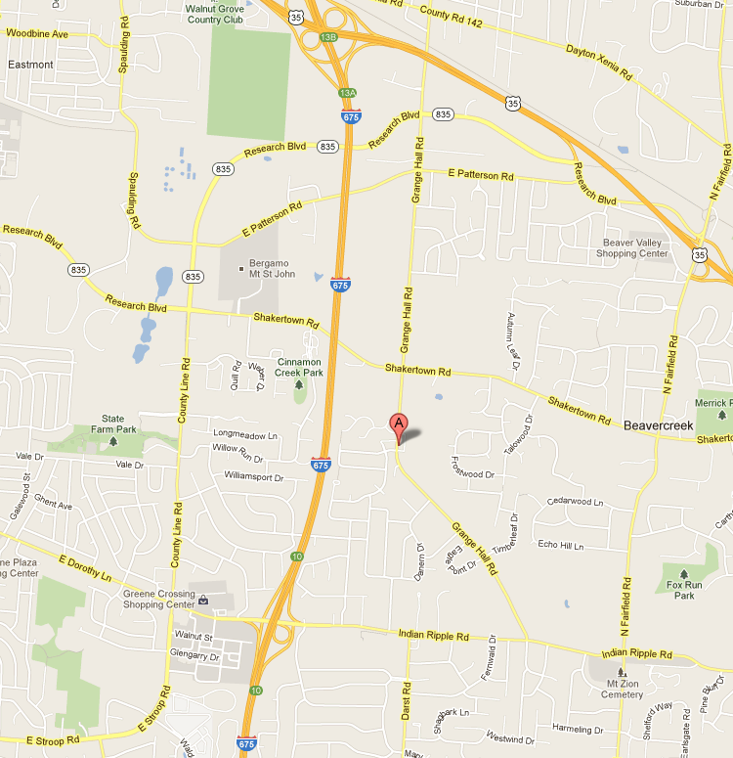

THE EIGHTH ANNUAL DAYTON AREA SHARKS
MASTERS SWIM MEET AND SPRINT PENTATHLON
Saturday, December 6, 2014
Sanctioned by Ohio LMSC and USMS, Inc. Sanction #TBD

NAME________________________________________ GENDER________
BIRTHDATE_______________________ AGE _____________________
USMS Number _____________________ TEAM_____________________
ADDRESS______________________________________________________
CITY, STATE__________________________________ ZIP______________
HOME PHONE (___)____________ BUSINESS PHONE(___)____________
E-MAIL________________________________________________________
ATTACH A COPY OF CURRENT USMS CARD

Circle the event numbers in which you would like to be entered and show your seedtime to the hundredth of a second. If you do not enter a time you will be entered with a “NT.”

# | Entry Time | Event | # | Entry Time | Event
1 |  | 400 Freestyle Relay | 10 |  | 200 Individual Medley
2 |  | 50 Butterfly (P) | 11 |  | 50 Freestyle (P)
3 |  | 100 Backstroke | 12 |  | 100 Freestyle
4 |  | 200 Breaststroke | 13 |  | 200 Butterfly
5 |  | 50 Backstroke (P) | 14 |  | 100 Individual Medley (P)
6 |  | 100 Fly | 15 |  | 100 Breaststroke
7 |  | 200 Freestyle | 16 |  | 200 Backstroke
8 |  | 50 Breaststroke (P) | 17 |  | 200 Freestyle Relay
9 |  | 200 Medley Relay | 18 |  | 500 Freestyle

(P) Marks a Pentathlon Event (Pentathlon participants must sign up for all five pentathlon individual events).

ADVANCE ENTRIES (received by 12/3/14): $30 per swimmer for the meet including three relays _____
DECK ENTRIES (due by 1:15 PM 12/6/14) $40 per swimmer for the meet including three relays _____

RELEASE TO BE SIGNED
I the undersigned participant, intending to be legally bound, hereby verify that I am physically fit and have not been otherwise informed by a physician. I acknowledge that I am aware of all the risks inherent in Masters Swimming (training and competition) including possible permanent disability and death, and agree to assume all of those risks. AS A CONDITION OF MY PARTICIPATION IN THE MASTERS SWIMMING PROGRAM OR ANY ACTIVITIES INCIDENT THERETO, I HEREBY WAIVE ANY AND ALL LEGAL RIGHTS TO CLAIMS FOR LOSS OR DAMAGES, INCLUDING ANY CLAIMS FOR LOSS OR DAMAGE CAUSED BY NEGLIGIENCE, ACTIVE OR PASSIVE, OF THE FOLLOWING: UNITED STATES MASTERS SWIMMING, INC., THE LOCAL MASTERS SWIMMING COMMITTEES, THE CLUBS, HOST FACILITIES, MEET SPONSORS, MEET COMMITTEES, OR ANY INDIVIDUAL OFFICIATING AT THE MEETS OR SUPERVISING SUCH ACTIVITIES. In addition, I agree to abide and be governed by the rules of USMS.

SIGNATURE: ________________________________DATE: _______________

