SAFETY PLAN

2014
USMS National Championship
2-Mile Cable Swim

Betsy Owens Memorial Swim

Saturday August 16, 2014
Mirror Lake in Lake Placid, NY

RACE PLAN

The Betsy Owens Memorial Swim is a 2-mile cable swim, which will be held in Lake Placid’s Mirror Lake on Saturday August 16, 2014.
- The 2-mile race will be four loops around a one-quarter mile cable course.
- The direction of the swim will be determined by a coin toss.
- The race will be conducted as two heats, separating participants by speed.
- Each heat will be started in waves of 8-12 swimmers, offset by 20-30 seconds, utilizing an in-water start.
- The finish will also be in-water, from which athletes will proceed to shallow water and exit onto the beach.

Schedule of Events – Saturday August 16, 2014
8:30 Check-in Opens
8:00 Coin Toss
8:30 Mandatory meeting of officials, lifeguards & water safety personnel
8:45 Warmup begins
9:15 Heat 1 check-in closes
9:15 Heat 1 Mandatory Briefing & Positive Check-in
9:30 Heat 1 Start
10:15 Heat 2 Check-in Closes
10:15 Heat 2 Mandatory Briefing & Positive Check-in
10:30 Heat 2 Start
12:15 Picnic & Awards

2013 Betsy Owens Memorial Swim
USMS 2-Mile Cable National Championships
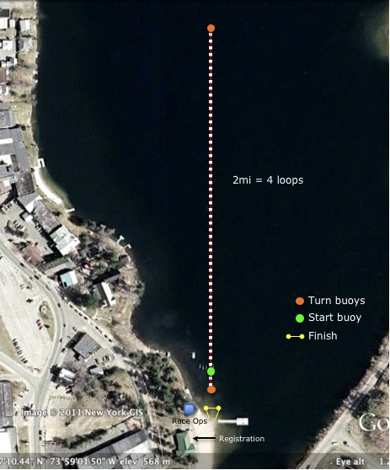
Course Overview
G
G
G
G
G
Guard
SAFETY PLAN

Safety Plan
- Motorized craft are not permitted on Mirror Lake and will not be used for the event.
- Lake Placid EMS will provide an on-site EMT equipped with first aid and an AED available.
- Lake Placid Ambulance Service is located within 2 miles of the site.
- An ambulance will be available with expected response time less than 5 minutes.
- At least 3 Red Cross certified lifeguards will be stationed among the start and on the water beginning at 8:45.
- The Safety Director will be stationed on the beach and in radio contact with safety, medical personnel and kayakers.
- Monitors in kayaks with flotation devices/rescue tubes will be stationed on the course
  - One at each turnaround to prevent swimmers from leaving the course and to secure the course
  - The remainder will be distributed evenly on each side of the cable course
- The ratio of swimmers to on-water personnel (guards + monitors) shall not exceed 20:1.
- The Safety Director will ensure safety coverage for all athletes when a staff member is engaged in emergency procedures.

Accounting for Swimmers and Staff
- One member of the race staff will be appointed as Accountant.
- The Accountant’s only role is to account for the entry and exit of swimmers and staff from the water.
- Each swimmer is assigned and marked with a number.
- Roll call is held at the pre-race meeting, from which swimmers will directly enter the course. Athletes and their race numbers are recorded as positively checked in at this time, and absent swimmers are noted as scratched from the event.
- Swimmers enter the water in order according to the assigned number and proceed to the start line in waves.
- The number of swimmers in each wave will be communicated to all finish line & timing personnel as a check on the total number of swimmers entering the water.
- Upon exiting the water, each athlete’s number will be recorded and checked out of the roll call listing.
- Athletes withdrawing from the race for any reason must report to race officials to check out of the water.
- Swimmers not checked out are Missing Swimmers, and the Missing Swimmer Emergency Plan will commence immediately.
- The Accountant will apply a similar method to account for staff members.

Race Procedures
Pre-race information
- Safety instructions & map are emailed with heat sheets to entrants the week before the race.
- A large course map will be posted at registration.
- If the weather forecast is for unusually cold temperatures, we will advise swimmers in pre-race notices to bring warm clothes.
Warmup
- Once the course direction is determined by a coin toss, all athletes must warm-up in that direction only.
- No warm-up will be allowed on the course after the start of Heat 1.
- Swimmers in Heat 2 are advised to arrive early enough to warm up on the course if desired.
- Athletes can warm up in the public beach area.
Start
- The start is an in-water start in waves of 10 swimmers, 30 seconds apart.
- Faster swimmers start first to minimize the number of swimmers who are overtaken by faster swimmers.
- Seed times are used to divide the race into 2 heats to minimize the number of swimmers overtaken by faster swimmers.
Time Limit
- Athletes who cannot complete 2mi in 1:45 hours are advised not to enter.
- Swimmers still on the course after 1:45 may be stopped and transported to the finish by safety personnel.
Mandatory Pre-race Participant Meeting
- Race officials will deliver a mandatory logistics and safety briefing to athletes approximately 15 minutes before heat start.
- The meeting will include a number check/roll call to account for all athletes and to note the absent swimmers.
- Swimmers will be advised of the start procedures, finish procedures, course markings and emergency procedures.
- Faster swimmers will be asked pass slower ones on the outside of slower swimmers. Slower swimmers can stay closer to the cable and remain on course.
- Athletes will be advised that course monitors will be alert for swimmers off course and for unsportsmanlike behavior (i.e., excessive physical contact). Swimmers will be disqualified for unsportsmanlike behavior.
Finish
- Upon exiting the water, swimmers will be assessed for cold challenge and mental status changes by qualified race-personnel.
- Water will be provided, and blankets will be made available to cold swimmers. Food will also be available.

Communications
- Communications will be conducted by two-way radios.
- Safety operations will communicate on a dedicated channel. Safety radios will be distributed to:
  - Safety Director
  - EMT
  - Lifeguards
  - Kayakers
  - Race Director
- A second channel will be used for Race operations. Race radios will be distributed to:
  - Race Director
  - Turn judges
  - Finish line personnel
  - Other race operations personnel
- Cell phone numbers for the following will be provided to all race personnel as a secondary communication method:
  - Race Director
  - Safety Director

Water Temperature
Water temperature will be measured 1 foot below the surface at one or more points on the course, and air temperature will be recorded at the start location.
- The race will be canceled if the water temperature is less than 60.8°F (16°C) or greater than 85°F (29.4°C).
- The race will be canceled if the sum of the water and air temperatures is less than 118°F (or 30°C) or greater than 175°F (or 61.6°C).

EMERGENCY PLAN

Swimmer in Distress
- Lifeguards and kayakers will monitor swimmers in their zone to identify signs of distress.
- Athletes requesting assistance during the swim are directed to
  - Raise an arm and signal the nearest kayaker
  - Move out of swimming traffic if possible
- A lifeguard or kayaker will provide a rescue tube or other flotation device or direct the athlete to hang onto the front or back of a kayak (not the side, which could capsize the kayak).
- Race officials/medical personnel reserve right to remove any participant from the course for the safety of the athlete or other athletes.

Medical Evacuation Plan
- For use in the event of an athlete medical emergency.
- If necessary, two kayakers on the course would form an “L” with their kayaks to protect the swimmer from other competitors and try to clear the distressed swimmer from traffic.
- Kayakers or lifeguards will provide a flotation device to the athlete and take the distressed swimmer to shore.
- In the case of an unresponsive swimmer, a lifeguard will enter the water with a rescue tube, support the distressed swimmer and be taken to shore by rescue board, rowboat or kayak.
- Once on shore, on-site EMT and lifeguards trained in CPR and first aid will commence emergency medical procedures.
- If an ambulance is required the Safety Director on shore will notify local EMS.
- EMS response time is expected to be less than 5 minutes.
- The hospital is 1.3 miles away, about a 4-minute drive.

Missing Swimmer
- All swimmers will be required to provide a personal cell phone contact and a coach/handler cell phone contact at registration.
- If a swimmer is reported missing and last seen in the water
  - The Safety Director will notify contact the Lake Placid Rescue Squad to activate their under-water search and recovery protocol.
  - The Safety Director will direct kayakers, lifeguards and volunteers to canvass the course and the shore.
  - Concurrently, meet operations will attempt to contact the emergency contact, coach and swimmer via cell phone and public address.
  - Meet Operations will review the start list and withdrawal list to confirm the swimmer actually started the race.
  - All swimmers are reminded before the race start that they must report to the nearest lifeguard if they withdraw from the race.

CONTINGENCY PLAN

Race Cancellation or Postponement
- Approximately ½ hour before the beginning of the race, race personnel will convene to assess current safety conditions.
- Any of the following individuals are empowered to independently order the race cancelled or postponed due to unsafe course or other conditions
  - Race Director
  - Safety Director
- The race may be cancelled or postponed at any time for any of the following reasons:
  - Presence of thunder/lightning
  - Excessively warm or cold water temperatures
  - Excessive currents or waves
  - Poor water quality
  - Any other unsafe course or other condition
- If conditions warrant, race officials will first postpone the start of the event or of a heat. If conditions are unlikely to change, race officials will cancel the event.
- There is no alternative date for the event.

Post-start Cancellation - Evacuation Plan
- The Safety Director will contact all staff by radio and signal with 3 blasts of an air horn.
- Guards will also signal race abandonment with 3 blasts of their whistles, repeating as necessary.
- Kayakers will raise their brightly colored paddles, block the course with their boats and guide swimmers to the course exit/finish chute.
- At the finish, safety officials will conduct normal swimmer accounting procedures.
- Upon cancellation, swimmers must:
  - Proceed directly to the finish on the appropriate side of the cable
  - Follow any directions from the officials or water safety personnel
  - Once safe on the beach, proceed to the finish area and check out.

Course Adjustments
- Due to the nature of a cable course, the course layout will not be adjusted.
- If necessary and appropriate, race officials may shorten the event.

DIRECTIONS TO ADIRONDACK MEDICAL CENTER

IN EMERGENCY CALL 911

1.3 miles – about 4 minutes
Adirondack Medical Center
29 Church St, Lake Placid, NY 12946
(518) 523-1717

1. Head south on Parkside Dr toward Lake Placid Club Dr/Shore Drive (drive 0.3 mi)
2. Turn right onto Morningside Dr (drive 295 ft)
3. Continue onto S Main St (drive 0.2 mi)
4. S Main St becomes Sentinel Rd (drive 0.4 mi)
5. Slight right to stay on Sentinel Rd/26A (drive 0.1 mi)
6. 2nd left onto Church St (drive 0.2 mi) Medical Center on the right

See map on next page.
DIRECTIONS TO ADIRONDACK MEDICAL CENTER

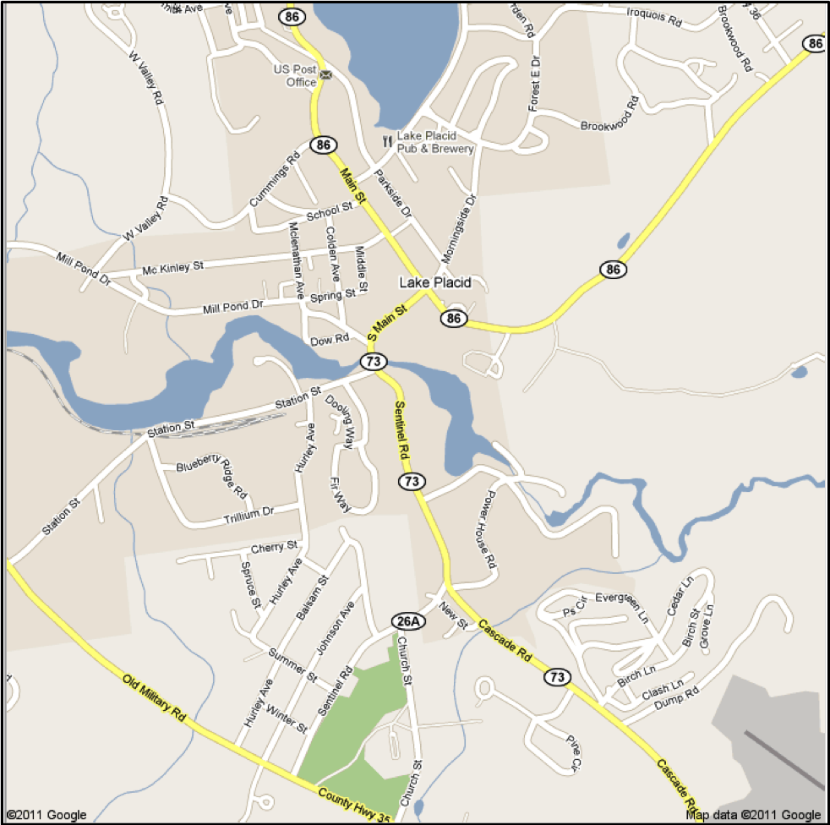
H
Mirror
Lake
Race Start

