The USMS National Office will create the entry form once the meet information has been finalized (Order of Events, social, shuttle, etc.). Please issue a sanction number for this event to begin the formal planning process. Please let me know if you have any questions.

Thanks,

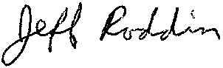

Jeff Roddin, Chair  
Championship Committee  
U.S. Masters Swimming  
240-464-3982 cell   
[championship@usms.org](mailto:championship@usms.org)