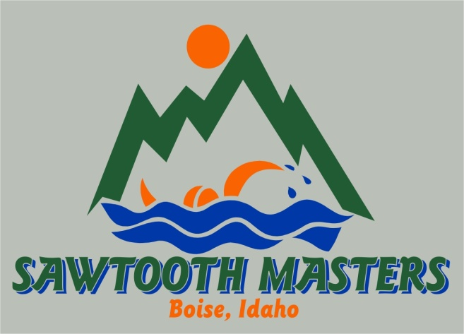

Broadside Harbor Open Water Swims
1 mile and 2 mile OW Swim and 1/4-mile Disability category
June 28, 2014
Boise, Idaho
Sanctioned by Snake River Masters for USMS:

Meet Registration Form

Location: Broadside Harbor has 2 side-by-side water ski competition lakes, each ½ mile in length. Water temp likely to be 70-75ºF.

Directions: From Boise, travel west on l-84. Take exit 26. Turn left (towards Notus/Parma) on Hwy 20/26 and follow for approximately 0.5 mile. Turn left on Look Lane. Follow Look Lane over the railroad tracks and turn left on Broadside Harbor Lane (dirt road). Follow to the lakes. Please park in the dirt lot to the west of the house.

Races:
•One-mile swim
•Two-mile swim
•1/4-mile Disability swim (Buddy swimmer provided for each participant)
•1/4-mile Beginner/First Timer swim

Eligibility: This event is open ONLY to USMS members or foreign equivalents. A legible photocopy of 2014
USMS card or foreign equivalent MUST accompany entries. One day USMS eligibility is available.

Rules: Current USMS rules will govern this event.
Two divisions - Non-wetsuit and Wetsuit

Start/finish: Swimmers will start in the water and will finish by going through a chute.

Water Temperature: Approximately 70⁰F.

Course: The 1-mile race will be an out and back of one lake. The 2-mile swim will be two circuits out and back of the same lake. The ¼ mile will be around designated buoys.

Age Groups: 18-24, 25-29, 30-34, and so on in 5-year increments.

Results: Will be posted online at www.sawtoothmasters.com
Schedule:
7:30 Check-in opens
8:30 Mandatory pre-race meeting
8:45 Start of 1-mile swim
10:00 ¼ mile Disability and First timer swim
11:00 Start of 2-mile swim

Entry Fees (includes all races) and Deadlines:
Entries received by June 16, 2014: $35
Race Day entries June 28, 2014: $45

Lodging: Hotels on I-84 at Exit 29:
La Quinta, 901 Specht Ave., Caldwell, ID 83605, (208) 454-2222.
Best Western, 908 Specht Avenue, Caldwell, ID 83605, (888) 454-7225

Camping: There will be primitive camping on-site. Some electrical hookups will be available
($10/day). Call Kristi Lee to arrange camping: 208-761-0006. A note: camping is with hearing range of train tracks.

Parking: Handicap parking available nearest the house.

Showers: There is a fresh water shower on the dock.

Dogs: No dogs are allowed on the dock. Dogs must be leashed and owners must clean up after their animals.

Porta-potties: 2 accessible units available for everyone to use and change in.

Post-race Potluck Picnic: Hamburgers, hotdogs, buns, paperware, non-alcoholic beverages, and condiments will be provided. Please bring a side dish to share. Guests: $5.00.

Questions: Event Director Jill Wright: 208-338-5287 swimjmw@msn.com.
Questions for Disability Swim: Karen Morrison: 208-720-6362 kmorrison@aquability.org

Mail Entries to: Jill Wright
Sawtooth Masters
1626 Williams St.
Boise, ID 83706

Broadside Harbor Open Water Swims
1 mile and 2 mile OW Swim and 1/4-mile Disability and First Timers category

OFFICIAL ENTRY FORM

June 28, 2014 Sanctioned by Snake River Masters by USMS Inc. Sanction number:

Last Name:*_______________________________ First: _______________________________ MI: ___
Street Address: ___________________________ City:____________________ State:____ ZIP:_______
E-Mail: _______________________________ Day Phone: ______________ Eve. Phone: ___________
Emergency Contact: __________________________ Phone: ______________ Age: ____ (on 616/2012) **
D.O.B: ____________ Sex: ____ Club Name or Unattached:___________________________________
USMS #: ________________________
*Print name as it appears on USMS registration card.
**18-year-olds must be 18 on 6/28/ 2014

Entry Fees and Deadlines
Circle all events you wish to swim:
One-Mile Swim Two-Mile Swim 1/4-Mile Disability Swim 1/4-Mile First Timers
$□$ I am willing to buddy swim with a person in the disability event

Entries received by : June 16, 2014 |  | $35
Race Day Entries &  Entries rec’d after 6/16/14 |  | $45
Guest Picnic tickets | # guests _____ | $5
1-day USMS registration |  | $15
Broadside Harbor t-shirt-size S M L XL $10
Total:

Make Check or money order payable to: Sawtooth Masters

Liability Release:
“I, the undersigned participant, intending to be legally bound, hereby certify that I am physically fit and have not been otherwise informed by a physician. I acknowledge that I am aware of all the risks inherent in Masters swimming (training and competition), including possible permanent disability or death, and agree to assume all of those risks. AS A CONDITION OF MY PARTICIPATION
IN THE MASTERS SWIMMING PROGRAM OR ANY ACTIVITIES INCIDENT THERETO, I HEREBY WAIVE ANY AND ALL RIGHTS TO CLAIMS FOR LOSS OR DAMAGES, INCLUDING ALL CLAIMS FOR LOSS OR DAMAGES CAUSED BY THE NEGLIGENCE, ACTIVE OR PASSIVE, OF THE FOLLOWING: UNITED STATES MASTERS SWIMMING INC., THE LOCAL MASTERS SWIMMING COMMITTEES, THE CLUBS, HOST FACILITIES, MEET SPONSORS, MEET COMMITTEES OR ANY INDIVIDUALS OFFICIATING AT THE MEETS OR SUPERVISING SUCH ACTIVITIES. In addition, I agree to abide by and be governed by the rules of USMS.” “Finally, I specifically acknowledge that I am aware of all the risks inherent in open water swimming and agree to assume those risks.”

Sign here: ___________________________________

MAIL ENTRIES TO: Jill Wright, Sawtooth Masters, 1626 Williams St., Boise, ID 83706

