Great Salt Lake Open Water Swim
Safety Plan

Great Salt Lake Open Water Swim
June 6-7, 2014
Introduction:

The Great Salt Lake Open Water Swim consists of two point-to-point swims:

- 1 Mile from Great Salt Lake Marina to Black Rock Beach
- 8.12 Miles from Antelope Island to Black Rock Beach

The one mile event will be held on Saturday June 7, 2014. The eight mile event will be held either Friday, June 6, or Saturday June 7, 2014 depending on weather. If the weather forecast is questionable for Saturday, a decision will be made by Wednesday evening to hold the 8 mile event on Friday instead. The decision to hold the event on Friday will only be made if the Saturday forecast is clearly a bad one and is at high risk of being a safety concern for the paddlers/swimmers should the event take place on Saturday.

If BOTH Friday and Saturday have high wind warnings, then the events will be canceled outright and not postponed to another day.

The event directors are:

- Gordon Gridley – Race director for the 1 mile swim
- Josh Green – Race director for the 8.12 mile swim
- Kelley Green – Safety Coordinator

Venue:

The swim will take place in the Great Salt Lake, near Salt Lake City, Utah.

Course Design:

The courses have been designed as straight line point-to-point swims.

The one mile course begins at the green buoy just outside of the Great Salt Lake Marina and follows a series of five neon orange buoys to the finish at Black Rock Beach. The only potential hazard on this course is a rocky area at just past the halfway point. A kayaker will be stationed near this area to divert swimmers away from the rocky shore.

Swimmers will also be instructed about this potential diversion during the safety briefing before the swim start.

The 8.12 mile course begins at the southern tip of Antelope Island. Each swimmer will receive a waterproof container that has a picture of the landscape looking towards Black Rock from Antelope Island. The picture has an arrow on it showing where the paddlers should be navigating to from a distance until they can clearly see the finish from about half way to the finish. The finish line is at Black Rock Beach.

Start:

The start for the 1 mile event will be a “deep water” start at the green buoy outside of the Great Salt Lake Marina. The starting line is perpendicular to the swim course. The starter will be clearly identified and visible to all participants on the rocky opening of the marina. A bull horn and a flag will be used to start the race.

The start of the 8.12 mile event will be within shallow water, clear of any hazardous debris (rocks, glass, etc). The starting line is perpendicular to the swim course. The starter will be clearly identified and visible to all participants and their paddlers. A whistle and a flag will be used to start the race.

Turn/Course Markers:

The one mile swim course will be well marked with six buoys (one green buoy and five neon orange buoys) that are clearly visible from the surface of the water. The course will follow a straight line from the Great Salt Lake Marina to Black Rock Beach (a landmark that is easily visible from the water). The course has no turns.

There are no course markers for the 8.12 mile swim. Swimmers will rely on their support paddlers for navigation. The support paddlers may use GPS devices or the picture provided within the waterproof container to navigate directly towards Black Rock Beach (a large landmark that is clearly visible from the water).

Finish:

Both events will finish at Black Rock Beach. The finish area is a sandy beach that is typically very clean year round, as it receives good attention from Utah Department of State Lands to keep it clean. The race directors will also inspect the beach and area near the finish to ensure that the area is clear of all debris (rocks, trash, etc) before the race. Volunteers at the finish line will keep non-participants clear and will ensure sportsmanlike conduct.

Maps / Diagrams:

Course Maps

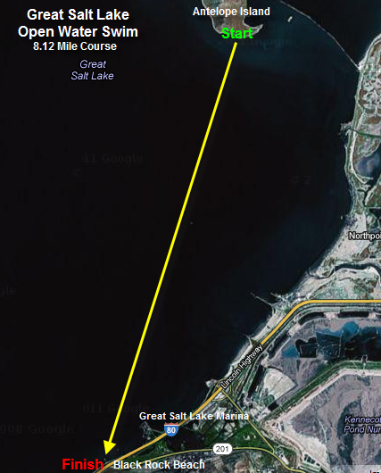

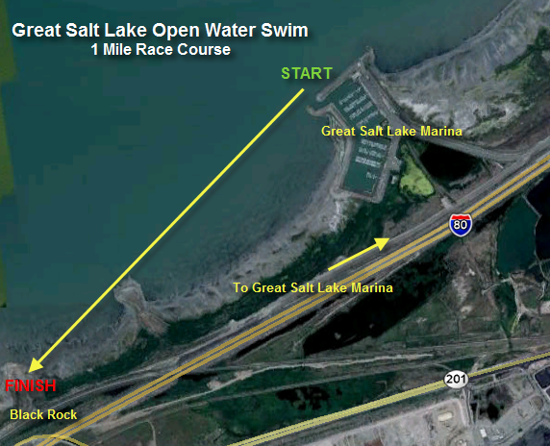

Site Maps
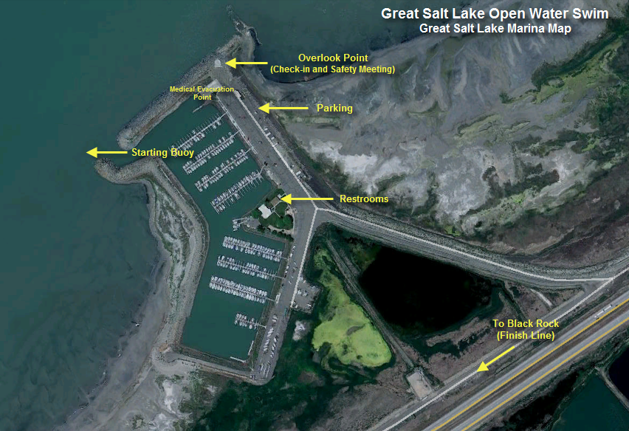

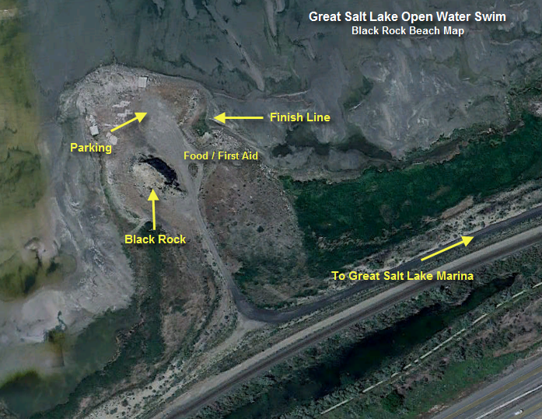
Emergency Medical Services

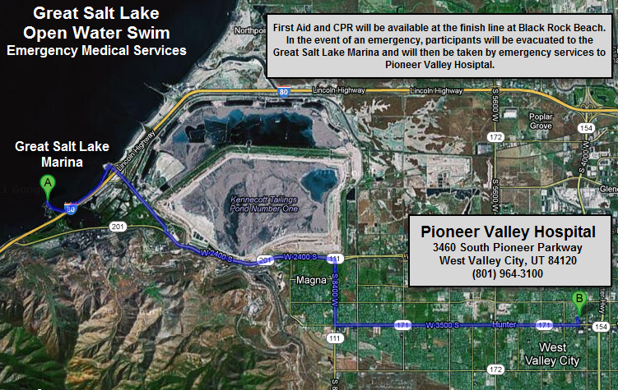

Water and Environmental Conditions

Water Look, Feel and Taste

Water conditions are expected to be good. The water at the Great Salt Lake is extremely salty and has an unpleasant taste. Because of the amount of salt in the water, it is highly recommended that participants use some type of body lubricant to prevent chaffing. Water temperatures are expected to be in the low to mid 60’s as visibility is estimated at three feet.

Local and Seasonal Trends.

There are no significant local and seasonal trends that would cause concern.

Participant Safety

Waiver / Disclaimer / Warning

Participants share responsibility for their own safety and will be required to sign a waiver at the time of registration and also at event check in. The standard USMS waiver for open water events will be used.

Emergency Contacts

Each participant will be required to provide an emergency contact and phone number in case of emergency.

Participant Identification

Each participant will have their race number written on their arm and/or hand (if wearing a full sleeve wetsuit) as well as their cap. This race number will be linked to participant information and an emergency contact.

Participant Visibility

Each participant will be required to wear an event cap for the duration of the swim. Event caps will be brightly colored and easily visible from the water. In addition, there will be at least 10 NON MOTORIZED watercraft (kayak, paddleboard, etc) spread along the 1 mile course to assist in watching the swimmers progress. Each of the 8.12 mile swimmers is required to have their own support paddler, who will provide support and navigation assistance.

THE HARBORMASTER MAY BE OUT ON THE WATER IN HIS MOTORIZED RESCUEBOAT ALONG WITH HIS DEPUTY. THESE RESCUEBOATS ARE OWNED AND OPERATED BY DESIGNATED STATE EMPLOYEES FOR THE PURPOSE OF SEARCH AND RESCUE. THEY HAVE AGREED TO STAY COMPLETELY OUT OF THE WAY AND OBSERVE FROM AFAR.

Participant Safety Briefing

There will be two participant safety briefings, one for each of the two events. This briefing will cover the following information:

- Description of general race time conditions (water temperature, weather conditions, etc)
- Opportunity for withdrawal prior to the start if any participant had apprehension as to their ability or desire to participate.
- Participants’ obligations if they drop out before the swim or quit during the swim.
- Course and safety monitor locations
- Procedure for getting assistance or aid during the swim
- Course directions/markers/rules.
- Starting procedure/signals
- Encouragement to participants to position themselves appropriately at the start according to speed and ability.
- Finish procedures/cut off times
- Evacuation points and procedures

Boat Operator Briefing

This briefing will cover the following information with the two motorized boat operators on the course (both owned and operated by Utah State Parks):

- Description of general race time conditions (water temperature, weather conditions, etc)
- Instruct boat operators to stay clear of swimmers unless there is an emergency.
- Instruct boat operators to assist with directing other boat traffic away from the swimmers.
- Procedures for swimmer assistance or aid during the swim
- Course directions/markers/rules.
- Evacuation points and procedures

Postpone / Cancel / Modify

In the event that the race needs to be postponed, canceled or modified due to weather or other conditions, the Safety Coordinator, event directors and volunteers will follow the Event Cancellation or Postponement Plan under the “Emergency Action Plans” section of this document.

Plan for Potential Situations

In case of emergency, the event staff will follow the plan outlined in the “Emergency Action Plans” section of this document.

Staffing for Safety

Event Directors

The event directors are as follows:
- Gordon Gridley – 1 mile swim
- Josh Green – 8.12 mile swim

Due to the fact that the two event directors will be occupied with overall event management, a separate Safety Coordinator has been assigned. Kelley Green has been designated as the event Safety Coordinator.

Safety Coordinator

USMS rules require that a Safety Coordinator be designated. The Safety Coordinator will report directly to the event directors. All safety issues have been assigned to the safety coordinator who has sufficient authority to ensure that safety directives are observed or enforced. The Safety Coordinator will:

- Assist in preparation of a written safety plan before the event
- Provide accurate maps, course descriptions, course markings, and other pertinent information with entry forms and event information packets including anticipated water temperature and general water conditions.
- Require that all participants wear the brightly colored event caps
- Acquire and keep a copy of emergency contacts for all participants
- Acquire necessary safety equipment
- Plan and execute communication among safety personnel
- Plan for escort paddlers or craft
- Manage course monitors and ensure that management is in place for other watercraft
- Inform participants of the anticipated water temperature, specific weather and water conditions and know hazards
- Plan for possible cancellation, postponement and/or modification of the event
- Work with the event directors
- Work with the EMS personnel

EMS Services

EMS services will be provided by the Utah State Parks. Dave Shearer (Harbormaster) and his team are trained first responders and will provide emergency services if needed. In addition, the event directors and Safety Coordinator are trained in CPR and first aid.

In the event of a more serious emergency, the Magna Police Department will be contacted to send an ambulance to the marina.

A supply of blankets and warm fluids as well as a basic first aid kit will be available at the finish line.

On-Water Course Monitors

On-water craft (including kayaks and paddle boards) will be assigned and distributed along the entire length of the 1 mile swim course to ensure that participants are covered visually at all times. These course monitors will be available to help and encourage struggling swimmers and signal the Monitor Craft in case of emergency. On-water course monitors will have radios and flags to signal the Monitor Craft in the event in case of emergency.

All on-water course monitors will “sweep” the 1 mile course and follow the last swimmer to the finish.

Each swimmer participating in the 8.12 mile swim is required to have their own support craft and paddler. These paddlers will serve as on-water course monitors for the 8.12 mile event. Each support boat will have a radio to communicate with event directors, the Safety Coordinator and Monitor Craft.

Escort and Pilot Craft

Individual escort craft is required for each participant in the 8.12 mile event. Each escort will be given a flag and radio to use in the event of emergency.

Monitor Craft

Two monitor craft will be provided by Utah State Parks. The craft will patrol the 1 mile and 8.12 mile courses. Each monitor craft will have a first aid kit and trained first responders. Radio communication will be maintained between the Monitor Craft and Safety Coordinator in the event of an emergency.

Evacuation Craft

The Monitor Craft described above will also serve as Evacuation Craft in the event of an emergency. These motorized craft should not approach the course at any time unless absolutely necessary. Where practical, persons in trouble should be brought to the evacuation boat. First responders may use their judgment on making exceptions to the above statement.

In the event that a participant needs to be evacuated from the course, they will be taken to the marina to await emergency vehicles to arrive.

Safety Patrol Craft

The two boats provided by Utah State Parks will also act as Safety Patrol Craft and will assist in keeping craft not associated with the swim off the course.

Pre-Race Safety Briefing

The event directors will ensure that the safety staff knows their jobs and their place in the safety planning. These responsibilities include:

- Equipment and its use
- Event procedures outlined
- Positioning of personnel and water craft
- General assistance duties
- Response and care duties
- Communication
- Evacuation
- Cancellation

Safety Monitor Training

The event directors will ensure that monitors are trained before assisting participants. A clinic will be offered in the week leading up to the event to provide training for on-water safety monitors.

Safety Gear

Basic first aid kits will be available at the start and finish. EMS equipment is located on the Monitor Craft.

Participant Supervision and Management

Accounting for Participants

Each participant will have their race number marked on their body and their race cap. This number will correspond to their emergency contact information and will also be used to ensure that all participants are accounted for at the end of the event. Event staff will:

- Know the number of participants starting
- Know the number of participants who got out or were pulled out during the swim. (Safety Coordinator)
- Know the number of participants finishing
- Account for each participant or find the missing participant before event officials leave the venue.
- Ensure that all participants have left the venue before event officials leave the venue.

Layers of Surveillance

The event host will “layer” protection at the event. Monitors will watch swimmers, evacuation boats and the Safety Coordinator will watch, or maintain radio communication with, the other personnel on the water.

Qualifying Standards

Specific qualifying standards are not required for this event. However, the risks of the swim will be explained to participants, who will have the opportunity to withdraw if they are not confident in their ability.

Time Limits

Time limits for the two events are as follows:

- 1 mile swim – 1 hour time limit
- 8.12 mile swim – 8 hour time limit

At the discretion of the event host, swimmers who exceed the time limits may be picked up by an event craft, and may be disqualified.

Communication

A variety of communication devices will be used during the event including:

- Marine band radios – for communication between support crew on the water, event directors and safety coordinator
- Cell phones – for communication between event directors, volunteers and safety coordinator.
- Whistles – for use by on-water safety monitors to alert monitor craft of potential emergencies.
- Flags – for use by on-water safety monitors to alert monitor craft of potential emergencies. Also to be used by the event starter to signal the start of the race.
- Bull horn – to be used for giving pre-race safety and race instructions and for starting the event.

Emergency Action Plans

Written Action Plans

Written emergency actions plans have been prepared as follows:

Medical Evacuation Plan

In the event that a participant needs to be evacuated from the course for medical reasons, the following procedures will be followed:

On-water safety monitors (1 mile swim) and individual support paddlers (8 mile swim) will be the first line of communication. If these volunteers see a struggling participant, they will make their way to the participant and try to determine the problem while suggesting that the participant hold onto the support craft.

The on-water safety monitor or individual support paddler will signal the monitor craft by using their whistle and flag. Marine radios will also be use to establish communication with the monitor craft and safety coordinator. The on-water safety monitor or support paddler will identify the swimmer by race number and name, describe the problem, and identify their location on the course.

Instructions for transmitting a May Day (life threatening emergency) or Pan Pan (non life threatening) call:

Transmit May Day or Pan Pan on Channel 16 as follows:
- May Day, May Day, May Day (or Pan Pan, Pan Pan, Pan Pan)
- This is 'Vessel Name' repeated three times, followed by Ship Station License call sign
- May Day (or Pan Pan)
- 'Vessel Name' is at Position (Lat and Long), or distance and bearing from landmark
- We are (describe nature of emergency)
- We require (describe nature of assistance needed)
- Aboard are (describe number of people, age and condition if relevant)
- We have (describe safety equipment)
- 'Vessel Name' is (description: length, sail/power, design type, hull color, trim color)
- Over
The monitor craft will make its way to the participant and assist in getting the participant on board the monitor craft. Emergency services will be provided as needed. The monitor craft will alert the safety coordinator of the situation. The monitor craft will transport the participant to the Great Salt Lake Marina.

The safety coordinator will alert emergency services (911 and/or Magna Police Department) to the situation and request that an ambulance be sent to the Great Salt Lake Marina. After contacting emergency services, the safety coordinator will update the event directors on the situation.

The safety coordinator will contact the emergency contact person associated with the participant’s race number.

The safety coordinator will assist emergency services in providing information, filling out forms and anything else needed by emergency services.

The safety coordinator and/or event director will follow up with the participant and/or their family and emergency contact.

Event Cancellation or Postponement Plans

The event may be canceled or postponed at the discretion of the safety coordinator and event directors. Potential situations that may cause event cancellation or postponement include: weather conditions (wind, rain, lightning, water temperature, etc), emergency, or other environmental conditions (contaminated water, debris, etc).

In the event of cancellation or postponement the following procedures will be followed:

Cancellation

If the Safety Coordinator and event directors determine that conditions are unsafe, the event may be canceled.

Participants will be notified of the situation and the reasons for cancellation. They will also be reminded that refunds will not be given due to cancellation of the event.

The safety coordinator will answer any questions regarding the unsafe conditions.

Postponement

If the Safety Coordinator and event directors determine that conditions are unsafe to start the event as planned, the event may be postponed.

In this situation, participants will be notified of the situation and the reasons for postponement and will be asked to move to the Observation Deck to await further instructions and updates. Any participant who decides to withdraw from the race should notify the Safety Coordinator before leaving the venue.

If the situation has not improved within an hour of the original start time, the event may be canceled and the event staff will follow the “Cancellation” plan above.

