Safety Plan for Open Water

Basic Information
Name of Host Club: Chattanooga Open Water Swimmers and Outdoor Chattanooga
Name of Event: USMS 2.4 Mile Open Water National Championship
Event Location: Tennessee River Downtown Chattanooga Waterfront at Coolidge Park
City: Chattanooga, TN
Event Date: May 17, 2014

Key Personnel
Event Directors:
1) Karah Nazor
Email: karahnazor@gmail.com
Cell Phone: 423-488-3143
2) Philip Grymes
Email: Philip@outdoorchattanooga.com
Cell Phone: 423-421-5227

Command Center: Kacee Nazor
Safety Director: Buck Meyer
Head Referee: TBD
Medical Safety Officer: Danielle Mitchell, M.D.
Head of Non-Motorized Water Craft (kayaks and paddleboards): Kori Warriner
Motor Boat Captain for private boats: Skip Brannen and Will Smith, M.D.
Venue and Logistics Coordinator: Ruthie Thompson
Registration and Body Marking: Jenn Grymes, Tami Chamberlain

Event Website: http://www.cowsswim.com/2014-usms-national-champion.html
Online Event Entry Page: USMSOpenWaterChampionship2014.edgereg.com
Event Race Entry Host: EdgeReg (https://www.edgereg.com/site/)
Timing: Scenic City Multisport (http://www.sceniccitymultisportllc.com/chip-timing/)

Pre-Race Officials and Technical Meeting
Tentative Date and Time: Friday May 16th at 6 p.m. at Outdoor Chattanooga
Officials, timers, motorboat volunteers, and safety personnel required to attend to discuss the following:
  - Event logistics and schedule, safety plans, kayaker and SUP roles on the water, course, access points, emergency plans, morning check in, morning pilot and swimmer briefing and timing.

Pre-Race Athletes Meeting:
A Pre-race athletes meeting for pilots and swimmers will be held on the morning of race day and is mandatory.

Pilot Briefing
At 9:50 a.m. on race day, pilots will gather at the Command Center for a Pilot Race Briefing.
Agenda:
- Race directors will give a safety briefing. Each paddler will be assigned a position that they shall maintain on the course. Kayakers with safety tubes will be strategically positioned. Paddlers will be instructed in how to deal with a swimmer in distress or an emergency situation, will be given a laminated list of cell phone numbers of safety motorboats, the command center, race directors, etc. Paddlers will be given an overview of the racecourse and positions of buoy, and review the swimmer rules. Paddlers will be given water and snacks for themselves and swimmers. The weather emergency plan and evacuation route will be explained. Pilots will enter the water at 10:20 a.m.

Swimmer Briefing
At 10:30 a.m. on race day, swimmers will gather at the Command Center for a Race Briefing.
Agenda:
- Race directors will give a safety briefing, an overview of the racecourse and position of buoys, and review the rules. Swimmers will be informed about the roles of the kayakers and how to wave a kayaker over if they are in need. The weather emergency plan and evacuation route will be explained. Swimmers should wear parkas and other warm clothes that can be dropped in clear plastic bags on the ramp before entering the water and will be taken to the command center by volunteers.

Event Conditions

Race Day Conditions:
Expected Air Temperature: Low 58, High 78
Expected Water Temperature: 68-72
Combined Air and Water Temperature: Low: 126, High: 150

Heat 1: Championship 2.4 Miles Wetsuits Not Allowed
Heat 2: Non-championship 2.4 Miles Wetsuits Allowed
Heat 3: Non-championship 1.2 Miles Wetsuits Allowed

Body of Water: River, Freshwater
Water Type: Open Course

Agency that controls traffic on the river:
James Alter, MST3
USCG MSD Nashville
220 Great Circle Road, Suite 148
Nashville, TN 37228
Phone: 615-736-5421
Fax: 615-736-7315

We are requesting a partial river closure as the racecourse goes through the main traffic channel of the river (located in the center of the river). This means barges cannot pass during our event. Other boats will be able to pass through at the South Shore boat lane.

Water depth of course: >25 feet except at boat launch entry where water is between 1-5 feet deep.

Expected water conditions: Visibility of 3-5 feet. The river water is green. No marine life expected to be seen. The Tennessee River is a dam-controlled river. Estimated release from the Chickamauga dam by the Tennessee Valley River Authority will be known 48 hours in advance. Downstream currents are present when water is being released from the dam which is located ~6 miles upstream from the racecourse. In the event that more than 30,000 cfs is being released from the dam, a downstream alternate course will be used (see section Alternate Route at the end of this document). A water quality test will be performed one week prior to the event and sent off for testing.
Course Marking and Start/Finish
- Turn Buoy Height: 5 feet, large cylindrical orange inflatable open water buoys
- Intermediate Buoy Height: 1.5 feet smaller orange buoys. Approximate distance between: 100 yards

Start: In water. Swimmers must maintain a position underneath the Market Street Bridge. A grab rope will be present for holding onto that is stretched between two anchored boats.

Finish: On land at the boat launch ramp through a finish chute under a finish line banner. A long rug/carpet will be placed in the water and up the ramp through the chute to avoid the slippery concrete underneath.

Nourishment
Nourishment may be passed on to athletes at a series of kayakers positioned on the inside perimeter of the racecourse in between the turn buoys. Kayakers will have water, energy drinks, and bananas in their kayaks to hand out to swimmers. Swimmers can wave their arms to signal and yell “feeding” to signal a the kayaker over at any point if they need a feeding. Swimmers can also swim up to a kayaker and ask for a feeding. Trash will be placed in the kayaks. Kayakers can replenish their feeding supplies by paddling over to volunteer motor boats on the east and west ends of the course. Volunteer motor boats will have a safety monitor watching for swimmers and paddlers.

Event Safety

Medical Safety Officer: Danielle Mitchell, M.D., experienced in open water distance swimming events, bike races, running races.

First Aid Station and Personnel
An area will be designated close to the finish line and the Command Center tent for emergency personnel. EMTs and other medical staff will be stationed here to be on call for all emergencies. They will be coordinating directly with the medical safety officer as well as the other emergency personnel staff who are on the water on the Fire Boat. The fireboat also has certified EMT personnel on it and is capable of ALS services. An ambulance will be stationed next to the tent and will be equipped with a defibrillator. Standard first-aid supplies and hypothermia equipment will be available at the first aid station as well as on each of the motorboats and volunteers on the South Shore. The closest hospital is Erlanger, which is located 2 miles away (5 minutes) and maps will be available at the first aid station. Three lifeguards will be present on the water in kayaks or on stand up paddleboards and will be carrying safety tubes. Lifeguards will also monitor the warm-up and warm-down lane on the North Shore and will be stationed at the Access Steps labeled on the map.

Non-motorized Pilots
Kayakers that line the perimeter of the course and stand up paddlers patrolling the course are integral for athlete safety during the event as these volunteers are the ones closest to the swimmers in the water and have a watchful eye on swimmer status as they swim past them. The role of the kayakers and paddleboarders as pilots
in this event is outlined below in the section entitled “Water Craft.”

Race Overview
The race will take place on Saturday May 17th, at 11:00 a.m. in the Tennessee River at the Downtown Chattanooga Waterfront at Coolidge Park/Renaissance Park. The race is a 2.4 mile distance consisting of two 1.2 mile laps. The expected water temperature is between 68-72.

There will be three heats:
- Heat 1 will be the Championship 2.4 Mile Race. All swimmers must be annual USMS members and no wetsuits will be allowed. (Green Caps)
- Heat 2 will be the Non-Championship 2.4 Mile Race. Swimmers may purchase One-Event USMS Registration for $20 or be annual USMS members. Wetsuits allowed. (Pink Caps)
- Heat 3 will be the Non-Championship 1.2 Mile Distance and will consist of 1 lap. Swimmers may purchase One-Event USMS Registration for $20 or be annual USMS members. Wetsuits allowed. (Orange Caps)

The championship event Heat 1 will start as the first wave 15 minutes ahead of the Heat 2. Heat 2 will start 10 minutes ahead of heat 3.

Coolidge Park/Renaissance Park Swim Race Course
(See Two Course Maps)
The race start is in the water under the Market Street Bridge at River Mile 464.2 at the Coolidge Park/Renaissance Park ramp located in North Shore downtown Chattanooga. Swimmers will enter the water via the ramp and will the finish the race on land. A long rug/carpet will be placed in the water and up the ramp through the finish line chute to avoid with the slippery concrete underneath. The course is trapezoid shape with four legs. The swim start will be under the Market Street Bridge next to a large orange open water swimming buoy #1. Each orange buoy 2, 3, 4, and 5 mark the turn points of the trapezoidal course. Swimmers must swim on the left side of all large buoys and will be instructed to keep the buoys to their right. Turn judges in kayaks will be present at each turn and disqualify swimmers for not swimming on the correct side. Smaller 1.5 foot tall orange buoys will be placed every 100 yards in between the larger orange turning point buoys. Swimmers will complete 2 laps swimming clockwise around the course. The finish will be on-land under the Market Street Bridge on the ramp through a finish line chute. For more details see the Race Day Timeline Section below.

Spectators:
Spectators will be able to view the swimming race from the waters edge at Coolidge Park. Spectators will be able to walk across the Market Street and Walnut Street Bridge to view the swim race from above. Additionally, the South Shore’s Tennessee River Walk and the steps in front of the Aquarium offer additional viewing locations.

Command Center
All race operations will take place in and around the command center. The command center will be a large tent able to accommodate key personnel, timing, and the first aid station. The tent will house body marking, check-in on the day of registration, a race command table, timing, lost and found, and water stations. The command center will also be the site of the award ceremony, post race meal, and provide a place for spectators to congregate if they desire.

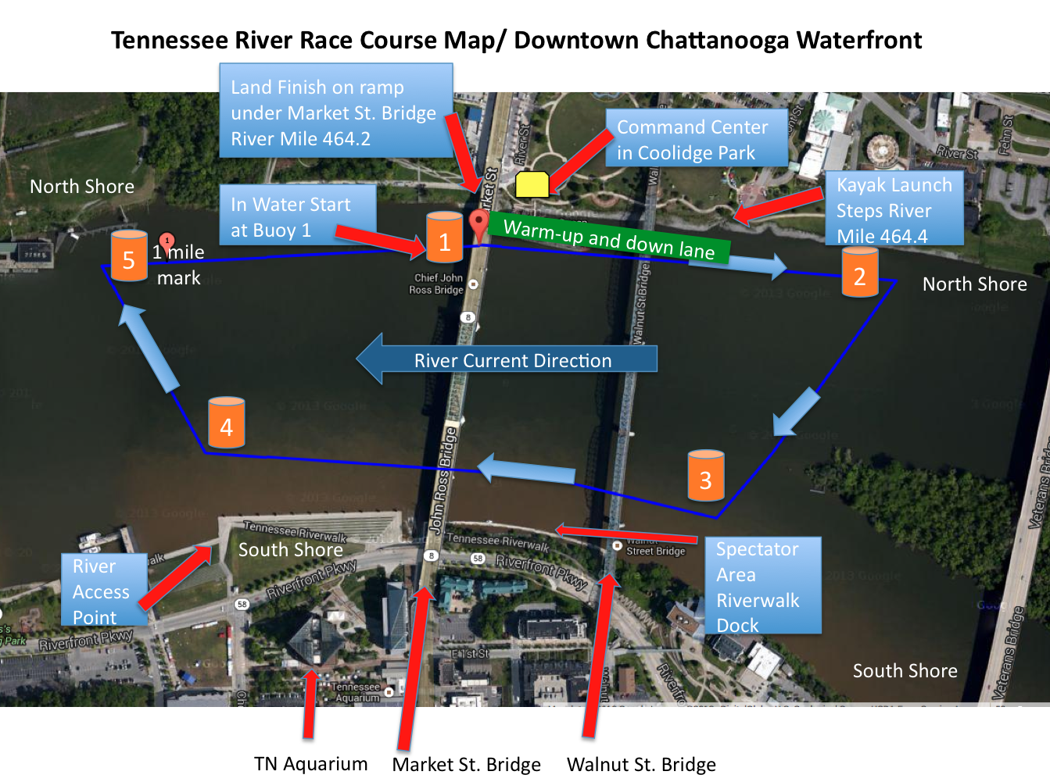

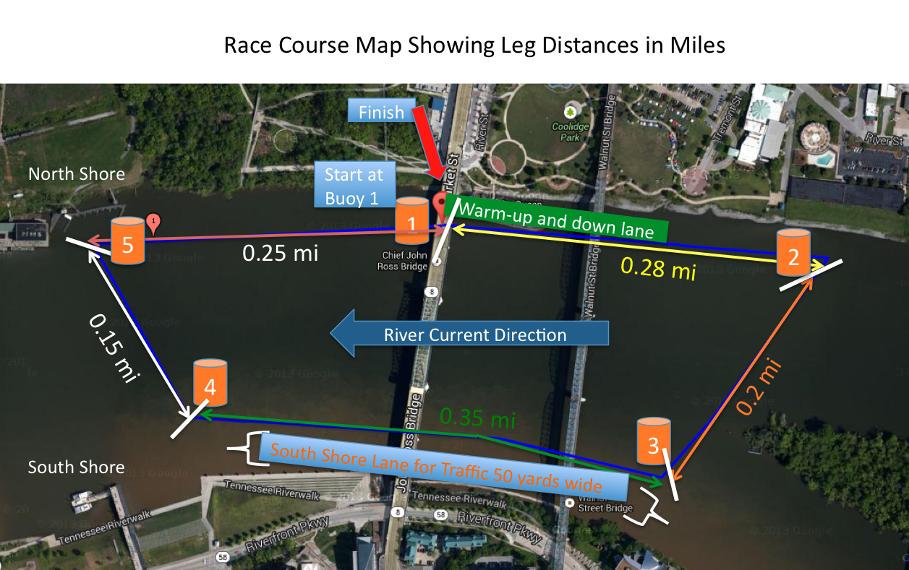

Race Day Timeline
1. 9:00-10:15 a.m. Swimmer and Pilot Check-in, Swimmer Body Marking and Timing Station at Command Center
- All registered swimmers will report to the Check in and Body Marking Station where both upper arms will be marked with their race number.
- Racers will visit the Timing Station at the Command Center. Timing chips will be placed on the swimmer’s ankle. Digital Race Timing performed by Scenic City Multisport.
- All kayakers and stand up paddlers will check in at a separate table in the Command Center.

2. 9:50 a.m. Mandatory Pilot Briefing
- At 10:00 a.m., pilots will gather at the Command Center for a Pilot Race Briefing. Race directors will give a safety briefing, an overview of the racecourse and position of buoys, and review the rules.

3. 10:20 a.m.
- Pilots Enter Water

4. 10:30 A.M. Mandatory Swimmer Briefing
- At 10:30 a.m., swimmers will gather at the Command Center for a Race Briefing. Race directors will give a safety briefing, an overview of the racecourse and position of buoys, and review the rules. Swimmers should wear parkas and other warm clothes that can be dropped in clear plastic bags on the ramp before entering the water and will be taken to the command center by volunteers.

5. 10:40 a.m.
- At 10:40 a.m., all swimmers will be called down to the water’s edge and line up according to their race numbers to make sure each participant is present and to get the final swimmer count. There will be 1 volunteer counting for every 50 swimmers to expedite the process.
- Clothes should be placed in plastic bags and left on the ramp.

3. 11:00 a.m. Official In-water Race Start for Championship Heat 1 2.4 Mile
- Immediately after the final count, safety and race briefing, the race directors will instruct the swimmers to enter the water and swim ~20-30 yards to the starting line where they will place their right hand on the starting rope stretched out between 2 anchored boats.
- The swimmers in the front will be able to grab the rope with their right hand in water that is 25 feet deep. Swimmers must maintain their position underneath the market street bridge until the official start of the race.
- Water depth is ~25 feet at the starting line.
- Once every athlete is lined up in the water, a 1 minute warning will be given, a 30 second warning, and a 10 second countdown will commence with 1 long loud horn blow at the end of that 10 seconds indicating the official start.

4. 11:15 a.m. Official In-water Race Start for Non-Championship Heat 2, 2.4 Mile

5. 11:25 a.m. Official In-water Race Start for Non-Championship Heat 3, 1.2 Mile

- The Swim
See course route and maps.
- Swimmers will start at Buoy 1 and will start with an ~0.28 mile upstream leg to the first turn point at open water buoy 2 located on the North Shore.
- Swimmers will turn around buoy 2 and swim ~0.2 miles across the river to the second turn point at open water buoy 3 located just upstream of the Walnut Street Bridge on the South Shore.
- The leg from buoy 3 to buoy 4 along the South Shore is downstream and is ~0.35 miles long.
- Swimmers will swim ~0.15 miles across the river returning to buoy 5 at the North Shore.
- Swimmers will turn at Buoy 5 and swim upstream ~0.25 miles back to Buoy 1 marking the completion of one lap.
- The course will be repeated for a second lap.

7. The Finish
- After the second lap, the swimmers will swim to the boat launch (where they entered the water) and exit underneath the Market Street Bridge for an out-of-water finish.
- Swimmers will run through a finish line shute and complete the race underneath a finish banner. This is where the official time will be recorded using digital timing chips (Digital Race Timing performed by Scenic City Multisport).
- Volunteers will check off swimmer numbers as they cross the finish line and make sure every athlete is accounted for.
8. Awards Ceremony and Post Swim Refreshments
- Pizza, Gatorade, and water will be available to each participant at the race finish. Spectators are invited to lunch for $8.
- At 2:30 p.m., or as soon as the majority of the racers have completed the event, the awards ceremony will commence at the Command Center. Medals will be awarded as follows:
Awards: Championship Heat:
- 2014 USMS 2.4 Mile National Championship medals will be awarded to the top six finishers in each men/women age group (18-24, 25-29, 30-34, etc.) and special awards for the first overall USMS male/ female finisher. USMS Long Distance National Championship patches will be awarded to the first male and female finisher in each age group.

Non-Championship Heats:
- Prizes will be awarded to the top three finishers in each men/women age group (18-24, 25-29, 30-34, etc.).

Water Craft
Pilots: Kayaks/ Stand Up Paddle Boarders
Thirty volunteer kayakers and ten stand up paddle boarders, referred to as “paddlers,” will be positioned on the perimeter of and the inside of the buoys of the entire racecourse. Paddlers are integral to swimmers safety and will they will play escort roles if needed. Kayakers will maintain their approximate position on the course so that swimmers will pass 7-8 kayakers per side of the four-sided racecourse. Stand up paddlers will provide zone coverage and patrol their areas and will not need to be stationary. Among these paddlers will be three lifeguards with rescue tubes along with other experienced safety boaters.
The role of the paddlers will be the following:
- A paddler and relief paddler will be assigned as the turn judges at each buoy to make sure swimmers go on the correct side of the buoy, and if they fail to go on the correct side, the judges will write down their swimmers number and the swimmer will be disqualified.
- Paddlers will serve as spotter crafts to monitor swimmer safety, needs, and conditions.
- Kayakers will maintain their approximate position on the course so that swimmers will pass 7-8 kayakers per side of the four-sided racecourse. This will provide visual assistance to the swimmers of the swim route to the next buoy as well as make sure there are many eyes on the swimmers at all times.
- Kayakers and paddle boarders will be trained to recognize a distressed swimmer such as a swimmer asking for assistance, waving arms or swimmers that display low body position, as well as watching for swimmers who are constantly rotating to a back float position.
- Kayakers will have water, bananas, and energy drinks in their kayaks to hand out to swimmers. Swimmers can wave their arms to signal the kayakers over at any point if they need a feeding or simply swim up to a kayaker and request a feeding.
- Paddlers will have cell phones and will be able to call the medical safety officer in case of an emergency.
- Paddlers will have a cell phone, orange signal flag, and whistle and can use this equipment to signal other kayakers or stand up paddlers over for assistance.
- Swimmers having difficulty can signal kayakers or paddle boarders over to them for assistance and can elect to withdrawal from the race at any point. If they choose to end the race early, they will be escorted to the shore by a kayaker or a motorboat, only in case of emergency.
- As the lead packs of swimmers finish the race the kayaks will then pick up and paddle with the lone swimmers at the back of the pack and follow them around the course.

Plan of action for paddler for swimmer in distress:
- Kayakers and paddle boarders will be able to escort swimmers or tow swimmers in need outside of the racecourse to the nearest exit point, with a preference for the North Shore. Swimmers can exit at the North or South shore and be assisted by volunteers waiting there. Access points will be reviewed with swimmers and pilots during the race briefings and maps of the access points will be displayed at the command center. Each paddler and swimmer will be given a paper copy of the map highlighting access points and emergency exit routes.
- If the distressed swimmer requires assistance, the kayaker or paddle boarder will approach the swimmer bow first and speak to the swimmer. If the swimmer requires floatation, then the swimmer should hold on to the bow or grab bow loop or toggle. A paddler with a safety tube will be called over via whistling and orange flag waving to provide the tube. The paddler will drift with the swimmer until he/she has exited the course or returns to shore on their own (the swimmer will be considered disqualified – DQ- if they hold on and seek assistance).
- The escorting paddler will exit the water with and accompany their swimmer until they have made it to the first aid station at the command center. The Medical Safety Officer will be present to monitor the swimmer’s health.
- The kayaker will notify the Command Center of the swimmer’s condition and the swimmers name will be checked as having exited the water.
- If a swimmer exits the water at the two exit areas indicated on the course map on the South Shore, event volunteers will drive the swimmer over to market street bridge to the command center at Coolidge Park and the swimmers name will be checked as having exited the water.
- If a swimmers exits the water at the North Shore, event volunteers will be at each exit area: 1) the boat launch/finish line under the Market Street Bridge and 2) the River Access Point Steps.

Plan of action for paddler In Case of Emergency:
- If distressed swimmer is not in good enough shape to be escorted to either shore by a kayaker or paddle boarder, then the kayaker will call the fireboat or coast guard auxiliary boat by calling them on their cell phone, waving their orange flag, or blowing their whistle to indicate they need help. Additionally, one of the other kayakers can paddle a short distance over to the boat to alert them of the emergency.
- Two safety motorboats (as described below) will be positioned outside of the racecourse (as marked on map) and will be able pick up a swimmer and take them to nearest exit in case of emergency.
- These safety motorboats will be staffed with a swimmer and paddler safety monitor whose job is to visually spot swimmers and paddlers in the water to ensure they are not too close to the boat prop.
- Paddlers can tow the swimmer to the boat, which is still positioned outside of the racecourse so the boat does not get close to and endanger other swimmers.
- If the swimmer goes unconscious the lifeguards in the kayaks or paddleboards will support swimmer with the rescue tube and provide open airway and or rescue breathing. Volunteers on paddleboards will use their board to support the unconscious swimmer and escort them to the shore.
- The rescuing paddler will exit the water with and accompany their swimmer until they have made it to the first aid station at the command center. The kayaker will notify the Command Center of the swimmer’s condition and the swimmers name will be checked as having exited the water.

Safety/Emergency Response Government Boats
- Chattanooga Fire Department Fire Boat (requested by Philip Grymes)
- Watching the paddlers (kayakers and paddleboarders) who might have a distressed swimmer situation.
- Will be used for transporting distressed swimmer in emergency situations to exit area and will be met with EMS staff for treatment. If swimmer is unconscious, then they will provide Advanced Life Support to swimmer and the ambulance will be waiting at the most convenient access point.
- Will communicate with command center and medical personnel there via radio or cell phone.

- USCG Auxiliary Boats (has been requested on permit application by Philip Grymes)
- Will approach any recreational watercraft that is heading toward the east and west ends of the course and inform them about the event and tell them about the boat traffic lane on the South Shore and to have no wake.
- Will also act as “Look Out” and sound a series of 3 short horn blasts to “wave off” recreational boaters who may not be aware of the river closure.
- The boaters will be told that swimmers are in the water and to stay on the South Shore off of the course buoys.
- Additionally a wall of buoys will be placed in the river upstream and downstream of the event to alert and recreational motorboats of the event along the downtown Chattanooga waterfront.

Non-Government Volunteer Motor Boats
- Two event volunteer motorboats will be positioned at each end of the course on the outside perimeter of the course to observe the event and be present for assistance if needed. These boats will be staffed with an onboard swimmer and paddler monitor whose job is to visually spot swimmers and paddlers to ensure they are not too close to the prop. Boats are not expected to need to move outside the course area, except in case of emergency.
- These Course boats will have course officials, Race Directors, and volunteers aboard.
- Copies of the insurance forms will be provided to USMS.
- While the Fire Boat will be the first boat to be used for medical emergencies and evacuations, these boats will be available should the Fire Boat request their assistance. These boats will have 2 observers on board who will help safely load athletes.
- The boats will be equipped with athlete nourishment, first aid, and hypothermia equipment.
- Kayaks can approach boats to retrieve extra nourishment supplies should they run out.
Communications among watercraft, race directors, and command center
Primary method of communication between meet officials: cell phone
Secondary: VHS Radio Channel 63 (non-marine channel)

Communications among medical personnel, first responders, race directors, safety craft
Primary method of communication between meet officials: cell phone
Secondary: VHS Radio Channel 63 (non-marine channel)

Swimmer Management
Maximum number of swimmers on course at 1 time: 500
Registration will be considered full at 500 athletes. In case this many athletes are present, the heats will be broken up into smaller groups with staggered start times to prevent crowding at the first turn point at Buoy 2.
Lifeguard staff and escort paddlers will be distributed along the racecourse at specific locations to ensure their even distribution and access to athletes.

Athlete Accountability
Swimmers will be marked with their heat number and swimmer number on both upper arms. Non-championship heat athletes wearing a wetsuit will have their hands and feet marked. The Championship Heat will be called Heat A and the non-championship heat will be called Heat B. Heat A will wear green caps and heat B will wear pink caps. For example, for a championship heat swimmer number 43, the swimmer’s arms will be marked: “A-43.” Scenic City Multisport will provide electronic identification of athletes. Athletes will wear digital timing chips. Any athlete that fails to show up to the race will be noted during the swimmer count preceding the race and Race Directors will be note total number of athletes entering and exiting the water. Any swimmer that is pulled from or exits the event early will have their number taken and reported to the command center and race directors. Swimmers numbers will be checked off as they exit the water.

Warm-Up/Warm-down Lane and Safety Plan
- A warming up and down lane will be available for athletes prior to and after the race along the North Shore.
- See Swim Course Map. The lane is indicated by a green rectangular box on the North Shore and spans the distance between the two River Access Points:
  - Swimmers will be able to access the lane underneath the Market Street Bridge at the ramp at River Mile 464.2 or at the Kayak Launch Steps at River Mile 464.4.
- A lifeguard will be monitoring swimmers in the warm-up lane at both access points and 2 kayakers will be patrolling the lane during the following times:
Warm-up Time: 9:30 a.m. – 10:15 a.m.
Warm-down Time: From the first finisher until 15 minutes following the completion of the event.

Weather Contingency and Severe Weather Plan
Lightning or dangerous conditions prior to the event – Seek safe shelter at the main tent at the Command Center or in vehicles. We will observe the National Weather Service 30/30 Lightning Policy (within 30 sec you hear thunder after lightning strike is observed you wait 30 minutes). Weather radios will be on site. A minimum 30-minute warm-up and check in will be held prior to the start of the race. RACE DIRECTOR, SAFETY DIRECTOR and HEAD REFEREE, will make final call as to the start of the race based on weather and course safety: which includes all watercraft, (safety, turns, feed, and officials) being in place.

Lightning or dangerous conditions during the event – As determined by Race Director, Safety Director and Head Referee the course will be cleared. A “CLEAR THE COURSE” call will be made with a series of 3 long blasts on air horns or whistles, waving of Flags as well as announced over all radios from the Command Center. Swimmers will swim directly to the nearest access point on the North Shore, and seek immediate shelter. Paddlers will stop swimmers and escort them to the access points to exit at the North Shore. Immediately as conditions are acceptable, competitors should go to the Command Center and seek any meet official, and inform them of their safe arrival to shore. All boats are to remain on the course until ALL swimmers have made it to shore.

Swimmers are not anticipated to struggle swimming upstream against a release of 30,000 cfs during the upstream legs of the racecourse. If there happens to be an atypical flow exceeding 30,000 cfs being released from the Chickamauga dam on the race morning, The Head Referee and Race Directors may opt for a 2.4 mile downstream only race-course where swimmers will enter the water 2.4 miles upstream of the finish line underneath the Market Street Bridge. This is essentially the same route as will be used for IronMan Chattanooga except for the finish line will be the under the Market Street Bridge (See course map below). This decision will be made 48 hours in advance of the swim when the predicted flows will be published by TVA on their website. Athletes will be notified of parking changes and other logistical changes via email. The Race Directors will request that TVA releases a consistent flow of no more than 20,000 cfs during the morning of and the duration of the race, however, extreme rainfall in the days preceding the event may result in atypical release.

Alternative 2.2 downstream Course Map in case of flow exceeding 30,000 cfs.
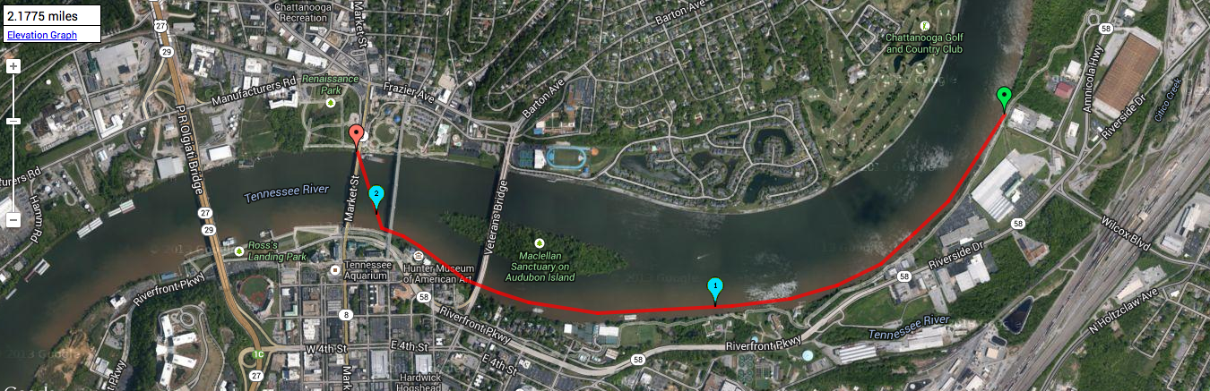
Updated:12/31/13 Safety Plan for Open Water

