LOCATION: Chattanooga, Tennessee in the Tennessee River in the Downtown Chattanooga Waterfront at Coolidge Park/Renaissance Park. The race will take place on Saturday May 17th, at 11:00 a.m. Visit Springhill Suites Marriot in downtown Chattanooga next to the river for discounted accommodations.
EVENTS:
Heat 1 is the Championship 2.4 Mile Race (No Wetsuits- Category I). Swimmers will complete two 1.2 mile laps. All swimmers must be annual USMS members.
Heat 2 is the Non-Championship 2.4 Mile Race (Wetsuits- Allowed Category II). Swimmers will complete two 1.2 mile laps. Swimmers may purchase the One-Event USMS Registration for $20 or be a full USMS member.
Heat 3 is the Non-Championship 1.2 Mile Race (Wetsuits Allowed- Category II) and will consist of 1 lap. Swimmers may purchase One-Event USMS Registration for $20 or be annual USMS members.

Temperature: The expected water temperature is between 68-72.
Start/Finish: Ankle deep run-in and out on a paved ramp.

ELIGIBILITY: Current USMS open water rules will govern this event. Open to all 2014 USMS Registered swimmers 18 years of age as of May 17, 2014 and those purchasing a One-event USMS Registration. All entrants must bring a copy of their USMS registration card to check in. FINA equivalent will be accepted for international swimmers. One-event USMS registration will be available for $20. USMS 2.4 Mile Open Water National Championship swimmers must be an annual member of USMS and may not use the One-Event option.

SAFETY OUR PRIMARY CONCERN: Safety boats, kayakers, and stand-up paddle boarders will monitor the course and medical personnel will be on-site. Swimmers must wear the swim cap provided for their distance until they exit the water via the finish chute, must display their race number and follow all announced safety rules without exception or will be banned from future events.

NOURISHMENT: A series of kayakers positioned on the inside perimeter of the racecourse in between the turn buoys will have water, energy drinks, and bananas in their kayaks to hand out to swimmers. Swimmers can wave their arms and yell “feeding” to signal a kayaker over at any point if they need a feeding. Swimmers can also swim up to a kayaker and ask for a feeding.
TIME LIMIT: If you can't complete 2.4 miles in 2 hours and 30 minutes or 1.2 miles in 1 hour and 15 minutes, we recommended for safety purposes that you do not enter this event. The course closes at 2:00 pm. Those who have not finished within the time limit will be removed from the course and scored as DNF (Did Not Finish).

QUESTIONS: Contact Karah Nazor, 423-488-3143 or karahnazor@gmail.com

WARNING: Participants should be adequately trained for competition. Experience swimming in cooler water (68-72 degrees) is strongly recommended, as is the ability to complete the distance within the time requirements. This course has upstream portions so having experience swimming against the current is recommended.

RULES: Current 2014 USMS rules will govern this event. Only Category I swimwear is allowed in the 2.4 mile event. (See Rules 303.7.1 & 303.7.2). Wetsuits may not be worn in the Championship Heat 1. Category I & II are allowed in heats 2 and 3. For a full list of rules visit: http://www.usms.org/rules/part3.pdf

REGISTRATION & FEES:
Before March 1, 2014: Early Entry Fee = $55, After March 1: Entry Fee = $65, After May 1: Entry Fee = $75.00. Entry Deadline for National Championship Heat: May 7, 2014. No entries will be accepted for the Championship heat after May 7, 2014. Entry Deadline for Heats 2 and 3: May 14, 2014. Entry fee includes a latex swim cap, custom event T-shirt, post-race pizza, and permits for government agencies and USMS Sanctioning. Please register early and online at https://www.edgereg.com/registration/splash/1059
Mailing address for paper entries: Print this documents, fill in, and mail to: Karah Nazor 1505 W 46th St. Chattanooga, TN 37409.
RESULTS: Preliminary results will available and awards presented per the posted schedule. Official results will be posted on usms.org, the event website (http://cowsswim.com/2014-usms-national-champion.html) , and USMSOpenWaterChampionship2014.edgereg.com in a timely manner.

AWARDS:
Championship Heat:
- 2014 USMS 2.4 Mile National Championship medals will be awarded to the top six finishers in each men/women age group (18-24, 25-29, 30-34, etc.) and special awards for the first overall USMS male/ female finisher. USMS Long Distance National Championship patches will be awarded to the first male and female finisher in each age group.

Non-Championship Heats:
- Prizes will be awarded to the top three finishers in each men/women age group (18-24, 25-29, 30-34, etc.).

REFUNDS: No refunds will be given. In the event of cancellation due to inclement weather (high winds/lightening) or conditions beyond our control no refunds will be given.

SCHEDULE: Packet Pick up: Friday May 16th from 6-7:30 p.m. at Outdoor Chattanooga. Requested for participants to alleviate race day congestion.

May 17 | Race Day Timeline
9:00 a.m. | Check In Opens Swimmers and Pilots
9:30-10:15 a.m. | Warm-Up
9:50 a.m. | Mandatory Pilot Safety Briefing at Command Center
10:20 a.m. | Pilots Enter Water
10:30 a.m. | Mandatory Swimmer Safety Briefing
10:40 a.m. | Swimmers in all Heats Line up at Water’s Edge
11:00 a.m. | Race Start for Championship Heat 1, 2.4 Mile
11:15 a.m. | Race Start for Non-Championship Heat 2, 2.4 Mile
11:25 a.m. | Race Start for Non-Championship Heat 3, 1.2 Mile
2:30 p.m. | Awards Ceremony

Top of Form
Bottom of Form

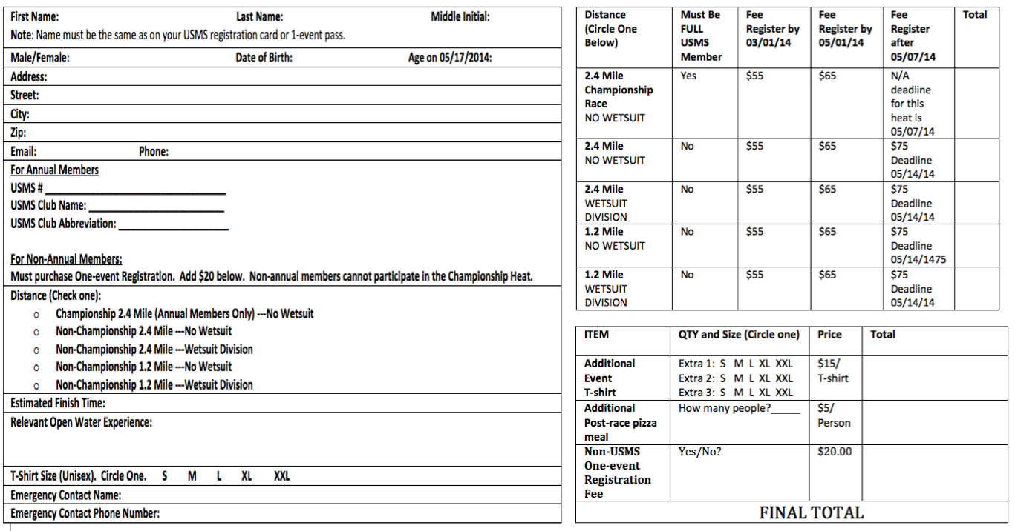

Liability Release
A signature and date are required.

PLEASE READ CAREFULLY BEFORE SIGNING ACKNOWLEDGMENT, WAIVER and RELEASE FROM LIABILITY (AWRL)
I, the undersigned participant, intending to be legally bound, hereby certify that I am physically fit and have not been otherwise informed by a physician. I acknowledge that I am aware of all the risks inherent in Masters swimming (training and competition), including possible permanent disability or death, and agree to assume all of those risks. AS A CONDITION OF MY PARTICIPATION IN THE MASTERS SWIMMING PROGRAM OR ANY ACTIVITIES INCIDENT THERETO, I HEREBY WAIVE ANY AND ALL RIGHTS TO CLAIMS FOR LOSS OR DAMAGES, INCLUDING ALL CLAIMS FOR LOSS OR DAMAGES CAUSED BY THE NEGLIGENCE, ACTIVE OR PASSIVE, OF THE FOLLOWING: UNITED STATES MASTERS SWIMMING, INC., THE LOCAL MASTERS SWIMMING COMMITTEES, THE CLUBS, HOST FACILITIES, MEET SPONSORS, MEET COMMITTEES, OR ANY INDIVIDUALS OFFICIATING AT THE MEETS OR SUPERVISING SUCH ACTIVITIES. In addition, I agree to abide by and be governed by the rules of USMS. Finally, I specifically acknowledge that I am aware of all the risks inherent in open water swimming, and agree to assume those risks. (rule book article 203.1)

PRINTED NAME_________________________________________________________ Age ___________________________

SIGNATURE_____________________________________________________________ Date __________________________

