The Jesse Coon Memorial Invitational Swim Meet 2014/Masters of Brazos Short Course Entry Form
Sanctioned by the Gulf Masters Swim Committee for USMS, Inc. Number ( )
(Please Print Name Exactly as it appears on your USMS card) No One will be allowed to swim without a current USMS #
LAST Name: __________________________ FIRST Name: __________________________USMS #: ____________________

Birthdate: _____________Team Name ___________________Team Abbreviation (5 letters max): _________ LMSC________

Swimmer’s Age as of 1/25/14: _______ Sex (circle): Male Female Is childcare needed? (circle): yes no

Address: ___________________________________ City: _______________________ State: ______ Zip: _________________

Home Phone #: _______________________Work Phone #: ______________________E-mail: __________________________

EVENT SCHEDULE
Circle the numbers of the events you wish to enter. Please list your seed times in the blanks as male or female (mixed may be used in relays.) Enter NT for no time. A maximum of 5 individual events may be entered, excluding relays. Swimmers will be grouped by times, but different sexes will be scored separately.

# Event Seed Times # Event Seed Times
Male Female Male Female
1 500 Free ___:___.__ ___:___.__ 11 100 IM ___:___.__ ___:___.__
2 200 Back ___:___.__ ___:___.__ 12 200 Free ___:___.__ ___:___.__
3 200 IM ___:___.__ ___:___.__ 13 200 Fly ___:___.__ ___:___.__
4 100 Breast ___:___.__ ___:___.__ 14 100 Back ___:___.__ ___:___.__
5 Medley Relays-400 ___:___.__ ___:___.__ 15 Freestyle Relays-800 ___:___.__ ___:___.__
Relay age __________ Mixed ___:___.__ Relay age __________ Mixed ___:___.__

6 100 Free ___:___.__ ___:___.__ 16 50 Free ___:___.__ ___:___.__
7 50 Back ___:___.__ ___:___.__ 17 200 Breast ___:___.__ ___:___.__
8 100 Fry ___:___.__ ___:___.__ 18 400 IM ___:___.__ ___:___.__
9 50 Breast ___:___.__ ___:___.__ 19 50 Fly ___:___.__ ___:___.__
10 Freestyle Relays-400 ___:___.__ ___:___.__ 20 Freestyle Relays-200 ___:___.__ ___:___.__
Relay age ____________Mixed ___:___.__ or Medley Relays-200 Relay age _______Mixed ___:___.__ 21 1000 Free (if demanded)___:___.__
22 1650 Free (if demanded)___:___.__

Entry Fee: Entries postmarked by January 18, 2014 $30
All late entries (postmarked after January 18th) $45

*Make checks payable to AEROFIT HEALTH & FITNESS CENTER. Mail entry form, photocopy of current USMS Registration and check to: Swim Meet, Aerofit Health and Fitness Center, 1900 W. Villa Maria Rd., Bryan, TX 77807

Liability Waiver: I, the undersigned participant, intending to be legally bound, hereby certify that I am physically fit and have not been otherwise informed by a physician. I acknowledge that I am aware of all the risks inherent in Masters Swimming (training and competition), including possible permanent disability or death, and agree to assume all of those risks. AS A CONDITION OF MY PARTICIPATION IN THE MASTERS SWIMMING PROGRAM OR ANY ACTIVITIES INCIDENT THERETO, I HEREBY WAIVE ANY AND ALL RIGHTS TO CLAIMS FOR LOSS OR DAMAGES, INCLUDING ALL CLAIMS FOR LOSS OR DAMAGES CAUSED BY THE NEGLIGENCE, ACTIVE OR PASSIVE, OF THE FOLLOWING: UNITED STATES MASTERS SWIMMING, INC., THE LOCAL MASTERS SWIMMING COMMITTEES, THE CLUBS, HOST FACILITIES, MEET SPONSORS, MEET COMMITTEES, OR ANY INDIVIDUALS OFFICIATING AT THE MEETS OR SUPERVISING SUCH ACTIVITIES. In addition, I agree to abide by and be governed by the rules of USMS. (rule book article 203.1)

Signature: ___________________________________________ Date: ___________________________

Please staple a photocopy of USMS registration here. No pending entries will be accepted. All swimmers must send a photocopy of their USMS card in order to participate!

The Jesse Coon Memorial Invitational Swim Meet 2014/Masters of Brazos Short Course

DATE: Saturday, January 25, 2014. Desk check-in and warm up begins at 9:30 am. Entries will end at 10:30 am. The meet
starts at 11:00 am. Relay cards must be in 30 minutes prior to the event.

ENTRY: Postmarked by January 25, 2014, $30. All late (postmarked after January 18, 2014) and Deck entries, $45.00.

FACILITIES: Eight lane, 25-yard indoor pool with regulation starting blocks. Two lanes reserved for warm up and cool
down. Locker/ shower facilities. Childcare is available for participants at $5.00 per child per hour. Ages: 2 months to 8 years. Please bring a lawn chair, we have very limited seating.

LOCATION: Aerofit Health & Fitness Center is located at 1900 W. Villa Maria, (Villa Maria is 7.5 miles from highway 6)
1/4 mile west of FM 2818 ( Harvey Mitchell Pkwy). See map below.

SPONSORS: The Masters of Brazos and Aerofit Health & Fitness Center

SANCTION: Sanctioned by Gulf Master’s Swim Committee for USMS, Inc. Number ( )

ELIGIBILITY: Open to all registered US Masters Swimmers, ages 18 and over who include a copy of their USMS
registration card. (New swimmers registering must email Henry Clark(clark@comp.tamu.edu)a copy of their card or bring a copy of the card to the meet. No one will be allowed to swim without a current USMS number.)

MEET ENTRY: Complete the attached entry form. A maximum of 5 individual events may be entered, excluding relays.

AWARDS: Participation awards will be given to all entrants, and medal awards will be provided for first through third place
high point earners in each USMS age/sex group. Deck entries will not be eligible for high awards. Relays do not earn points.

CONDUCT OF MEET: Event heats will be seeded by entry time (not by sex or age), and started slowest to fastest. All deck
entries will not earn points and will be seeded with a NT USMS Short Course Rules will govern the meet. Hand held watches
will be used for timing, official times will be determined according to USMS Rules and the meet will be reported to the Gulf
sanction chairperson for official top ten times.

MEET REFEREE: Felipe Zambrano

HOSPITALITY: Free fruit will be available at poolside for meet entrants.

SOCIAL: The social will be at Johnny Carino’s on Hwy 30 immediately after the meet.

QUESTIONS: Contact Judy Wagner at (979) 690-1123 (H); (979) 209-7396 (O) judybwagner@hotmail.com or
Kathy Langlotz at Aerofit (979) 823-0971or Traci Ombrello ext.105 at Aerofit.

HOUSING: Hotel rooms ($65) available at Quality Inn & Suites, 1027 N. Earl Rudder Freeway (HWY 6), Bryan, Texas77802
For Reservations call (979-703-8979) ask for Jesse Coon Aerofit Swim Meet Make Reservations before Jan. 7th.
* Results may be accessed on the web at “http://www.gulfmastersswimming.org”.
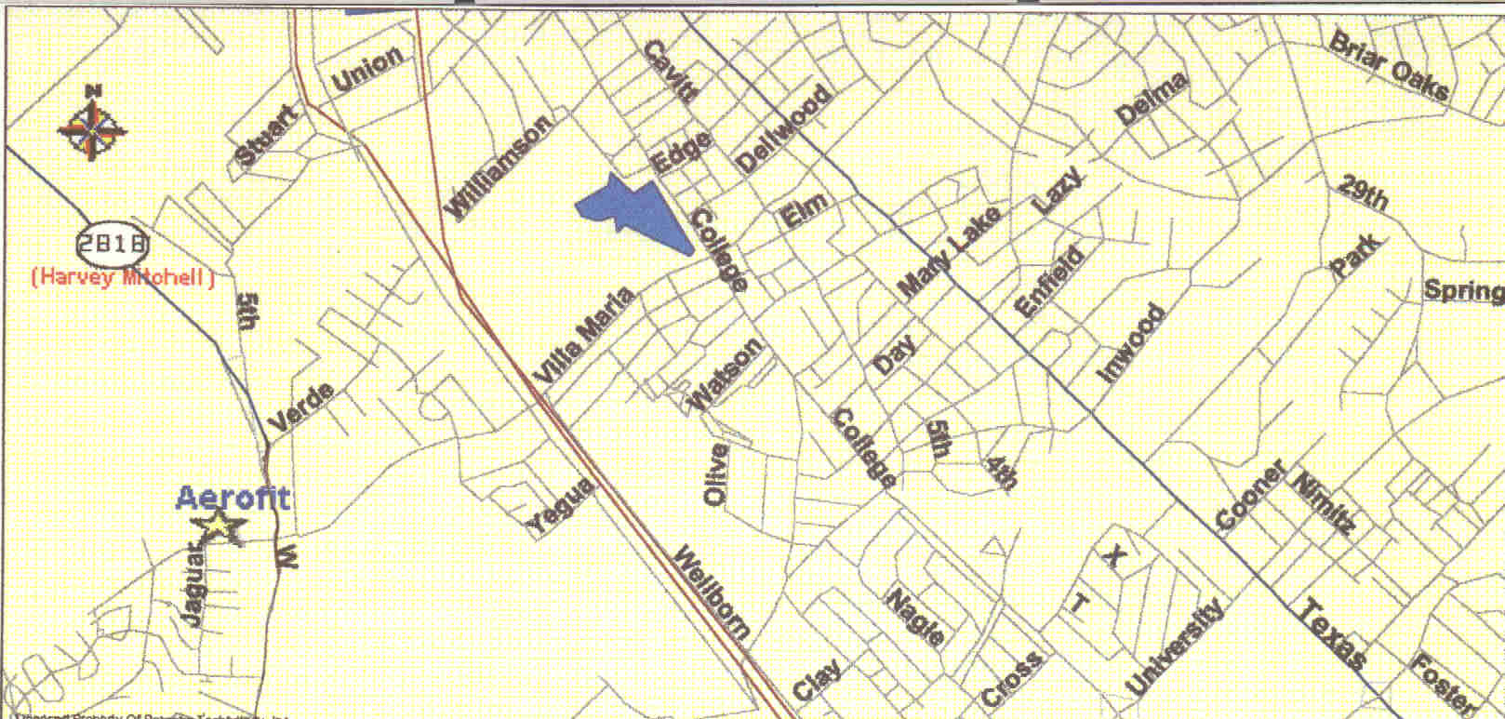

AEROFIT HEALTH & FITNESS CENTER 1900 W. Villa Maria Bryan, TX 77807 (979) 823-0971

