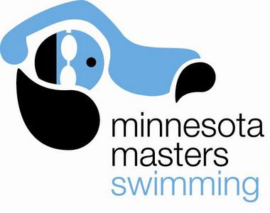 | Minnesota Masters  2013 Throwback Meet  Burnsville High School  Saturday, December 7, 2013 | 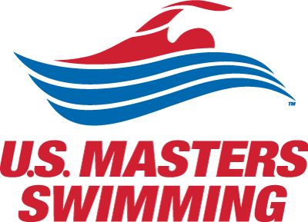

Schedule: Warm-ups – 12:30pm- 1:45pm Sanction #TBD
Meet – 2:00pm – 5:00pm

Meet Director Andrew Michelson (amichelson10@gmail.com)

Entry information You must be USMS registered to participate ($46 annual fee or $15 “one event” fee)

$10 meet fee for “early bird” registration on or before Sunday November 16
$15 meet fee advance registration on or before Wednesday December 4
$20 meet fee deck entry day of meet

ENTRIES CLOSE 30 minutes prior to Meet Start Time. Entry fees are non-refundable.

Register online at https://www.clubassistant.com/club/meet_information.cfm?c=1156&smid=4963
Paper entry form also available – contact Meet Director for more information
Maximum of 5 individual events per entry. Positive check in required for all events 400 yards and longer.

Relays: There will be a 5 minute break before each relay event – relay entries will be accepted through the start of the break before each relay. All relays must complete a relay entry card complete with first and last name and age of each swimmer. Each card must be completed completely with club name (all 4 members must be registered with that club), circle the distance and type of relay.

Results: Will be posted at the meet and on line at www.minnesotamasters.com within one week.

Event Number | Event | Entry Time |  | Event Number | Event | Entry Time
1 | 200y Medley Relay* | deck entry |  | 7 | 500y Freestyle | ___:____.____
2 | 200y Freestyle | ___:____.____ |  | 8 | 200y Free Relay* | deck entry
3 | 200y IM | ___:____.____ |  | 9 | 100y Backstroke | ___:____.____
4 | 50y Freestyle | ___:____.____ |  | 10 | 100y Breaststroke | ___:____.____
5 | 100y Butterfly | ___:____.____ |  | 11 | 400y Free Relay* | deck entry
6 | 100y Freestyle | ___:____.____ |  | 12 | 1000 Freestyle* | deck entry
* 200y Medley Relay, 200y Free Relay and 400y Free Relay will be seeded based on entries received on race day. |  |  |  | * 1000y Freestyle require positive check-in on race day

Print Name: ____________________________ Male Female USMS #: _______-________

Birthdate: ___/___/___ Age: ____ Club: ___________________ Phone: _____-_____-_______
I, the undersigned participant, intending to be legally bound, hereby certify that I am physically fit and have not been otherwise informed by a physician. I acknowledge that I am aware of all the risks inherent in Masters swimming (training and competition), including possible permanent disability or death, and agree to assume all of those risks. AS A CONDITION OF MY PARTICIPATION IN THE MASTERS SWIMMING PROGRAM OR ANY ACTIVITIES INCIDENT THERETO, I HEREBY WAIVE ANY AND ALL RIGHTS TO CLAIMS FOR LOSS OR DAMAGES, INCLUDING ALL CLAIMS FOR LOSS OR DAMAGES CAUSED BY THE NEGLIGENCE, ACTIVE OR PASSIVE, OF THE FOLLOWING: UNITED STATES MASTERS SWIMMING, INC., THE LOCAL MASTERS SWIMMING COMMITTEES, THE CLUBS, HOST FACILITIES, MEET SPONSORS, MEET COMMITTEES, OR ANY INDIVIDUALS OFFICIATING AT THE MEETS OR SUPERVISING SUCH ACTIVITIES. In addition, I agree to abide by and be governed by the rules of USMS. (rule book article 203.1)

Please Sign: ____________________________________________ Date: _________________

