The 5th Annual NCAM "Fall Brawl" Masters Meet
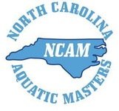 | Sunday, November 3, 2013  USMS Sanction: pending  North Carolina Aquatic Masters  Swim Meet Registration | 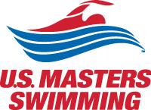

Registration Schedule
It is now 2:00 PM EDT on Sunday, September 29, 2013.
 | Open | Close
Swimmer Registration | Fri, September 27, 2013 12:00 AM EDT | Tue, October 29, 2013 11:59 PM EDT
Online Registration is in 'Build' Mode.
More Information Coming Soon...

Date: Sunday, November 3, 2013
Location: Koury Natatorium, UNC Campus
Warm-Ups: Warm-Ups for the 1650s at 9:00am, Start the meet at 10:00am
Warm-Ups for all other events at 10:00am, event 3 start time of 11:00am
Events:
1/2 1650-yard Free
3/4 100 IM
5/6 500 Free
7/8 100 Back
9/10 200 Mixed Free Relay
- 10-minute break -
11/12 200 Free
13/14 100 Breast
15/16 100 Free
17/18 200 Mixed Medley Relay
- 10-minute break -
19/20 200 Back, Fly or Breast (declare on meet day which stroke you will be swimming)
21/22 50 Free
23/24 100 Fly
25/26 400 Mixed Free Relay
Sponsor: North Carolina Aquatic Club
Eligibility: swimmers but be registered members of U.S. Masters Swimming for 2013 or 2014.
Meet Registration: Online registration only. Online entries are paid by credit card to ClubAssistant.com Events.
Entry Limits: maximum of 5 individual entries per person
Fees: $3 per individual event; $15 per athlete facility surcharge
Meet Director: Britton Banning-Arndt, britton1185@gmail.com
Please note: If paying by credit card, your credit card statement will reflect a charge from "ClubAssistant.com Events."

