

**2013 42nd Maui Channel Swim**

**9.5-mile Channel Crossing Relay**

**Saturday, August, 31, 2013, Labor Day Weekend**

**Lanai (club Lanai Pier) to Kaanapali (Black Rock) Maui, HI**





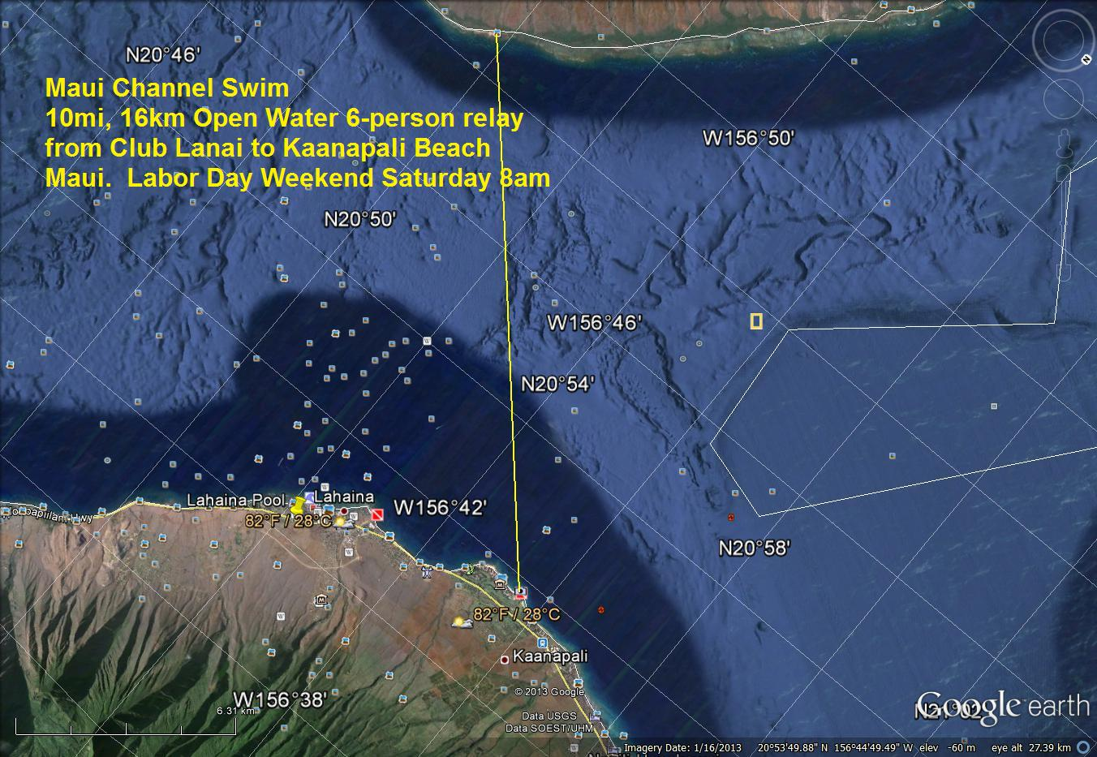

|  |
| --- |
| 10 Mile, 16km course  6-person relay. Each swimmer swims 30 minutes ONCE, then rotates through 10-minute swims until complete or 7 hours have passed. |

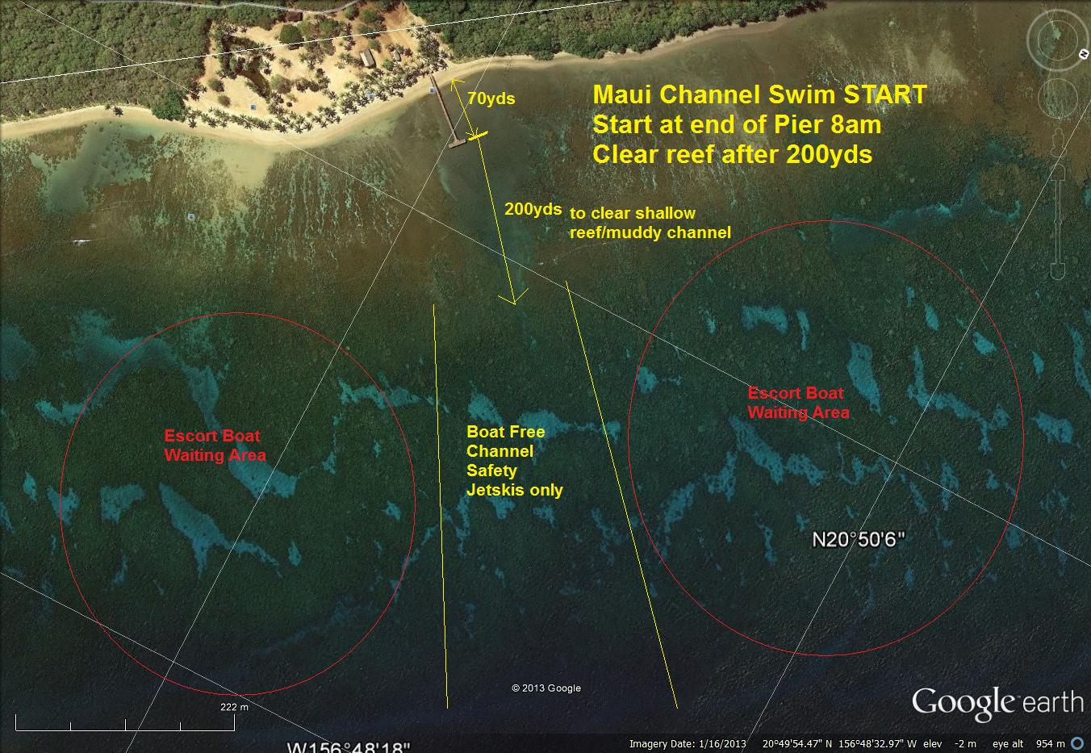

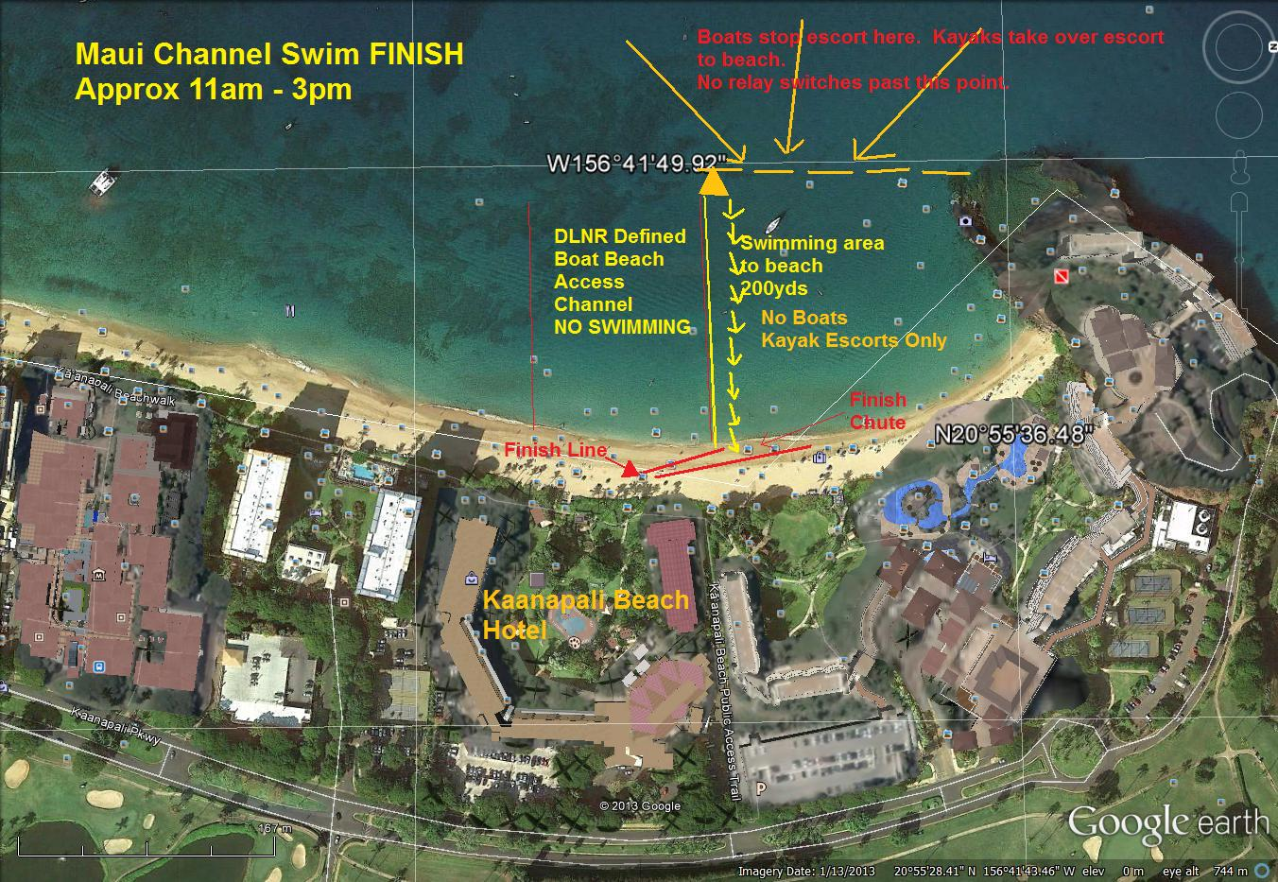

**Event and Safety Plan**

**Scope and Overview**

This plan describes the safety plan taken by race management to make sure the race meets sanction requirements from USMS, and that logistics are in place for ALL members of all teams are safe throughout the race – and that the race is fair.

To do this, in addition to this safety plan, an EXTENSIVE Race “Notice” is prepared with specific information about safety and how each escort boat has the responsibility to be the safety marshals for their swimmers.

**Event and Safety Plan**

**Race Plan:**

* **Hawaii Masters Swimming Association**
* **The race is a 6-person relay from The beach/pier at Club Lanai on Lanai to the beach at Black Rock in Kaanapali on Maui.**
* **Each swimmer's first leg is 30 minutes until all 6 swimmers have completed one leg of the race. Succeeding legs are 10 minutes per person, keeping the same swim order, except for the Ka’anapali Beach finish leg. For the final leg, if the swimmer has passed or is close to the final orange buoy and has reached the end of their 30-minute or 10-minute leg, the team captain may elect to have this swimmer complete the race. NO CHANGES, and no boat escort/traffic is allowed inside the final buoy.**
* **All teams MUST be escorted by a boat, insured to $1M, legal to carry passengers with all required safety equipment, with a licensed captain at the helm (who is the safety officer responsible for all swimmers in the water), and either an Inboard motor OR a Prop Guard for Outboard or Inboard/Outboard motors throughout the race.**
  + **The boat captain must also be separately named to be insured – not just the boat.**
  + **The boat captain must meet at the captain’s meeting or with the race director before the race for a meeting at an agreed on location to discuss race safety, responsibilities, logistics and more.**
  + **Each boat must have a basic first aid kit capable of taking care of basic first aid including abrasions, cuts, broken limbs, etc.**
  + **Proof of boat and captain’s insurance must be provided 24 hours before the race to the race referee for inspection. The captain and boat must show separate certificates of insurance – one for the boat, one for the captain.**
  + **All boats will be individually inspected immediately prior to the race regarding inboard or prop guard boat determination.**
* **The water is open ocean (saltwater) 10 mile/16 km course from Lanai to Maui.**
  + **The first 200m is out a narrow channel in water clarity that varies based on recent swells in murkines, clearing by 2-400 yards to crystal clear water.**
  + **The middle of the channel water conditions vary depending on winds (not much on tides) from smooth to choppy with small waves, usually building to large swells/seas of 6-10 feet in the center channel. Staying to the “right”/south of the wind line (blocked by West Maui Mountains) makes for much smoother water. The course is designed such that the West Maui Mountains block the prevailing trade winds that build during the morning (causing rougher seas) wrapping around and closing in behind the competitors as they swim to Kaanapali.**
  + **The last part of the course (last mile) coming in to Black Rock the swells drop, but north wind and (usually strong northern current) make for usually choppy waters until the last 300 yards is an unescorted swim in clear water shielded from most wind by Black Rock to a run up the beach to the finish line approx. 50 yards.**
* **The pre-race staging:**
  + **There is a “captain’s meeting” at 5pm, August 30, 2013 on the grass at the Kaanapali Beach Hotel. This is a mandatory meeting for all boat captains, and all Team captains; and strongly encouraged for all other team members.**
  + **There’s a pre-race meeting for lead-swimmers only on the beach at 7:45am – 15 minutes before race start – below high-water line at Club Lanai. Teams will be counted, swim caps & suits inspected, numbers verified on swimmers, and any final instructions given to swimmers.**
  + **All boats will be inspected by race officials right before the start of the race.**
* **The event will be sanctioned by USMS. All swimmers MUST be registered with USMS or a USMS-recognized FINA masters organization.**
* **Because of rule changes, including the requirement for for prop-guards, we’re expecting between 10 and 25 teams to participate.**

**Key Personnel**:

* **Race Director – Ian Emberson 652-4740**
* **Officials Boat – captain Joe Reicht 658-0116**
* **Course Advisor – Malcolm Cooper 280-4257**
* **Independent Safety Officer – TBD.**
* **Meet Referee – Sandy Drake, Maui Dolphins Swim Club; HI Swimming Official’s Chair. 298-8091**
* **Safety Officer – Malcolm Cooper 280-4257**
* **On-course Jetski setup and course monitoring – Grant Henry 870-4922**
* **Timer Carol Emberson 639-1109**
* **Radio VHF 71**
* **Coast Guard – Channel 16**
* **Ambulance. AMR posts ambulances roaming on the west side. There’s no way to know the best place to post (Kaanapali Beach Hotel close to finish, Mala Wharf typically fastest if mid-channel), Other … dependent on the boat captain.**

**General Meetings**:

**4:30pm, Saturday, August 31st – Kaanapali Beach Hotel. Mandatory Team & Boat Captain meeting. Highlight the following:**

* **For each team, the BOAT CAPTAIN is the SAFETY OFFICER responsible for each team’s safety from when they “pick up swimmer”, through the last swimmer dropped at the beach.**
* **All boats must have proper liability insurance (minimum $1 million), and show same 24 hours before the race.**
* **The boat must be operated by a licensed captain who must show separate proof of insurance.**
* **All Outboard and Inboard/outboard boats must have properly installed prop guards. (This will be inspected before race start by a race official.)**
* **Each boat must have a basic first aid kit.**
* **All engine propellers must be disengaged or off when any swimmers are within 20 feet of the boat. (Turning off engines risks difficulty starting leaving swimmers moving ahead too far from the escort boat).**
* **There will be 3 jetski’s available on the radio to help with relaying issues, locating a swimmer if necessary, transport someone quickly, checking for safety issues on boats. (The jetski’s are volunteer with certifications to use with rescue sled; proof of insurance on the sled must be provided to the race director 24 hours before the race.)**
* **There will be a race official that can get to a boat to relieve it, or take the passengers if a boat becomes disabled or not seaworthy.**
* **At the start, boats must leave a 100yd wide channel (patrolled by jetski) while spotting their swimmers for 20 minutes. (This gives time for swimmers to spread out in space, leaving room for boats without endangering swimmers.)**
* **The lead off swimmer MUST wear a bright color swim cap with their race number large and very legible.**
* **If ANY BOAT or TEAM decides to leave the race for whatever reason, they MUST notify the Finish Line by radio.**
* **DLNR has defined an area where boats may enter the beach area to pick up/drop off swimmers for ~100yds SOUTH of a buoy off Black-Rock. NO SWIMMING in this area.**
* **There will be an Orange Tetrahedral buoy 200yds off shore at the finish approx. 200yds south of Black Rock. Swimmers MUST swim between this buoy and Black Rock. Another round buoy will be near shore marking the line where no boats may enter … swimmers must stay in this area.**
* **Swimmers will be escorted by kayak from the tetrahedral buoy in to land. NO BOATS are allowed in this area (which is also a no-boating area demarked by DLNR). 3 kayaks will rotating through as needed when swimmers arrive at the last 200 yards to the beach inside the orange buoy.**
* **Each boat must display the Team Number on the side of the boat.**
* **This race is conducted in the open ocean, without immediate access to emergency health care. While every effort will be made to assist getting emergency care to a boat ASAP, boats must be prepared for normal emergencies.**
* **This race is conducted in the open ocean with all associated hazards:**
  + **6-10ft (2-3m) waves with occasional larger waves or sets of waves (swell) in the middle of the channel. These waves will break – especially in windier conditions – near the crest.**
  + **Intense Tropical Sunlight for 3+ hours (beware and be prepared to deal with sunstroke, heat stroke, heat exhaustion, sunburn, dehydration).**
  + **Sea-Life. Turtles, Jellyfish, Man-O-War, Dolphins, and Sharks have all been seen during this race various years at various times.**
    - **Jellyfish (and manowar) can be encountered while swimming. It is common on a long swim center channel to have areas where “bits” of jellyfish or manowar tentacles (and their nematocysts) can give little stings or “wrap” a piece around an arm, leg, body … or face. The pain typically dissipates with time. Do NOT rub it (fires off more nematocysts increasing sting). Treatment is similar to “Box Jellyfish” below.**
    - **BOX Jellyfish … are a particular hazard – and significantly more painful and dangerous. Peaking 8-10 days after full moon – in 2013 August 29-31. While Box jellyfish are most prevalent on Oahu (Waikiki), they can be in the open ocean. They normally settle in to deep water as the sun rises … but some can remain near the surface. “**The tentacles of jellies and their relative, the Portuguese man-of-war, are lined with microscopic stinging cells (nematocysts) that are activated by touch or chemical cues. Each cell fires a barbed thread that can penetrate the skin and deliver toxin that causes a burning sensation and, sometimes, more severe reactions. Many lifeguards and doctors recommend rinsing the area with seawater, then applying a paste of unseasoned meat tenderizer and vinegar to the sting—this helps deactivate the toxin. However, sensitivity varies from individual to individual; some may be highly allergic to jellyfish or man-of-war stings or even to the treatment listed here and need physician’s care. Use this treatment at your own risk, and consult your physician in all cases.”
    - **Sharks. There are many types of sharks. Near shore 4-6’ reef sharks (Black Tip, White Tip) are not uncommon usually roaming near the bottom. In the center channel larger (10-20’) sharks can be encountered. It is up to the swimmer and captain to determine if and when waters are safe if a shark is encountered. (N.B.; If leaving the water waiting for a shark (or your boat) to leave the area, boats may move parallel to the finish line only or face disqualification).**

**Race Day (Saturday August 31 ~8am start)**

**7:00-7:50am – Club Lanai – Boat Arrival.**

* **Each Boat Checks in by Radio with “lead/officials” boat.**
* **Prior to the race, Jetski’s take safety rep to each boat to inspect for properly installed Prop guard for all outboard and inboard/outboard escort vessels.**
* **7:50am Send lead-off swimmer to beach**
* **7:55am Non-lead-off swimmers warming up back to boats**
* **7:50-8:00am Final Instructions to lead swimmers. Check-in number of swimmers. Verify caps and suits meet regulations.**
* Walk swimmers out to starting line at end of pier.

**8:00am (approximately) – Race Start in waist deep water.**

**8:00am-Finish: Every 30 minutes for 6 cycles (3 hours), then every 10 minutes, swimmers have +/-30 second window for relay exchange (TAG).**

**11:00am (estimate) – first relay team completes race.**

**3:00pm. All relays MUST be completed by this time. Relays failing to do so will be disqualified and their times NOT recorded in race results. Any boat in this situation will be notified by the Finish Line personnel by Radio.**

**AWARDS will be given out at Dinner on the grass at Kaanapali Beach Hotel Saturday evening 6:00pm.**

**Venue Plan**:

* **The venue is the ‘Au’Au Channel one way from Lanai to Maui (Club Lanai dock to Kaanapali Beach by Black Rock).**

**Warm-Up and Start.**

* **Warm-ups for all swimmers are in the reef area just offshore. Anchored boats and jetskis serve as lifeguards and safety officers in this area.**
* **The start will be in waist deep water approx 70yd off shore east side of the dock in the channel. A red flag will mark 1-minute to start. A horn and green flag will be sounded and dropped at the start.**

1. **Expected Race Day Climactic Parameters** 
   1. **Expected Water Temperature – 77-79F**
   2. **Expected Air Temperature – 80-85F**
   3. **Sun – Expect mostly clear skis – all participants and officials should wear sunscreen and cover up as much as possible.**
   4. **Expected Wind – Probable trade winds LIGHT from the north at the start. Trades build and wrap around West Maui Mountains towards Lahaina as the race continues.**
   5. **Sea Life – This is a Hawaii open ocean salt water close-to-shore environment. Near shore, It is virtually certain that small fish 1” to 18” will be seen by competitors; possibly turtles 2-5 head-to-tail in length.**
      1. **It is possible but unlikely that swimmers will see manta rays, eagle rays, eels, or black/white tip reef sharks. (Reef sharks normally only in the reefs.)**
      2. **It is also possible althought unlikely a boat or boats will encounter tiger sharks in the channel, but they are there.**
      3. **Man-o-war and Box Jellyfish. Man-o-war pieces can accumulate if there are south or southwest (aka Kona) winds. These can be tiny pieces or longer strands that can “wrap”. You’ll feel these like small stings or a line of stings around an arm. If allergic to bee-stings, and you feel any issue with difficulty breathing, flag for help. BOX JELLYFISH are a strong and dangerous jellyfish that show up 10-12 days after full moon and generally head back to deeper waters after sunrise. Some can be “caught” near shore. Waikiki is notorious for large infestations of box jellyfish every month peaking 10-11 days after full moon. Maui occasionally see a few. We will monitor for box jellys.**
   6. **Tides – Starting ~0.1ft above avg, rising to ~1ft by end of competition.**
   7. **Water Clarity – dependent on recent swell, wind and rain. Typical clarity is poor within 200yds of Lanai, clear (70-100ft or more) the rest of the way.**
2. **Administration** 
   1. **Pre Race meeting Friday night to discuss all safety and race issues 5pm at Kaanapali Beach Hotel on the grass.**
   2. **Pre-Race (morning of swim) inspection of boats before start for prop guards.**
   3. **Pre-Race (morning of swim) meeting with lead-off swimmers on the beach at Club Lanai … includes Athlete Check, Suit Inspection, Athletes Numbering, Swim Cap Issue.**
   4. **Spectators may observe from any boats at discretion of boat captain as long as sufficient safety material (life jackets) are aboard. The beach at Kaanapali is open and spectators are welcome to observe finish from there.**
   5. **Communication during the race is by radio to all boats that should be monitoring throughout the race.**
3. **Facilities**
   1. **Toilets – available at the hotel … and whatever facilities are available on each teams’ escort boat.**
   2. **Showers – outdoor open showers to rinse.**
4. **Water quality in the ocean in this area is monitored by the State Health department. No special testing is required.**
5. **Parking**
   1. **Available at Kaanapali Beach Hotel. There is a fee for parking both for hotel guests and visitors.**

**Safety During the Race:**

**Boats Independent for safety in the channel:**

1. **Each Team is escorted by an insured boat captained by a licensed captain responsible for the safety of his/her passengers – including having a boat in proper condition to carry passengers with all the required safety equipment; and any passenger beside the boat that is swimming.**
2. **Boat captains are instructed pre-race of their responsibilities, the communication on VHF Channel 71, and if necessary to contact Coast Guard Channel 16.**
3. **In an emergency, boat captains cal call 911 or coast guard channel. (911 can help guide the boat to the quickest/best place to meet an ambulance if needed.)**
4. **Boats can also call to a jetski water patrol … below.**

**Rescue Jetski(s)**

1. **Jetski’s are provided with licensed operators and sleds to provide a water patrol rendering aid to vessels and swimmers as needed. The patrol is coordinated by Grant Henry 808-870-4922 … and will also be monitoring VHF Channel 71.**
2. **Jetskis will also provide the coordination in the start channel protecting swimmers until they are “picked up” by their boats.**
3. **At least one jetski will be in the last 200yds area to assist kayaks if necessary when boats are in the finish zone.**

**Finish Kayak Escorts**

**Kayaks and stand-up paddle boards will be provided from the orange buoy to the beach over the last 200yds of the course where boats can’t go and while the jetskis are monitoring the competitors still out on the course. One jetski will stay in the same area when boats are there.**

**Course Officials**

**Course officials including the race director will be on an “officials boat” with contact cell (808)652-4740 or via VHF Channel 71.**

**Other course officials will also be on this boat or others. Some will inspect boats for proper prop guards pre-race.**

**Finish timing official will be on the beach. Race Referee will station herself where she believes most effective (start and finish?)**

**Weather Contingencies**

**Most weather conditions will not require cancelling of the race. But they are listed here…**

* **Strong current – current is typically north to south through the channel getting stronger near shore. Captains and Teams are informed about this and try to anticipate a finish that “flows” into the finish line.**
* **High Surf – High surf is a rarity and only a dangerous concern near shore. If necessary, the start can be moved away from land. High surf at the finish is even more rare. If surf does exist, the kayak escort will help swimmers time the finish into the beach.**
* **Murky Waters (from run-off or surf) – the water is often a bit murky for the first 2-300 yards then clears up to the beach at the finish.**
* **High Winds – if winds reach a point to make chop unsafe for the boats … or swimmers are unsafe getting in and out of their boats, the boat captain has the right and responsibility to remove his swimmers from the race. If a swimmer is too weak to continue in heavy seas due to high winds, the boat or team captain will bring him/her in.**
* **Hurricane – The race will be cancelled and evacuated following directions from County officials in case of Hurricane. If a hurricane is passing nearby causing expected strong or unusual currents Ocean Safety considers dangerous, the race may be cancelled or adjusted for safety.**
* **Tsunami – The race will be cancelled and evacuated following directions from State and County officials in case of Tsunami.**
* **Lightning or dangerous conditions at sea … the boat captain is responsible for the safety of his passengers and will pull swimmers out of the water and get to safety away from unsafe conditions as best he/she can.**

**Closing the Course**

* **Lightning or dangerous conditions during the event – As determined by Race Director, Safety Director and Head Referee the course will be cleared. A “CLEAR THE COURSE” call will be made with a series of 3 long blasts on air horns or whistles, waving of the Yellow Flags as well as announced over all radios from the Command Center. Swimmers will head directly into shore area, and seek immediate shelter, closest to their shore arrival. Immediately as soon as conditions are acceptable, ALL competitors should seek any meet official, and inform them of their safe arrival to shore. All boats are to remain on the course until ALL swimmers have made it to shore or picked up by any of the course, safety and officials boats. Any boat that picks up a swimmer should immediately notify race officials through the Command Center, with the name/number of their athlete. A complete race will be determined by the rules of USA Swimming. If the race is ruled incomplete, the day and time of the restarted race will be determined by the Head Referee, Race Committee and Race Director.**

**Course Evacuation Plan**

**2013 Plan:**

**The following priority will occur in this order, if the Safety Officer, Meet Referee, or Meet Director becomes aware of any situation requiring abandonment (including inclement weather).**

**1. Radio Communication to Officials and Safety Personnel on Course.**

**2. All Lifeguards issue a 3 loud short blast whistle command, and instruct all swimmers to evacuate the course.**

**3. Announcer instructs all swimmers, safety personnel, and Officials, to exit the course. If the reason for abandonment is inclement weather, announcer will instruct all athletes, coaches, parents, and meet personnel to go to the shelter, team bus, or vehicles, until inclement weather passes.**

**4. Everyone will be instructed to go to vehicles, until safe conditions return.**