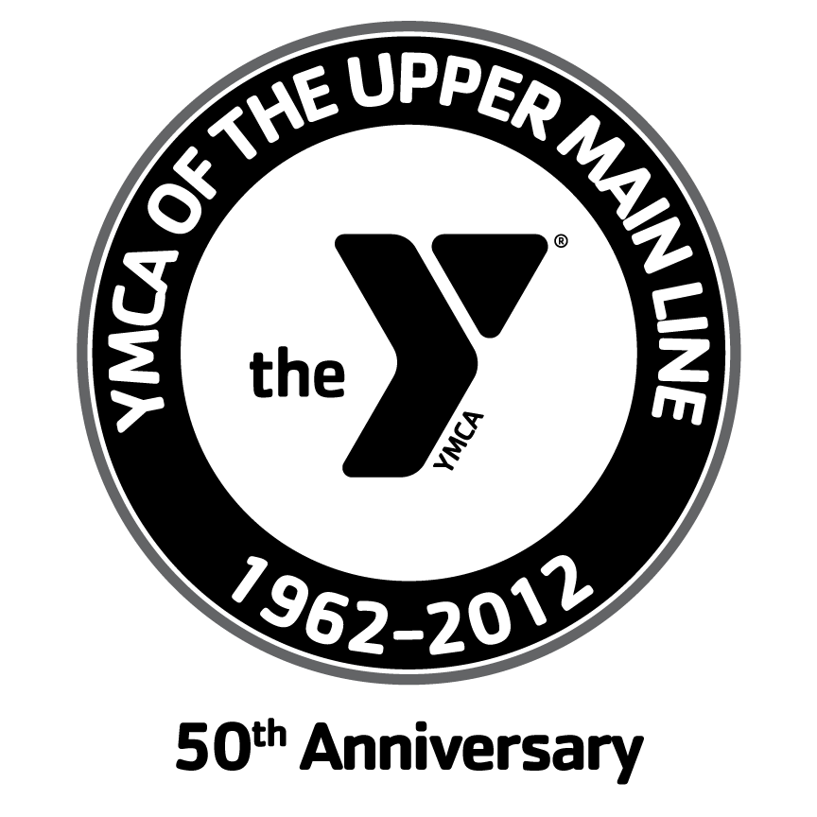


2013 Merryman SCY Swim Meet

Sponsored by: Upper Main Line YMCA and Delaware Valley Masters

This Fundraiser event’s proceeds go directly to the Y-Cares Scholarship Program and The Cameron Evans Memorial Scholarship Fund

Date: Sunday, June 16, 2013
Time: Warm-up at 8am; Meet start approx. 8:30am
Location: Upper Main Line YMCA, 1416 Berwyn-Paoli Road, Berwyn, PA 19312
610- 647-YMCA (9622). For directions please go to www.UMLY.org.

Facility: Six lanes, 25yd. pool, electronic timing, non-turbulent lane ropes. Separate warm-up pool will be available throughout the meet. Absolutely NO DIVING in any pool during warm-up. (Enter feet first). Spectator and swimmer seating, locker rooms with showers, and ample parking are also available.

Seeding: Events will be seeded based on SHORT COURSE YARD TIMES regardless of sex or age. Heats will run slow to fast. If you do not know your time for an event please estimate. NT entries are not acceptable.

Eligibility: This meet is open to all swimmers of all ages. (Young swimmers must be capable to swim 50 yards comfortably and unaided). If you are USMS registered a copy of your 2013 USMS registration card must be included with your entry for TOP TEN consideration. Swimmers may only represent the team listed on the card sent with meet entry. Eligibility considerations for top ten will be your age on the day of the meet.

Awards: 1st, 2nd, 3rd place ribbons for each event and age group by sex. USMS Age groups: 18-24, 25-29, 30-34, 35-39, 40-44, 45-49, 50-54, 55-59, 60-64, etc. (5 yr. age groups) There will also be recycled medals and ribbons for anyone who would like.

Entries: Entries must be received no later than FRIDAY, June 7, 2013. There are NO exceptions!! No deck entries accepted.

Entry fees: Entry fees for this fundraiser are $20 regardless of the number of events.
Printed copies of the results will be available after the conclusion of the meet and will also be available on the www.DVMasters.org website.

* HEAT SHEETS MAY BE AVAILABLE ON THE DELAWARE VALLEY MASTERS WEBSITE A DAY PRIOR TO MEET. (www.DVMasters.org) Please be aware that there may be changes made day of race.

MAKE CHECKS PAYABLE TO: “Upper Main Line YMCA” or “UMLY”

Mail to: Merryman Meet
c/o Upper Main Line YMCA
1416 Berwyn-Paoli Road
Berwyn, PA 19312
ATTN: Glenn Neufeld

Events: Participants are limited to 5 individual events and two relays

1. 500 Freestyle (3 heats only) 7. 100 Freestyle
2. 100 Backstroke 8. 100 Butterfly
3. 50 Breaststroke 9. 50 Backstroke
4. 100 IM 10. 200 Medley Relay (4x50)
5. 50 Butterfly 11. 100 Breaststroke
6. T-SHIRT 200 Freestyle Relay (4 x 50) 12. 200 Backstroke *10 minute break* 13. 50 Freestyle

*Relay team must be mixed (2 female any age/2 male any age); or consist of same sex to qualify for USMS top ten.

Note: Event #6 You must provide your own t-shirt. Only one shirt per team is needed. Please be creative for your own team t-shirt design. Do not use glitter or ornaments that can come off in the water.

Event #6 & #10 We encourage teams to consist of family members, friends & swim coaches to make it fun!

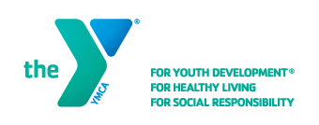

2013 Merryman Meet ENTRY FORM

NAME: _____________________________________________________________ PHONE#:_____________________________________
ADDRESS: ___________________________________
E-Mail: _______________________________________
AGE: ______ BIRTHDATE: ____/______/______ (check one) Male __ Female__
USMS TEAM: __________________________________ USMS#:_____________________
(Optional) YMCA Branch affiliation: _____________________________

Entry Deadline: This completed form and check must be received by FRIDAY, June 7, 2013.
USMS registered swimmers MUST attach a copy of their 2013 card for TOP TEN consideration.
Entry fees: $20 inclusive for up to maximum of 5 individual events and 2 relays.
Entries: Fill out form below.

USE SHORT COURSE YARDS FOR SEED TIME
EVENT# Event Description Seed Time Entry fee
1. ______ _____________ ________
2. ______ _____________ ________
3. ______ _____________ ________
4. ______ _____________ ________
5. ______ _____________ ________

RELAYS TEAM NAME Sum of ages
Event #6 200 Freestyle t-shirt relay _________________ __________
Event #10 200 MR (4 x 50) relay _________________ __________
Relay age groups (based on sum of ages): up to 39, 40-79, 80-119, 120-159, 160-199, 200-239, 240-279 …(40 year increments as high as necessary).

Release from Liability: Must be signed and dated before the swimmer may compete.
Release by participant from liability: I, the undersigned participant, intending to be legally bound, hereby certify that I am physically fit and have not been otherwise informed by a physician. I acknowledge that I am aware of all risks inherent in Masters Swimming (training and competition) including possible permanent disability or death, and agree to assume all of these risks. AS A CONDITION OF MY PARTICIPATION IN THE MASTERS SWIMMING PROGRAM OR ANY ACTIVITIES INCIDENT THERETO, I HEREBY WAIVE ANY AND ALL RIGHTS TO CLAIMS FOR LOSS OR DAMAGES INCLUDING ALL CLAIMS FOR LOSS OR DAMAGES CAUSED BY THE NEGLIGENCE, ACTIVITY ACTIVE OR PASSIVE OF THE FOLLOWING: United States Masters Swimming, Inc., the local Masters swim committees, the clubs, host facilities, meet sponsors, meet committees, or any individuals officiating at the meets or supervising such activities. In addition, I agree to abide by and be governed by the rules of USMS and the YMCAs of America.

SIGNED:_______________________________________________ DATE: _JUNE 16, 2013_
(Parent or guardian must sign if swimmer is under 18 years old)

PRINT NAME: __________________________________________________

