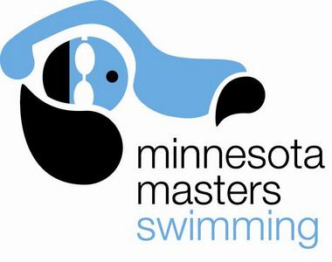 | Minnesota Masters  Long Course Meters Meet  University of Minnesota  Aquatic Center  Sunday, May 19, 2013 | 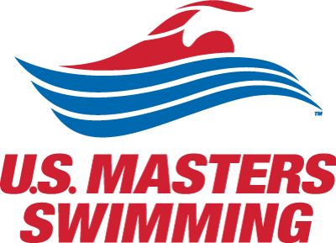

Schedule: Warm-ups – noon – 12:45pm Sanction #...
Meet – 1:00pm – 5:00pm

Meet Director Tom Moore (tom.moore.mn@gmail.com or 626-676-8006)

Entry information You must be USMS registered to participate ($42 annual or $15 “one event” membership fee)
$15 meet fee for “early bird” registration on or before Sunday April 28
$20 meet fee advance registration on or before Thursday May 16
$25 meet fee deck entry day of meet. ENTRIES CLOSE 30 minutes prior to Meet Start Time

Entry fees are non-refundable.

Register online at xxx
Paper entry form also available – contact Meet Director for more information
Maximum of 5 individual events per entry. Positive check in required for all events 400 yards and longer.

Relays: There will be a 5 minute break before relay events. Each relay entry card must include the event number, the Club name (all 4 swimmers must be registered with the same club), and the first and last name of each swimmer, listed in order.
Relay entry cards will be accepted through the start of the event prior to the relays so that there is time to enter the information into the meet computer. Late relay entry cards will not be accepted.

Results: Will be posted at the meet and on line at www.minnesotamasters.com within one week.

Event Number | Event | Entry Time |  | Event Number | Event | Entry Time
1 | 50m Butterfly | ___:____.____ |  | 11 | 50m Breastroke | ___:____.____
2 | 400m IM* | ___:____.____ |  | 12 | 400m Freestyle* | ___:____.____
3 | 100m Freestyle | ___:____.____ |  | 13 | 200m IM | ___:____.____
4 | 200m Backstroke | ___:____.____ |  | 14 | 100m Backstroke | ___:____.____
5 | 100m Breastroke | ___:____.____ |  | 15 | 50m Freestyle | ___:____.____
6 | 200m Freestyle | ___:____.____ |  | 16 | 200m Breastroke | ___:____.____
7 | 50m Backstroke | ___:____.____ |  | 17 | 100m Butterfly | ___:____.____
8 | 200m Butterfly | ___:____.____ |  | 18 | 200m Free Relay* | N/A
9 | 200m Medley Relay* | N/A |  | 19 | 400m Medley Relay* | N/A
10 | 400m Free Relay* | N/A |  | 20 | 800m Free Relay* | N/A
 |  |  |  | 21 /  22+ | 800 Freestyle* /  1500 Freestyle* | ___:____.____
* 200m Medley Relay, 400m Free Relay, 200m Free Relay, 400m Medley Relay and 800m Free Relay will be seeded based on entries received on race day |  |  |  | * 400m IM, 400m Free, 800m Free and 1500m Free require positive check-in on race day  + Swimmers may enter either 800 Free or 1500 Free.

Print Name: ____________________________ Male Female USMS #: _______-________

Birthdate: ___/___/___ Age: ____ Club: ___________________ Phone: _____-_____-_______
I, the undersigned participant, intending to be legally bound, hereby certify that I am physically fit and have not been otherwise informed by a physician. I acknowledge that I am aware of all the risks inherent in Masters swimming (training and competition), including possible permanent disability or death, and agree to assume all of those risks. AS A CONDITION OF MY PARTICIPATION IN THE MASTERS SWIMMING PROGRAM OR ANY ACTIVITIES INCIDENT THERETO, I HEREBY WAIVE ANY AND ALL RIGHTS TO CLAIMS FOR LOSS OR DAMAGES, INCLUDING ALL CLAIMS FOR LOSS OR DAMAGES CAUSED BY THE NEGLIGENCE, ACTIVE OR PASSIVE, OF THE FOLLOWING: UNITED STATES MASTERS SWIMMING, INC., THE LOCAL MASTERS SWIMMING COMMITTEES, THE CLUBS, HOST FACILITIES, MEET SPONSORS, MEET COMMITTEES, OR ANY INDIVIDUALS OFFICIATING AT THE MEETS OR SUPERVISING SUCH ACTIVITIES. In addition, I agree to abide by and be governed by the rules of USMS. (rule book article 203.1)
Please Sign:

____________________________________________ Date: _________________

Event | Event Number |  | Event | Event Number
Individual Medley |  |  | Freestyle
200m IM | 13 |  | 50m Free | 15
400m IM | 2 |  | 100m Free | 3
 |  |  | 200m Free | 6
Backstroke
50m Back | 7 |  | 400m Free | 12
100m Back | 14 |  | 800m Free | 21
200m Back | 4 |  | 1500m Free | 22
Breaststroke |  |  | Relay
50m Breast | 11 |  | 200m Medley Relay | 9
100m Breast | 5 |  | 400m Medley Relay | 19
200m Breast | 16
 |  |  | 200m Free Relay | 18
Butterfly |  |  | 400m Free Relay | 10
50m Fly | 1 |  | 800m Free Relay | 20
100m Fly | 17
200m Fly | 8

