BOZEMAN BARRACUDA SWIM CLUB

hosts the
BOZEMAN MAY SWIM CLASSIC
MAY 17-19, 2013 in Bozeman, Montana

Held under the Sanction of USA Swimming, Inc., issued by Montana Swimming, Inc. Sanction # ____.
This meet is dual sanctioned with Montana Masters sanction # ____.

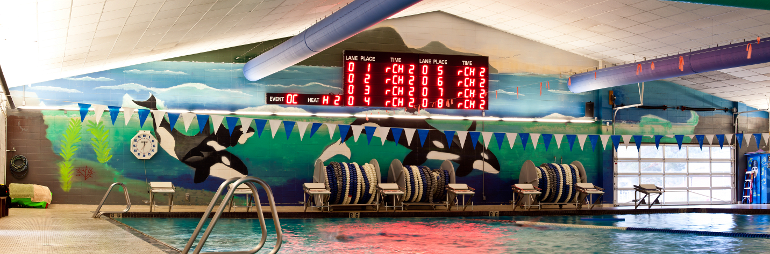

Meet Referee Meet Director Meet Registrar
Craig Smith Tami Peters Cindy Smith
(406) 556-1855 (h) (406) 585-1299 (h) (406) 556-1855 (h)
craigsmith427@live.com (406) 209-5639 (c) (406) 581-2886 (c)
btpeters@q.com bozemanbarracudas@yahoo.com
Bozeman Swim Club,
attn Cindy Smith
P.O. Box 804,
Bozeman, MT 59771

Facility The Bozeman Swim Center, located on the west side of Bozeman High School at 1211 West Main Street, is an 8-lane, 50-meter regulation long course pool. It is equipped with Kiefer non-turbulent Lane Lines and brand new Spectrum Xelerator starting blocks. The pool is 9 feet deep at the start end and 3.5 feet deep at the turn end. The altitude is 4793 feet. There is no separate warm-up and cool down facility therefore, the provision of a warm-up cool down lane and/or 10 minute warm-up breaks will be inserted into the meet schedule at the discretion of the Meet Referee. The competition course has not been certified in accordance with 104.2.2C(4). Montana Masters Swimming had it certified and we are in the process of completing the certification.

An Automatic Colorado Timing System will be used with touch pads at both ends, 3 backup times, and display will be on a new 8 line LED scoreboard. Each club will be responsible for providing at least two (2) timers at all times. A sign-up sheet will be posted at the announcer's table specifying lane assignments.

Directions: From I-90, arriving either east or west bound, take exit 306 onto N 7th Avenue. Turn south onto N 7th Ave and travel 1.2 miles to the tee intersection with West Main Street. Turn right (west) onto W Main Street. Bozeman Swim Center will be on your right in 0.5 miles, just past the Bozeman High School. OVERNIGHT PARKING OR CAMPING IS NOT PERMITTED IN THE PARKING LOTS ADJACENT TO THE SWIM CENTER.

Meet Format This will be a split session meet. Events will be swum 12 and Under in the morning sessions and 13 and Over in the afternoon sessions. 1500 and 400IM will be available to 11 and Over swimmers. 400 Free will available to 9 and Over swimmers. 400 Free and 400 IM will be a part of the afternoon sessions 3 & 5 respectively. Events will be swum as listed on the schedule of events. All events are timed finals.

Swimmers entered in the 1500 Free, the 400 Free, and the 400 IM must provide their own timers. Swimmers entered in the 1500 Free must also provide their own counters. Positive check-in will be required for all swimmers in these three (3) events.

Warm-ups: In accordance with USA Swimming guidelines, there will be a published warm-up procedure for all swimmers and coaches attending the meet. The Marshal will ensure all teams, coaches, and swimmers follow all warm-up procedures. Meet Management reserves the right to change general warm-up times and general meet start times according to the number of entries. Check your program or the Barracuda Web Site (www.bozemanbarracudas.org) after Thursday, May 16th for the actual warm-up and start times.

An open warm-up session will be available to all swimmers on Friday from 4:00 - 5:00 p.m. All swimmers must have a certified coach overseeing them during this warm-up.

The Meet Referee reserves the right to provide a warm-up/cool down lane or insert 10 minute warm-up breaks throughout the meet for the benefit of the swimmers.

FRIDAY Open warm-up 4:00 - 5:00 p.m.
Session 1 (1500 Free) Warm-up 5:15 - 5:50 p.m.
Meet: 6:00 p.m.
SATURDAY Session 2 (12 & under) Warm-ups 7:15 - 8:00 a.m.
Meet: 8:10 a.m.
Session 3 (13 & over) Warm-ups: Immediately after Event 33
Length: 45 minutes
(An estimated start time will be set after entries received & seeded)
SUNDAY Session 4 (12 & under) Warm-ups 7:15 - 8:00 a.m.
Meet: 8:10 a.m.
Session 5 (13 & over) Start time: Immediately after Event 77
Length: 45 minutes
(An estimated start time will be set after entries received & seeded)

Safety The Montana Swimming Safety guidelines are in effect for this meet and will be enforced. For circle swimming during warm-ups and cool downs, swimmers must enter the pool using a three point entry. Coaches are advised to closely supervise their swimmers at all times. NO running or horseplay will be tolerated. A safety marshal will be on deck.

Racing Starts Any swimmer entered in the meet, unaccompanied by an USA Swimming member coach, must be certified by an USA Swimming member coach as being proficient in performing a racing start or must start each race from within the water. It is the responsibility of the swimmer or the swimmer’s legal guardian to ensure compliance with this requirement. Any swimmers who must start in the water shall be listed in a separate document returned with the entries.

Rules The meet is approved by Montana Swimming and USA Swimming. 2013 USA Swimming Rules and Montana Swimming Rules will govern the conduct of the meet, except where rules therein are optional and exceptions are stated. The USA Swimming Code of Conduct and athlete protection provisions will be enforced. All persons acting in any coaching capacity on deck must be currently registered coach members of USA Swimming. Swimmer, official, and coach registration will be confirmed with Montana Swimming Registration Chairperson prior to the start of the meet. Use of audio or visual recording devices, including a cell phone, is not permitted in changing areas, rest rooms or locker rooms. Changing in or out of swimsuits is allowed in locker rooms or other designated areas only. Deck changing is not appropriate and is absolutely prohibited. No glass containers, tobacco, or alcoholic beverages are allowed in the swimming venue. This meet may be covered by the media, including photographs, video, web casting and other forms of obtaining images of athletes participating in the meet. Entry into the meet is acknowledgement and consent to this fact.

Eligibility All swimmers must be registered with USA Swimming Inc., the Canadian equivalent, or US Masters Swimming (USMS) prior to the entry deadline. Masters swimmers are welcome and encouraged to compete. There will be no on deck USA Swimming registration available at this meet. Teams entering swimmers who are not currently registered USA Swimming athlete members may be fined $25 per swimmer by the Montana Swimming Registration Chair. Age as of the first day of the meet (May 17th, 2013) shall determine the age group in which the swimmer must compete.

Swimmers with disabilities
The Bozeman Barracuda Swim Club welcomes all swimmers with disabilities as described in the USA Swimming Rules and Regulations, Article 106, to compete at the meet. Disabled swimmers or their coaches are required to provide advance notice in writing to the meet referee and meet director to arrange for any needed accommodations including personal assistants required and/or registered service animals by the meet entry date. It is at the discretion of the meet referee to determine whether the needed accommodations can be met by the meet resources. Failure to provide advance notice may limit the Bozeman Barracuda's ability to accommodate all requests.

Officials/Timers To the extent possible, teams are asked to provide timers and other certified meet officials. On deck training time will be available for those wishing to train as an official. E-mail the meet referee prior to the meet if you plan to officiate and sign in at the officials meeting each day in the hospitality room. Trainees should attend the pre-meet officials meetings daily and sign in. All officials on deck must be registered and certified with USA Swimming and registrations will be verified by the MT Swimming Registration Chair. Any official’s assistance will be greatly appreciated and will help to ensure a great meet for the swimmers.

Each club will be responsible for providing at least two (2) timers at all times. A sign-up sheet will be posted at the announcer's table specifying lane assignments.

The officials’ meetings will be held in the hospitality room at 5:30 p.m. Friday and at 7:15 a.m. on both Saturday and Sunday.

Coaches All coaches on deck must be registered and certified with USA Swimming. Coach registration will be verified with the MT Swimming Registration Chair.

A coaches' meeting will be held in the office Saturday at 7:00 a.m.. Other meetings may be held at the meet referee’s discretion. Meet Management requests that at least one coach representative from each team attend all coaches meetings.

Entry Fees An entry fee of $16.00 plus $2.00 per event will be charged. The relay fee is $5.00 per relay. Make checks payable to the Bozeman Swim Club. No entries will be accepted without payment of fees. There will be no refunds.

Entry Limits Each swimmer may compete in a maximum of nine (9) individual events with a maximum of five (5) individual events on Saturday. No more than four (4) events on Sunday.

Entry Format All entries may be submitted by e-mail (preferred) as a Team Manager file to: bozemanbarracudas@yahoo.com or by mail on the enclosed master sheet. Please include a printed copy of your entries with your payment. Also complete and return the USA Swimming Registration Confirmation, Waiver and Accounting Sheet with your entries (all enclosed in the entry packet).

Relays: Relay entries may be mixed age as well as mixed gender, and will be seeded and swum as such. We encourage mixed age group if possible.

Entry Deadline All entries must be received in Bozeman no later than Friday, May 10, 2013.
E-mail entries to: bozemanbarracudas@yahoo.com.
Mail entries to: Bozeman Swim Club
attn: Cindy Smith
P.O. Box 804
Bozeman, MT 59771
Entries must be made through the swimmer’s club with a team check. Unattached swimmers may make direct entries. Phone entries will be accepted until 8:00 p.m. Saturday May 11th. Phone entries called in to Cindy Smith (406) 556-1855. Phone entries for entire teams will not be accepted. Late entries, if accepted, will require double entry fees.

Entry Verification An email will be sent to the person submitting the entry confirming receipt of the entry within 48 hours of receipt.

Age Groups 8 & U, 9-10, 11-12, 13-14, 15-16, 17-19, 20 and Over. All combined events will be posted and scored separately by age group. Age on May 17th shall determine the swimmer’s age group for the meet.

Seeding Each swimmer will be seeded according to age group and submitted times in meters. Failure to convert yard times before submitting could result in your swimmers being incorrectly seeded. Yard times will be entered as submitted and will not be converted. “No time” entries will be accepted. Deck seeding may be provided if there are open lanes and at the discretion of the referee. The 1500 Free; 400 Free, 400 IM will be seeded and swum fastest to slowest with heats alternating between women and men.

Positive Check-in Positive check-in, located at the announcer's table, will be required 30mins before the start of each session for the following events:
- 11 & Over 1500 Free (Session 1)
- 9 & Over 400 Free (Session 3)
- 11 & Over 400 IM (Session 5)

Failure to check-in for these event by the stated deadline may result in the swimmer being scratched and not seeded.

Swimmers entered in the 1500 Free, the 400 Free, and the 400 IM must provide their own timers. Swimmers entered in the 1500 Free must also provide their own counters.

Scratches Coaches should report scratches on the scratch sheet or to the meet referee prior to the start of the meet both days. There will be no penalty for swimmers who fail to scratch from an event.

Protests: All protests should be given to the meet referee.

Awards Participation awards will be given to each swimmer and heat winner prizes will be awarded. No individual awards will be given.

Final Results Meet results will be posted to the Montana Swimming website at: www.mtswimming.com
Results will also be posted on the Bozeman Barracuda Web Site: www.bozemanbarracudas.org

Concessions Concessions will be available. Absolutely no glass containers are allowed in the locker rooms or deck areas.

Swim Shop Personalized meet t-shirts and/or clothing will be available for sale as well as an array of swim items in the Swim Shop.

Hospitality A hospitality room will be available for all coaches, officials, and volunteering meet personal.

Spectators The west and north sides of the deck (coaches side and start end) will be a "Closed Deck" area, open to coaches, swimmers, and meet officials only.

Announcements MT Swimming IMX awards by age group will be announced on Saturday.
MT Swimming AAA swimmers will be recognized on Sunday.
Spring HOD Meeting will be held one (1) hour after the conclusion of Saturdays events (May 18th) in the downstairs conference room of the Magnuson Grand City Hotel located approximately 0.5 miles east of the pool at 507 West Main Street.

New Spectrum Xelerator starting blocks:

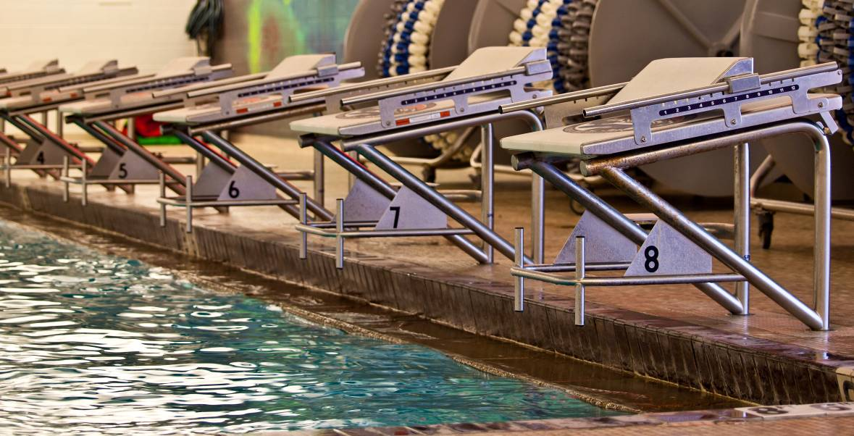

Hotel Information
Updated 4/9/13

Best Western Grantree Inn
1325 N. 7th Ave
587-5261
Double queen room $89/night
Suites: $10 more than double queen rate

** Ask for room under Bozeman Barracuda name, or if booking online use the promo code: "swim" to get these rates.

Magnuson Grand Hotel
507 W. Main St.
587-3158
Double queen room $89/night

Comfort Inn
1370 N. 7th
587-2322
Double queen room $89/night
Suites with 2 queen beds $129/night

C’Mon Inn
6139 E. Valley Center Rd.
587-3555
Double queen room $119/night
Suites: King living room $159/night
King Jacuzzi room $189/night

Days Inn
1321 N. 7th Ave.
597-5251
Double queen room $79/night
Suites: $129/night

Hampton Inn
75 Baxter Ln.
522-8000
Double queen $139/night

My Place Hotel Bozeman
5889 East Valley Center Road
586-8228
Double queen room $74/night
** Brand new! Opened April 2013.

Hilton Garden Inn
2023 Commerce Way
582-9900
Double queen $129/night
King with sofa bed $149/night

Holiday Inn
5 E. Baxter Ln.
587-4561
Double queen $129/night

Homewood Suites
1023 Baxter Ln.
587-8180
Double queen room $116/night
King Studio:
One king bed with pull-out sofa, $107/night

Holiday Inn Express
2305 Catron
582-4995
Double queen $109/night

Super 8
800 Wheat Dr., Bozeman
586-1521
Double queen $64/night

** Mention Barracuda Swim Meet when making reservation

Mountainview Lodge
A special rate of $79.00/night is offered through our Barracuda "Gold Dollars" program. If you are interested please call the coordinator of this program at 406 585-0237.

Order of Events
(Pg 1 of 2)

Friday Session 1 May 17, 2013
Warm-ups: 5:15 - 5:50 p.m.
Meet Begins: 6:00 p.m.

Girls Boys
1 11 & Over 1500 Free 2

Saturday Session 2 May 18, 2013
Warm-ups: Starts 7:15 a.m.

Girls Boys
3 11& 12 200 Breast 4

5 8 & Under 50 Fly 6
7 9 & 10 50 Fly 8
9 11 & 12 50 Fly 10

11 10 & Under 100 Back 12
13 11 & 12 100 Back 14

15 8 & Under 100 Free 16
17 9 & 10 100 Free 18
19 11 & 12 100 Free 20

21 10 & Under 200 IM 22
23 11 & 12 200 IM 24

25 8 & Under 50 Breast 26
27 9 &10 50 Breast 28
29 11 & 12 50 Breast 30

31 11 & 12 200 Fly 32

33 Mixed 12 & Under 200 Free Relay
(Mixed gender and/or age)

Saturday Session 3 May 18, 2013
Warm-ups: TBA (immediately following event #33)

Girls Boys
35 9 & Over 400 Free 36

10 minute Warm-up/Cool down

37 13 and over 200 Breast 38

39 13 and over 100 Back 40

41 13 and over 50 Fly 42

10 minute Warm-up/Cool down

43 13 and over 100 Free 44

45 13 and over 200 IM 46

10 minute Warm-up/Cool down

47 13 and over 50 Breast 48

49 13 and over 200 Fly 50

51 Mixed 13 and over 800 Free Relay
(Mixed gender and/or age)

Order of Events
(Pg 2 of 2)

Sunday Session 4 May 19, 2013
Warm-ups: Starts 7:15 a.m.

Girls Boys 53 11 & 12 200 Back 54

55 10 & Under 100 Fly 56
57 11 & 12 100 Fly 58

59 8 & Under 50 Free 60
61 9 & 10 50 Free 62
63 11 & 12 50 Free 64

65 10 & Under 100 Breast 66
67 11 & 12 100 Breast 68

69 10 & Under 200 Free 70
71 11 & 12 200 Free 72

73 8 & Under 50 Back 74
75 10 & Under 50 Back 76
77 11 & 12 50 Back 78

79 Mixed 12 & Under 200 Medley Relay
(Mixed gender and/or age)

Sunday Session 5 May 19, 2013
Warm-ups: TBA (immediately following event #79)

Girls Boys
81 11 & Over 400 IM 82

10 minute Warm-up/Cool down

83 13 and over 200 Back 84

85 13 and over 100 Fly 86

10 minute Warm-up/Cool down

87 13 and over 50 Free 88

89 13 and over 100 Breast 90

10 minute Warm-up/Cool down

91 13 and over 200 Free 92

93 13 and over 50 Back 94

95 Mixed 13 and over 400 Medley Relay
(Mixed gender and/or age)

2013 BOZEMAN MAY SWIM CLASSIC
Entry Fee Summary and Waiver/Release Form

Complete and email or mail this form along with entry fees to (checks payable to Bozeman Swim Club):
Mail entries to: Bozeman Swim Club E-mail entries to: bozemanbarracudas@yahoo.com
attn: Cindy Smith
P.O. Box 804
Bozeman, MT 59771

Team Name
Club Code
Coach
Coach Phone
Coach Email
Team Address

Item | Total Number | Cost per | Total
Swimmer Surcharge |  | $16.00 per event
Relay Entries |  | $5.00 per relay
Individual Entries |  | $2.00 / swimmer event
Total Fees Due

Waiver, Acknowledgement and Liability Release:
I, the undersigned coach or team representative, verify that all of the swimmers and coaches listed on the enclosed entry are registered with USA Swimming. Swimmer and coach registration will be verified. I acknowledge that I am familiar with the Safety Rules of USA Swimming, Inc. and Montana Swimming, Inc. regarding warm-up procedures and meet safety guidelines, and that I shall be responsible for the compliance of my swimmers with those rules during this meet. Bozeman Barracuda Swim Club, Bozeman Swim Center, Montana Swimming, Inc., and USA Swimming, Inc., their agents, employees, and coaches shall be held free and harmless from any and all liabilities or claims for damages arising by reason of illness or injury to anyone during the conduct of this meet. I also acknowledge that by entering this meet, I am granting permission for the names of any or all of my team’s swimmers to be published on the internet in the form of Psych Sheets, Meet Results, or any other documents associated with the running of this meet. This meet may be covered by the media, including photographs, video, web casting and other forms of obtaining images of athletes participating in the meet. Entry into the meet is acknowledgement and consent to this fact.
We hereby submit our team’s entry sheets and fees for your upcoming meet and verify that the above named coaches will be in attendance. These coaches are current in all the requirements set forth by USA Swimming; Red Cross Safety Training for Swim Coaches or Lifeguard Training, First Aid and CPR.

_____________________________________________________________________________________
SIGNATURE (Coach or Club Representative) CLUB

_____________________________________________________________________________________
TITLE DATE

Master Entry Sheet
Club:________________________ Age Group__________ Coach:___________________
Contact:______________________ Phone:_______________
Name |  | Age  Sex | USA # | Event # | Event # | Event # | Event # | Event # | Event # | Event # | Fees
 |  | Age  Sex | USA # | Time | Time | Time | Time | Time | Time | Time | Fees
Tally
Swimmers this sheet X $16.00= $________
Events this sheet X $ 2.00= $________
Total $ this sheet $________

