Swim Across America
Atlanta 2013
Water Safety Plan

Event Overview
- Description
- Date, Location, and Directions
- Timeline
- Swim Distances
- Practice Opportunities

Water Safety Plan
- Race Director
- Head Lifeguard/Swim Supervisor
- Map of Water Safety Personnel locations
- Medical Personnel
- Distressed Swimmer Protocol
- Lifeguard equipment
- Nearest Hospital or Treatment Center

Lake Spivey Safety Elements
- Visual safety survey of race area
- Water depths
- Synopsis of lake overview
- Water Quality Testing

Guidelines and Regulations
- Enforcing restrictions
- Incident Reports
- Permits and Regulations

Swimmer Guidelines
- Entering and Exiting Water

Boater Guidelines
- Water Safety Personnel
- Volunteers

Public Notices
- Bacteriological Test
- Inherent Risk

Event Overview
Description

Swim Across America is a grassroots organization with a 25-year history and a national presence. SAA holds 17 community oriented open-water swims from coast to coast, each used to fundraise for local beneficiaries supporting cancer research, prevention and treatment. Our organization is characterized by our desire to make a meaningful impact in the fight against cancer through our love for swimming. Beginning in 1987 with an event in Nantucket, Mass., SAA has grown to hold dozens of events each year and has raised more than $45 million since inception. Our goal is to raise as much money for cancer research, prevention and treatment as possible while making a measurable impact on communities across the country through swimming.

Swim Across America – Atlanta

Fundraising efforts for Swim Across America Atlanta go to The Aflac Cancer and Blood Disorders Center of Children’s Healthcare of Atlanta. These funds benefit both the patients at the Aflac Cancer Center and the doctors who will work to advance pediatric cancer research.

The Aflac Cancer and Blood Disorders Center of Children’s Healthcare of Atlanta provides advanced diagnostic and clinical care as well as innovative treatment and research options to children, adolescents and young adults. The center treats more than 6,500 children each year with cancer and blood disorders. This includes diagnosing a different child almost every day with cancer and caring for more children with sickle cell disease than any other pediatric hospital in the country. Supporting research performed by doctors such as Tobey MacDonald, M.D., is one of the main goals of Swim Across America. Dr. MacDonald, Director of the Neuro-Oncology Program at the Aflac Cancer Center, has focused on medulloblastoma (MB), the most common malignant brain tumor in children.

Swim Across America is proud to support such efforts.

Date, Location, and Directions
May 5th, Lake Spivey
Lake Spivey is a 600+ acre private lake located in Clayton County, Georgia and home to 1984 Olympic Gold Medalist, Steve Lundquist. This is no place in this part of our country as beautiful and unique as this lake, which will provide for a closed course and amazing support from local residents. The lake provides for water sports, fishing and relaxing and is conveniently located near the large transportation hub of Atlanta's Hartsfield Airport, a few minutes from interstate highways of 75-85, 285 & 675.

Located approximately 15 miles south of Atlanta Hartsfield-Jackson Airport.
Take Freeway 75 south to exit 238. Turn right onto GA 138W. Immediately turn left onto Spivey Road. Turn right onto Walt Stephens Road. Parking will be located on the right hand side of the road at Indian Lake - look for SAA signs.
Shuttles will run every 5 minutes for the 2 mile ride to Creek Indian Trail Road located 1.5 miles away.

Address for parking:
2390 Walt Stephens Road, Jonesboro, GA 30236
Address of Lake Spivey access for swimmer/volunteer drop (no parking):
2580 Creek Indian Trail, Jonesboro, GA 30236

Timeline

EVENT DAY TIMELINE
6:00 – 8:30 am: Registration/Check in
6:50 am: 10K swimmer safety talk
7:00 am: 10K swim start
8:30 am: Why I Swim
8:45 am: Group Photo & Swimmer Safety talk
9:00 am: 5K start
9:30 am: 1 mile start
9:45 am: 1/2 Mile start

Swim Distances
½ Mile, 1 Mile, 5K, 10K

Practice Opportunities
A practice-swim at Lake Spivey, the weekend before the race, will be held for swimmers and kayakers to become familiar with the waterway on April 28th. Please visit www.swimacrossamerica.org Atlanta for more information.

Course Map
½ Mile, 1 Mile, 5K, 10K

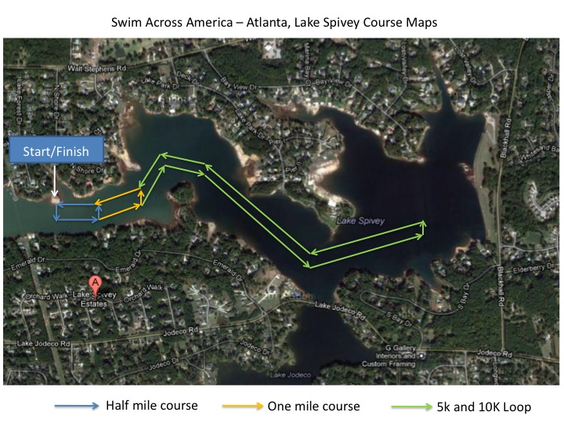

Water Safety Plan

Race Director
Megan Melgaard
Megan has spent the last several years of her life obtaining training and certifications as they relate to open water swimming and wilderness adventure. She has a broad understanding and appreciation of safety and emergency skills as a USA Triathlon certified Race Director and Swim Course Coordinator. Her certifications further include CPR for the Professional Rescuer, First Aid, AED, Safety Training for Swim Coaches, Lifeguard, Lifeguard Instructor, Blood borne Pathogens, and Oxygen Administration.

Head Lifeguard/Swim Supervisor
Kristine Croft
Kristine is a former EMT/Firefighter with 13 years of teaching and certifications in the following: Aquatics Examiner, Lifeguard Instructor Trainer, Water Safety Instructor Trainer, CPR/AED/First Aid Instructor Trainer and Emergency Medical Responder Instructor Trainer. She thoroughly enjoys making sure everyone is prepared to be a First responder in the event of an emergency. Kristine is involved in leadership and networking groups. She has 2 boys that are her pride and joy. In her free time she enjoys singing and spending time w/ her friends.

Overview
The Swim Across America Atlanta Water Safety Team will utilize a combination of motorized and non-motorized boats to achieve proper water safety for the race. This will include boats with inboard motors, kayaks, canoes, paddle boards, and jet ski.

Three motorized boats and one jet ski with inboard motors will be contracted through Clayton County and/or the Lake Spivey Homeowners Association. These watercraft will be used to patrol the outside perimeter of the swim course and assist in life saving operations. 18 non-motorized watercraft with Red Cross Certified Lifeguards, contracted by K C Health & Safety Training, will be utilized for lifesaving duties and precautions along the course. Kristine Croft, Head Lifeguard, will position these guards along regular distance intervals. Communication with the guards, Head Guard, SAA RD, EMT, Water Safety and SAA Personnel will be achieved via water proof radios provided by K C Health & Safety Training and SAA and through whistle protocol.

The Head Lifeguard will patrol from the water utilizing a jet ski or non-motorized watercraft.

Two Clayton County EMT personnel will be positioned near the swim exit.

The protocol for assisting a swimmer is as follows:
- Identify distressed swimmer visibly or audibly
- If a distressed swimmer is identified, the lifeguard closest will offer their rescue tube to help the person in need.
- Upon assisting an active drowning victim, the lifeguard will give three (3) long whistle blows to let surrounding personnel know he/she needs further assistance to exit the water with a swimmer along with radio communication to the nearest boat to pull the swimmer from the course.
- Once the swimmer has been removed from the water the lifeguard will continue surveillance.
- If immediate medical attention is required, a designated Water Safety Personnel boat will transport the swimmer back to the finish area where the land based EMT unit will treat on-site or transport to the nearest hospital.
- Swimmers may hang on buoys, kayaks, or rescue tubes to rest without being disqualified from the race; however, they may not make forward progress with the help of the aforementioned or another swimmer.
- If there is a swimmer who is identified as non responsive the lifeguard will go on the boat to administer needed CPR/and/or AED until they have reached the shore to hand off to EMS.
- In the event of a missing swimmer, all personnel will be notified to begin the mandatory search procedures as trained in Waterfront certification.
- Swimmers may hang on buoys, kayaks, or rescue tubes to rest without being disqualified from the race; however, they may not make forward progress with the help of the aforementioned or another swimmer.
- If there is a swimmer who is identified as non responsive the lifeguard will go on the boat to administer needed CPR/and/or AED until they have reached the shore to hand off to EMS.
- In the event of a missing swimmer, all personnel will be notified to begin the mandatory search procedures as trained in Waterfront certification.

Each swim wave will be assigned a different swim cap color. Caps will be brightly colored.

White ½ mile
Hot Pink 1 mile
Orange 5K
Yellow 10K

Map of Water Safety Personnel locations

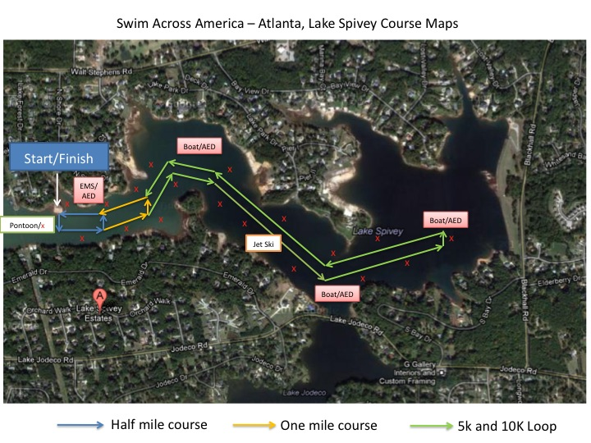

Medical Personnel
Medical Personnel from Clayton County will be on site. This will include 2 EMT units, one land based, and one water based at the far end of the course.
AED units will be on each Water Safety Personnel boat, as well as on land. 4 AED units will be on hand, with trained Professional Rescuers responsible for these units.

Lifeguard coverage plan
All guards will be placed along the OUTSIDE of the buoy line to ensure no swimmer swims outside of the designated path. Where there is a buoy placed along the course a lifeguard will be placed offset from the buoy. All lifeguards will be evenly placed along the entire swim course to ensure adequate coverage during the swim. Communication among the guards will be a constant throughout the swim to warn the next guard up the line of potential problems particular swimmers may have. The mandatory pre race safety meeting will designate areas of responsibility for each guard and they will all be in place and ready for the swimmers 15 minutes prior to opening bell.

Lifeguard equipment
Kayak
Paddle
Life Vest
Rescue Tube
Whistle
Lifeguard Uniform

Nearest Hospital or Treatment Center
Piedmont Henry Hospital
1133 Eagles Landing Parkway
Stockbridge, GA 30281
(678) 604-1000

Lake Spivey Safety Elements
Lake Spivey is a 600+ acre private lake located in Clayton County, Georgia and home to 1984 Olympic Gold Medalist, Steve Lundquist. This is no place in this part of our country as beautiful and unique as this lake, which will provide for a closed course and amazing support from local residents. The lake provides for water sports, fishing and relaxing and is conveniently located near the large transportation hub of Atlanta's Hartsfield Airport, a few minutes from interstate highways of 75-85, 285 & 675.

Visual safety survey of race area
From multiple visual surveys performed in 2012 and 2013, consultations with the Lake Spivey Homeowners Association, and assessments from Water Safety Professionals, the lake is safe and suitable for swimming.

Guidelines and Regulations
Enforcing restrictions
The Head Lifeguard will patrol from the water by jet ski or non-motorized watercraft. The water should be clear of boater traffic, unless approved and permitted by SAA and the Lake Spivey Homeowners Association. Three designated safety boats and jet ski will help to prevent any non- authorized boaters from coming closer than 400 feet from the race course. (*) The Race Director will request communication on race day with a representative of the Lake Spivey Homeowners Association to help enforce and inform the community of these rules prior to the event.

Incident Reports
Any and all incidents must be reported to the Race Director and/or Head Lifeguard immediately and with a sense of urgency. Any emergency action taken by SAA staff or contracted service providers should be documented using the designated Incident Report Form once the situation has been addressed in a timely and safe manner.
Appendix A – Incident Report

Permits
The Lake Spivey Homeowners Association has voted and agreed upon the use of Lake Spivey and approved land spaces for the purposes of the 2013 Swim Across America Atlanta Event.

A Special Event Permit has been submitted to Clayton County.

Weather Policy
On race day, there is always the potential for extreme or severe weather conditions (for example: lightning, tornado, high winds, extreme hot or cold temperatures, etc...). In the event of inclement weather including storms, thunder, and lightning, etc., the race may be delayed as race officials consult public safety officers. If there is more than a reasonable delay, or if conditions persist, race officials reserve the right to shorten or cancel the race. Entry fees are non-refundable.

Should weather conditions change during the race; multiple blasts from an air horn will be sounded by the Race Director to notify swimmers and lifeguards.
Lifeguards will be notified by radio to begin clearing the course and directing swimmers to the closest exit point.

Swimmer Guidelines
Entering and Exiting Water
Athletes will enter the water from a boat loading ramp. They will gather on the shore near the dock. Once lined up in designated heats, the Race Director will re-announce the swimmer safety plan and relevant information from a nearby dock for all swimmers to hear. Swimmers will WALK into the water and wait in the shallow water until the start signal is sounded.

EVENT DAY TIMELINE
6:00 – 8:30 am: Registration/Check in
6:50 am: 10K swimmer safety talk
7:00 am: 10K swim start
8:30 am: Why I Swim
8:45 am: Group Photo & Swimmer Safety talk
9:00 am: 5K start
9:30 am: 1 mile start
9:45 am: 1/2 Mile start

Upon completion of the swim, athletes will exit the water by using a ramp, built by the Lake Spivey Homeowners Association, next the Marina. The area has been inspected by the Lake Spivey Homeowners Association, Clayton County Personnel, and SAA Personnel; and is free of any potentially harmful debris. Aforementioned parties will re-inspect the area two weeks, one week, and the 48 hours leading up to the race. There are no known obstacles under the water in this area at this time.

Timing
Each swimmer will be provided with a timing chip that is programmed to each individual and their assigned race number. Swimmers should not mix their chip with anyone else's chip. A time will be recorded as swimmers cross the start and finish line mats. The chip must pass within one foot of the start and finish line mats to assure activation. Timing officials will use the timing chips to reconcile swimmers as a safety check to ensure an equal amount of swimmers in and out of the water.

If a swimmer chooses not to finish the race or is pulled from the water by a race official, the official MUST IMMEDIATELY inform the race director of the athlete #. The race director must then immediately inform the timing official of this swimmer exiting the race for proper safety measures.

Each athlete will also be body marked with their appropriate race number.
Each athlete will wear a designated colored cap with the their race number marked on it.

A manual back up time and athlete check in/out will also be taken by SAA volunteers/staff.

Boater Guidelines
Water Safety Personnel
There will be 4 boats, 1 jet ski, and 18 kayaks designated as Water Safety Personnel watercraft. These boats have the authority to enter the race course in the event of emergency. Otherwise, these watercraft should maintain position as assigned by the Head Lifeguard to monitor and ensure the safety of the swimmers. (Please refer to the above Water Safety Personnel Map for safety boat locations.) 2 Pontoons will serve as Feeding Stations.

Volunteers
Volunteers are required to attend a pre-race safety meeting and sign a volunteer waiver. They should not, by any means, enter the race course unless permitted by the Race Director and/or Head Lifeguard. Swimmers requesting a personal kayaker for the 10K swim must have their volunteer approved by the Race Director and Head Lifeguard.
Kayakers for the 10K swimmers will be required to wait in a designated area, 100 meters beyond the farthest 1 mile turn buoy. Kayakers may then accompany the 10K swimmer back to this point. The swimmer must then go unassisted around the platform to complete the first 5K. Upon rounding the platform, the 10K kayakers may return to assist their swimmer, 100 meters beyond the farthest 1 mile turn buoy.

The water should be clear of boater traffic, unless approved and permitted by SAA and the Lake Spivey Homeowners Association. The three designated boats and jet-ski, will help to prevent any non-authorized boaters from coming closer than 400 feet* from the race course. (*Where the shoreline does not allow a passing of more than 400 feet, boater traffic may not pass, or pass ONLY with accompaniment from SAA designated safety watercraft and radio/verbal approval from the Race Director and/or Head Lifeguard.)

Public Notices
Bacteriological Test
Inherent Risk
Lake Spivey, though meeting the requirements for bacteria count and water testing, is subject to contamination from natural sources and has an inherent risk of illness and infection for those that enter this or any surrounding body of water.

