Basic Information
Name of Host Club: Southern Masters Swimming
Name of Event: Tri-Lakes Open Water Swimming Carnival
Event Location: 18605 Barnett Road |  | Event Date: May 4, 2013
City: Zachary | State: LA |  | LMSC: Southern | Zone: Dixie
Length of Race(s): 1km, 3km

Key PErsonnel
Meet Director(s): Tim Root
Cell Phone: (832) 339-9241 | Work Phone: (225) 977-8145 |  | E-mail:timothy.s.root.82@gmail.com
Meet Safety Officer: Mark Smith |  | Phone: (225) 933-2521 |  | E-mail: mark@divewithua.com

PRE-RACE MEETING
A pre event meeting will be held with all volunteers and safety personnel to review the safety plan, communications procedures, and procedures for distressed swimmer, severe weather, evacuation, etc.

Pre-race meetings will be held 10 minutes before each race to brief competitors of the course and safety procedures.

RACE PLAN

Race Day conditions
Expected air temperature: 85°F | Expected water temperature: 75°F-80°F  Minimum Allowed: 60.8°F Maximum Allowed 5K+: 87.8°F
Combined air & water temperature: (Must be between 118°F and 177.4°F) 155°F -165°F
Type of body of water: Water Ski Pond | Water type: Fresh Water
General water depth of course: 4-7 ft. | Course: Closed course (not accessible by boat)
Expected water conditions for the athletes: (marine life, tides, currents, underwater hazards) Pond is closed to non-facility water craft. Water ranges from 4-7 feet in depth. Water is calm, without currents or tides. A wind shop may exist if wind speed is high enough. Bottom is muddy and semi-solid.
How is the course marked?

Turn buoy height: 7 feet Color: Orange
Intermediate buoy height: 4-5 ft Color: Orange
Starting Location: In water
Finish Location: In water

Attach a Google Earth Map (or equivalent) of race course. Indicate on the map the locations of the start/finish, turn buoys, intermediate buoys, all safety craft, Lifeguard/First Responders, onsite medical care, feeding stations, etc.

1Km race, start and finish of 3k race:

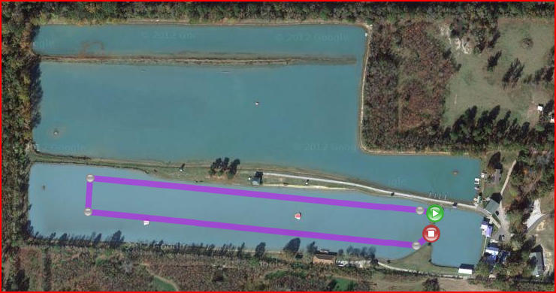

Middle lap of 3k race

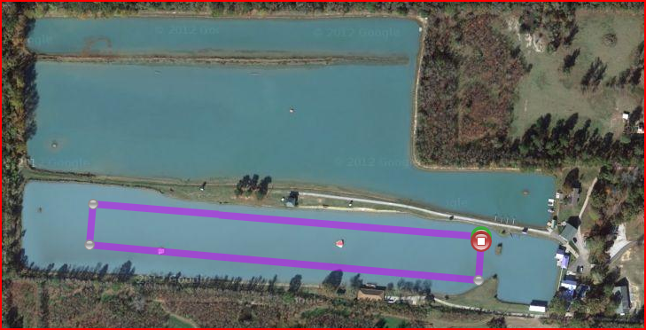

MEET SAFETY PLAN

MEDICAL Personnel
Name of lead medical personnel (emergency trained) on site : Mark Smith, EMT
Will medical personnel be located on the course? Yes No
The required number of medical personnel will be dependent on the course layout, number of athletes in the water, expected conditions, etc. How many medical personnel do you plan to have on site? (minimum 4 for closed 1K loop course) 4

FIRST RESPONDERS/LIFEGUARDS
Indicate the qualifications of the first responders (prefer open water experience). ARC Lifeguards

Number on course: 6 on course, 1 in warm up area
Indicate their location on the Race Plan Map.
Race Course Main Straight is 470m, including extra start straightaway. Short Straights are 50m.
Warm Up Area is ~150m long, and ~50m wide at its longest point
Lifeguards stationed at Red Dots, located on Kayaks. Lifeguard/Kayak will start near the middle of the course, erring toward the side of the course that more of the field is swimming on. One of the lifeguards will be stationed in the warm up area. 7 lifeguards stationed along the length of the course is roughly a spacing of 60 meters, allowing for a 15-20 second response time from the spotting of a distressed swimmer to arrival on location of the swimmer.

ON SITE MEDICAL CARE
Describe the on site set up for medical care, such as medical treatment tent, heating or cooling tent or facility. Indicate the location on the Race Plan Map.

Medics and race organization will be based on the “PA System Shelter”, outlined in Red in the picture below. This shelter is adjacent to the race pond, a 20 meter walk to the ramp where the race pond is entered, and a roughly 45m walk to the ramp to enter the warm up pond. Should an athlete become overheated, they could be cooled in the air conditioned pro shop, located between the race pond and warm up pond.

MEDICAL FACILITIES
Nearest Medical Facilities:

Lake After Hours Urgent Care – 4.3 miles, ~10 minutes transport time

Lane Memorial Hospital, Zachary – 6.3 miles, ~12 minutes transport time

Earl K Long Hospital, Baton Rouge – 12.8 miles, ~20 minutes transport time

WATER CRAFT
Sufficient coverage to cover the course: 1 motorized, operated by EBR Parish Dive Team
List other water craft for race supervision: (Boats, Jet Skis, Kayaks, paddle boards, etc) 7 kayaks on race course with lifeguards, 1 kayak with lifeguard in warm up area

ATHLETE ACCOUNTABILITY
Describe method of athlete body numbering (MANDATORY):
Both Shoulders, hands, and cap shall be marked with permanent marker
Describe different cap colors for the various age groups/genders? (Recommended):
Yellow caps for male athletes, powder blue caps for female racers
Describe method of accounting for all competitors before, during and at conclusion of race(s):

Ponds shall be single entrance and exit from the boat ramps at the corners of the pond (NE corner of race pond, SE corner of warm up pond)

All athletes must check in with ramp attendant before entering either the racing course or the warm up pond. Ramp attendant shall record the number of the athlete entering the water. When athlete exits the water, they must check out with the ramp attendant, who will strike the race number from their list.

If an athlete has not checked out within 10 minutes of the race end, emergency procedures to find missing swimmers shall be enacted.

WARM-UP/WARM-DOWN PLAN
Explain safety plan for warm-up/warm-down.

Warm up will be available on the race course prior to the beginning of the races. Full lifeguard and kayak staff shall be in position for this warm up.

During the meet, warm up and warm down will be available in the pond immediately to the north of the race pond. Racers shall not go beyond the narrow portion of this pond. A lifeguard will be present on shore, and a kayak shall be in the warm up area to attend to any possible distressed swimmers.

Check in/Check out procedure described above shall be in place for the warm up area during the duration of the meet.

COMMUNICATIONS
Primary method between Meet Officials: Radio

Secondary method: Cell Phone number of the race director and safety officer shall be distributed to all race volunteers.
Primary method for communicating between medical personnel, first responders & safety craft:
Radio(separate channel from above)

Secondary method: Cell Phone

SAFETY PLAN:
Maximum number of swimmers on course at a time: 50
If more participants show up on race day, what is the procedure for adjusting the safety plan to accommodate the increased number of entries?

While more entries are not anticipated, fields would be split into male and female divisions should the field size warrant this action.
How are the lifeguard staff and safety crafts distributed to supervise this event to maximize the recognition, rescue and treatment of any athlete?

Please see map above. In addition, fire department watercraft shall be roaming the course throughout the event.
How is the safety staff deployed to maximize the rapid response to a troubled athlete?

Please see map above.
How will the event be altered if insufficient safety personnel/craft are available race day?

Should insufficient coverage be available, the course shall be shortened, and the number of laps shall be increased.
Missing athlete plan:

Should an athlete fail to check out within 10 minutes of the arrival of the last apparent finisher, notification will be sent over the facility public address system. Kayakers will sweep the course, and the dive team shall begin their search. If necessary, they shall enter the water.

SEVERE WEATHER
Is a lightning detector or weather radio available on site? Weather Radio shall be available
What is the severe weather plan?

Should lightning be seen, all athletes and boaters will be forced to exit the water, and the meet shall be delayed for 30 minutes. Athletes and race organization shall be alerted to clear the water by the blast of an air horn.

Meet will not resume until no lightning has been detected for 30 consecutive minutes. If the lightning does not show any sign of clearing, the event shall be postponed.
What is the site evacuation plan?

Should weather dictate that the site be evacuated, all cars will be asked to leave the facility to the exit on Barnett Road.

