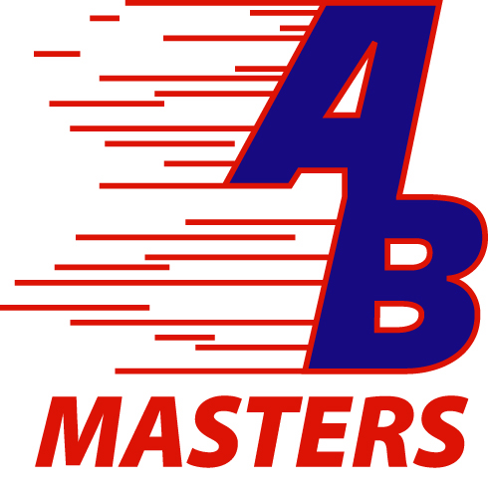
Anderson Barracuda Masters
2013 St. Patrick’s Day Swim Meet
The Dome Natatorium- M.E. Lyons YMCA

Saturday, March 16th, 2013

Sanctioned by OHIO LMSC for USMS, Inc. # 173-S003 SCY
Warm up for Event #1: 11:30 AM. 1000 Free begins at 12:30 PM.

Online entry: You are able to enter the meet online, and charge your entry fee to a credit card (Visa or MasterCard only) and receive confirmation of your entry. Go to https://www.ClubAssistant.com/club/meet_information.cfm?c=1559&smid=4489 to access online entry! Please note: Your credit card will be charged by "ClubAssistant.com Events".

Location: From Dayton or Columbus take 275 east to the Five-Mile Exit # 69; turn right (north) onto Five Mile. From Lexington or Louisville take Interstate 275 east, take the Five-mile exit #69, turn left and continue north on Five-Mile and drive 1.5 miles through the intersection of Five-Mile and Beechmont Avenue to 3-way intersection, where Five-Mile meets Clough Pike. Turn right (east) onto Clough Pike. Drive 2.5 miles, heading east on Clough. Once you past the Nagel Road intersection the YMCA entrance will be located on your left (200 feet).
Facility: The meet will be conducted in the Dome pool. The pool is a 6-lane 25-yard pool with Competitor non-turbulent lane markers, Colorado automatic timing ran with Hy-Tek software. There will be separate 6 lane pool available for continuous warm-up and warm down.
Eligibility: 2013 U.S. Masters Swimming rules will govern conduct of the meet. Because of insurance regulations, all swimmers must be registered U.S. Masters Swimmers. A copy of your USMS card must accompany your paper entry form, NO EXCEPTIONS. Limit 5 individual events. Only swimmers entered in the meet can participate in relays. Only relays from same club may score points.
Age Groups: Age of competitors on March 16, 2013 will determine age group.
MEET CHECK IN: Only for event #1, 1000 Free. Only the Top 24 entries will be allowed to swim the 1000. The 1000 will run FASTEST to SLOWEST. Entries of NT (no time) for event #1 will not be accepted. There is a time cut off of 20 minutes. Event #2 - Medley Relays will not start before 1:15 pm.
Seeding: Heats will be formed by times, regardless of age or sex, and progress from “no time”, deck entries, slowest to fastest.
Deadline: Pre-Entries are due by March 13, 2013. Deck entries will be accepted until noon on the day of the meet. If deck entering, please be sure to bring your USMS card. No deck entries for the 1000 Free.
Fees: There will be a flat fee of $25.00 to attend this meet for on-line entry, which includes 5 individual events and relays for the meet. For paper entries, there will be a flat fee of $40.00 and for deck entries the fee will be $55.00. For paper entries all Fees must accompany entry forms and a copy of your USMS card must accompany your entry form. Make checks payable to M.E. Lyons YMCA.

Mail paper entries to: Corey Mullins- Meet Entry Director - 2930 Turpin Lake Place Cincinnati, OH 45244
Email address: coreym@bcmullins.com
Cell phone # (513) 885-9801 Home phone # 513-232-9801
Meet Director: Corey Mullins - Cell phone # (513) 885-9801 Home phone # 513-232-9801
YMCA Contact: Tim Hart (513) 362-2075
Officials Contact: C.J. Rushman (513) 828-8972
Anderson Barracuda Masters
2013 St. Patrick’s Day Swim Meet
The Dome Natatorium- M.E. Lyons YMCA

Saturday, March 16th, 2013

Name: ___________________________ Sex: _____ Age: ______ Birthdate: _____________

Address: _________________________ City: ______________ State: ______ Zip: ________

Phone: _____________ Team: _____________ or Unattached: ______ USMS#: ____________

Entry Acknowledgment Email Address: ___________________________________________________________
Enter Your Age Group: __________ 19-24 25-29 30-34 35-39 40-44 45-49 50-54
55-59 60-64 65-69 70-74 75-79 80-84 85-89 90+
Event |  | Entry Time | Event |  | Entry Time
1 | 1000 yd. Freestyle |  | 11 | 50 yd. Backstroke
2 | 200 yd. Medley Relay | * Deck Entered * | 12 | 100 yd. Breaststroke
3 | 200 yd. Butterfly |  | 13 | 200 yd. Backstroke
4 | 100 yd. I.M. |  | 14 | 100 yd. Butterfly
5 | 50 yd. Freestyle |  | 15 | 50 yd. Breaststroke
6 | 200 yd. Breaststroke |  | 16 | 100 yd. Freestyle
7 | 100 yd. Backstroke |  | 17 | 200 yd. I.M.
8 | 50 yd. Butterfly |  | 18 | 200 yd. Freestyle Relay | * Deck Entered *
9 | 200 yd. Freestyle
10 | 400 yd. I.M.

On Line Pre-Entry Fees: 5 events + relays for = $ 25.00 Pre Entry Deadline: March 13, 2013
Paper Entries: 5 events + relays for =$ 40.00
Make checks payable to M.E. Lyons YMCA
Release by Participant from Liability:
I, the undersigned participant, intending to be legally bound, hereby certify that I am physically fit and have not been otherwise informed by a physician. I acknowledge that I am aware of all the risks inherent in Masters Swimming (training and competition), including possible permanent disability or death, and agree to assume all of those risks. AS A CONDITION OF MY PARTICIPATION IN THE MASTERS SWIMMING PROGRAM OR ANY ACTIVITIES INCIDENT THERETO, I HEREBY WAIVE ANY AND ALL RIGHTS TO CLAIMS FOR LOSS OR DAMAGES, INCLUDING ALL CLAIMS FOR LOSS OR DAMAGES CAUSED BY THE NEGLIGENCE, ACTIVE OR PASSIVE, OF THE FOLLOWING: UNITED STATES MASTERS SWIMMING, INC., THE LOCAL Masters Swimming COMMITTESS, THE CLUBS, HOST FACILITIES, MEET SPONSORS, MEET COMMITTEES, OR ANY INDIVIDUALS OFFICIATING AT THE MEETS OR SUPERVISING SUCH ACTIVIES. In addition, I agree to abide by and be governed by the rules of USMS.

Signature ___________________________________________________ Date __________________

Sanctioned by OHIO LMSC for USMS, Inc. # 173-S003 SCY

