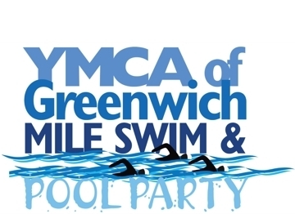
*Online registration is available at firstgiving.com
March 3rd
8am-2pm
Registration (Please Print Clearly)
Youth Registration (up to 17 years of age): $20
Adult Registration (18 & over): $35

D.O.B: Gender: T-shirt Size:
Name: Email address (Required):
Address: City: State: Zip:
Home Phone: Cell Phone:
What is you approx. Mile Time?
How much do you plan to raise?

WAIVER
I understand that the YMCA of Greenwich assumes no responsibility for injuries or illnesses which I may sustain as a result of my physical condition or resulting from my participation in any athletic activities, sports program and the use of any equipment, exercise or other activities. I expressly acknowledge that I assume on behalf of my heirs and myself the risk for any and all injuries and illnesses, which may result from my participation in these activities. I hereby release the Greenwich Family YMCA, its officers, directors, members, employees and agents from any and all claims for injury, illness, death, loss or damage which I may suffer as a result of my participation in these activities. In an emergency, I authorize the YMCA of Greenwich to administer first aid by trained staff and to obtain emergency medical treatment for any person listed on this application. I accept responsibility for all fees incurred in the care and transportation. I understand that the YMCA of Greenwich is not responsible for personal property lost or stolen while members and/ or program participants are using YMCA facilities or on YMCA premises. I give my permission to the YMCA of Greenwich to use, without limitation or obligation, photographs, film footage or tape recordings that may include my image or voice for promoting or interpreting YMCA programs. I acknowledge the Waiver and accept the Membership Conditions set forth above and in the Program Brochure and being in sympathy with the goals and purposes of the YMCA, herby apply for membership.

I/we agree to abide and to require and such family members and guest to abide by all rules and policies established by the YMCA of Greenwich

Payment Method
Total Payment:
Check Enclosed: check # Visa Master Card AMEX
Credit Card Number: Expiration:
Cardholder Signature:

