29th Annual Jack King One Mile Ocean Swim
June 24 2012
Safety Plan
Jack King is held at the Oceanfront at 10:00 am Sunday morning. Virginia Beach Lifesaving Service, a professional lifeguard service, guards the event, and is equipped with state-of- the-art equipment required to guard one of the world’s greatest beaches. The race director, June McDaniels, is in constant contact with Deputy Chief Tom Gill, via radio or cell phone. Tom has provided enormous support to our race, including extra guards in and out of the water, to provide a safe and adventurous swim for our participants. Deputy Chief Tom Gill determines race morning if the water is safe to swim in and starts the race from the lifeguard stand after holding a safety meeting with all the swimmers. In cases of emergency, the Virginia Beach Lifeguarding Service, a professional lifeguarding service, determines what emergency action is required.
In the event a swimmer or swimmers must be removed from the water:
The VBLS uses PWCs with sleds attached and radio capabilities to initiate immediate evacuation of an individual with a life-threatening emergency. In addition for a mass evacuation of the water the PWC operators would initiate a sweep of the course with the assistance of guards on paddleboards to notify and escort swimmers to the shore. (The course runs parallel to the shore so no one is ever too far from safety.)
In terms of rescue qualifications:
VBLS is certified by both the USLA and Virginia Emergency Medical Service (as a BLS Non Transport Certified Agency).

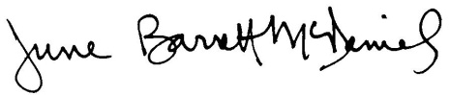
March 26, 2012

